

Global Humanitarian Assistance Report 2022

We hope you find this Word version accessible and easy to use. If you have any feedback, please contact us at [publications@devinit.org](mailto:publications@devinit.com).

Contents

acknowledgements 1

acronyms and abbreviations 3

foreword 5

executive summary 7

chapter 1: people and crisis 19

People affected by crisis 20

Humanitarian need and intersecting dimensions of risk 26

Forced displacement 30

chapter 2: volumes of humanitarian and wider crisis financing 33

International humanitarian assistance 35

Volumes of assistance compared with appeal requirements 38

Appeal requirements 39

Funding commitments to appeals 40

Funding inside and outside appeals 41

Red Cross Red Crescent appeals 41

Gender-relevant funding 46

Climate finance flows 49

What is climate finance? 49

Climate-relevant finance to vulnerable countries 51

chapter 3: donors of humanitarian and wider crisis financing 55

International humanitarian assistance: largest donors 57

Largest donors of gender-relevant humanitarian funding 64

Private donors of humanitarian assistance 66

Multilateral development bank financing to countries experiencing crisis 69

World Bank financing in crisis contexts 72

Development financing for disaster risk reduction 86

chapter 4: recipients and delivery of humanitarian funding 90

Which countries did humanitarian assistance go to? 91

Channels of delivery 94

Direct funding to local and national actors 96

Pooled funds for crisis response 103

Earmarking 105

Cash and voucher assistance 108

chapter 5: methodology and definitions 111

What is humanitarian assistance? 111

notes 122

# 

# acknowledgements

The lead author of this report is Angus Urquhart, with co-authors Fran Girling, Erica Mason and Suzanna Nelson-Pollard. We are grateful to all those who have contributed to the *Global Humanitarian Assistance Report 2022*. At Development Initiatives: Tom Urry, project manager; Niklas Rieger and Dan Walton, data analysis leads; Carina Chicet, Archie Donnelly, Jasmin Jilma and Kirsty Lazer, analysis throughout the report; Jordan Beecher, Duncan Knox, Mattie Price and Jenny Rickard, research and analysis on specific areas; Harpinder Collacott and Daniel Coppard, editorial guidance; Georgina Carver and Emma Woodcock, production management in collaboration with Martha Jackson and Simon Murphy; Ben Campbell, communications lead, with support from Sarah Harries and Anna Hope; Amy Cox, engagement lead, with support from Archie Donnelly and Alys McCarthy. Design: Steve Green at Definite.design; and Tim Harcourt-Powell, freelance designer. Copy-editing: Nina Behrman.

Expert information and advice: Michèle Plichta and Lydia Poole, Centre for Disaster Protection; Cat Pettengell, Climate Action Network UK; Simon Anderson, International Institute for Environment and Development; Lizzy Whitehead, Mercy Corps; Sarah Colenbrander, ODI; Jamie Livingston and Lyndsey Walsh, Oxfam; Romano Lasker, UN Development Programme; Julie Thompson, UN Office for the Coordination of Humanitarian Affairs; and Patricia da Camara, Maria Dimitriadou and Sonu Jain, World Bank Group.

Data collection: Luis Jabonero Diaz, Action Against Hunger Spain; Joseph Rwanjagarara, Catholic Agency for Overseas Development; Ruth McCormack, CALP Network; Philipp Hirt, Caritas Germany; Franziska Koller, Caritas Switzerland; Michael Mosselmans, Christian Aid; Michèle Ould, CARE International; Fiona Arnone, Food and Agriculture Organization of the UN; George Graham, Handicap International (Humanity and Inclusion); Kikonde Righa, HelpAge International; Joram Jesper Co, International Committee of the Red Cross; Martina Favaretto, International Federation of Red Cross and Red Crescent Societies; Jordan Menkveld, International Organization for Migration; Haroon Kash, Islamic Relief; Ria Alder, Mines Advisory Group International; Jean-Bernard Palthey, Medair; Marisol Gajardo, Médecins Sans Frontières; Douglas McKean and Lizzy Whitehead, Mercy Corps; Clarissa Crippa, Norwegian Refugee Council; Lyndsey Walsh, Oxfam; Cécile Varboom, Première Urgence – Aide Médicale Internationale; Marilyn Polena, Solidarity Now; Mohannad Ali, UN Office for the Coordination of Humanitarian Affairs; Wadih Al Eid and Catherine Barnett, UN High Commissioner for Refugees; Olga Basurmanova and Josephine Ferreiro, UN International Children’s Emergency Fund; Chiara Capozio, UN Relief and Works Agency for Palestine Refugees in the Near East; Stefan Jahn, Welthungerhilfe; Desideria Cosi and Otto Reichner, UN World Food Programme; Rafael Rovaletti, UN World Health Organization; Patricia da Camara, World Bank Group; Bernie Fortes, World Vision International; and Ane de Vos, ZOA International.

The programme’s funders: the Department of Foreign Affairs, Trade and Development, Canada; the Stabilisation and Humanitarian Aid Department of the Ministry of Foreign Affairs, the Netherlands; the Ministry of Foreign Affairs, Denmark.

## thank you

# acronyms and abbreviations

ADF African Development Fund

AsDB Asian Development Bank

Cat DDO Catastrophe Deferred Drawdown Option

CBPF Country-based pooled fund

CERF Central Emergency Response Fund

CRS Creditor Reporting System (DAC)

CRW Crisis Response Window

CSO Civil society organisation

CVA Cash and voucher assistance

DAC Development Assistance Committee (OECD)

DRC Democratic Republic of the Congo

DRR Disaster risk reduction

FCAS Fragile and conflict-affected state

FCV Fragility, conflict and violence

FIF Financial intermediary fund

FTS Financial Tracking Service (UN OCHA)

FY Financial year

GBV Gender-based violence

GCFF Global Concessional Financing Facility

GNI Gross national income

GRiF Global Risk Financing Facility

HRP Humanitarian response plan

ICRC International Committee of the Red Cross

IDA International Development Association

IDP Internally displaced person

IFRC International Federation of Red Cross and Red Crescent Societies

INGO International non-governmental organisation

IOM International Organization for Migration

L&D Loss and damage

L/NNGOs Local and national non-governmental organisations

L/NAs Local and national actors

MDB Multilateral development bank

MPC Multipurpose cash

NFI Non-food item

NGO Non-governmental organisation

OCHA Office for the Coordination of Humanitarian Affairs (UN)

ODA Official development assistance

OECD Organisation for Economic Co-operation and Development

RRP Refugee response plan

SPF State and Peacebuilding Fund

UAE United Arab Emirates

UNFCCC UN Framework Convention on Climate Change

UNHCR UN High Commissioner for Refugees

UNICEF UN International Children’s Emergency Fund

UNRWA UN Relief and Works Agency for Palestine Refugees in the Near East

WFP World Food Programme

WHO World Health Organization

WHR Window for Host Communities and Refugees

# foreword

It is 22 years since Development Initiatives published its first *Global Humanitarian Assistance Report*. Each year since 2000, the report has tracked growth in humanitarian need and the evolving shape and scale of humanitarian response. Over this time, a lot has changed, particularly with climate and conflict increasingly driving up humanitarian needs in all regions of the world.

Our 2022 report documents how the humanitarian system is being challenged as never before: facing the impacts of systemic shocks from the Covid-19 pandemic and climate change, and the unstinting growth of need, with more countries enduring crisis, for longer. It also shows how, at the same time, the budgets of countries on which so much humanitarian response relies are constrained by global economic slowdown and competing domestic and international demands for funding. In 2022, the crisis in Ukraine is a predominant concern for many donors, and includes the risk of wider conflict in the region, and knock-on impacts from the conflict on a global fuel and food crisis, as well as escalating humanitarian needs.

In this context, this year’s report provides a critical, system-wide and long-term overview of how financing has been organised and delivered to respond to crises. We analyse how the demand for and cost of humanitarian assistance remains historically high, how total funding has plateaued (Chapter 2) and how the donor base on which the system rests remains shallow and precarious (Chapter 3). The *GHA Report 2022* also summarises findings from new, in-depth research on gender-related funding, the role of private donors, and localisation (in terms of funding and indirect cost-sharing).

Given the increasing number of countries experiencing recurrent, protracted crisis, the report considers the increasingly important role of multilateral development banks in countries experiencing crisis, and their relationship with humanitarian response. As development budgets are squeezed to provide more humanitarian assistance, it is critical that we retain sight of the need for both immediate lifesaving support and also the long-term assistance that enables those in need to recover, adapt and break the cycle of enduring crisis.

This report also explores the interconnections between responses to climate change and humanitarian crisis. It examines the exposure of people in need of humanitarian assistance to climate risks, and unpacks how climate and humanitarian finance are related. Finally, we continue to provide unique analysis of efforts to improve the effectiveness and efficiency of humanitarian financing, as the Grand Bargain agreement between donors and humanitarian organisations enters its second phase. This year’s *GHA Report* includes updated analysis on funding to local actors, cash assistance and flexible funding.

At Development Initiatives, we have recently emerged from a period of strategic planning, setting a new course for the next decade of our work in response to ever-changing and growing global challenges. The *GHA Report* remains a key resource for the wider crisis-financing community and we will continue to ensure that it equips our partners with robust and meaningful data-driven evidence to support action on some of the most pressing challenges of our time. We hope that this year’s report provides you with the reliable, relevant evidence that you need, moving towards our shared goals of building resilient communities and reducing the incidence and impacts of crisis.

# executive summary

In 2021, the Covid-19 pandemic continued to overlay other pre-existing and emerging crisis risks, driving need and complicating response. Following the rapid rise in demand for humanitarian assistance in 2020, needs remained at historically high levels in 2021. Growth in the volume of total international humanitarian assistance has stalled, with only slightly more provided in 2021 than in 2018.

Despite the rapidly evolving context of humanitarian need driven by the Covid-19 pandemic, the ongoing impacts of climate change and emergent conflict (for instance, in Afghanistan in 2021 and in Ukraine in 2022), the picture of humanitarian financing has altered remarkably little in recent years. The *Global Humanitarian Assistance Report 2022* highlights the key trends in how much assistance there is, who is providing it and how. It re-enforces the imperative for change to the sources, structures and methods of humanitarian funding, and to the manner and extent of engagement with and targeting of wider sources of finance – developmental and climate-related – to countries vulnerable to and experiencing crisis.

**In 2021, Covid-19 overlaid other pre-existing and emerging crisis risks as humanitarian needs remained at historically high levels.**

* In 2021, the number of people in need of humanitarian assistance increased. An estimated 306.0 million people were assessed to be in need, 90.4 million more than in 2019 before the Covid-19 pandemic. Half of those requiring humanitarian support (155.9 million) lived in just nine countries.
* Long-term crisis is increasingly normal. The number of countries experiencing protracted crisis rose to 36 in 2021. These countries were home to three quarters (74%) of all people in need.
* Those experiencing humanitarian crisis have been left behind in efforts to recover from the Covid-19 pandemic. The average Covid vaccination rate is 26% for countries experiencing protracted crisis, compared to 64% for countries without a UN-coordinated humanitarian appeal.

Crisis and risks

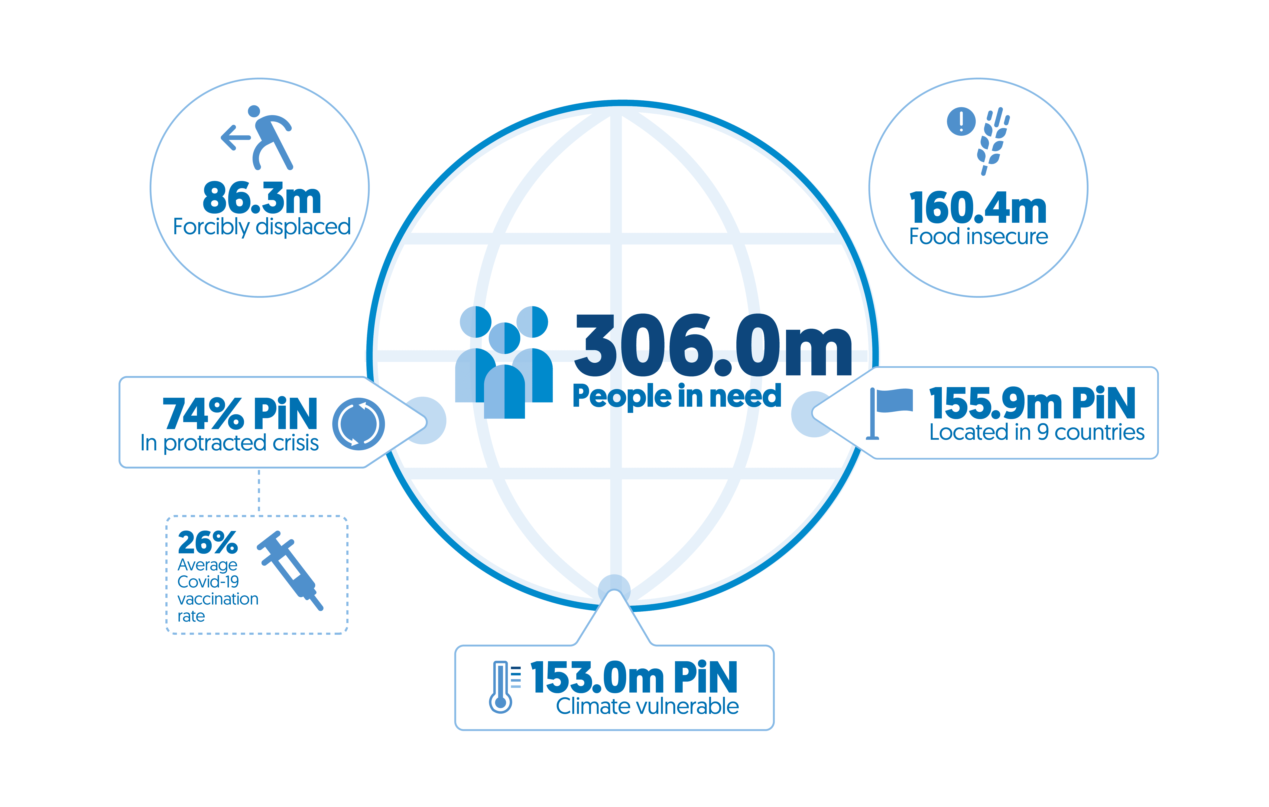

For full source and notes see Figures 1.1, 1.2, 1.3 and 1.4.

**The Covid-19 pandemic has complicated response to an already complex picture of intersecting climate, conflict and socioeconomic risks, with food insecurity and displacement continuing to increase.**

Multiple drivers of crisis intersect, compounding the risk of and exposure to crisis. Climate change acts as both a driver and multiplier of crisis risks, with those already in need of humanitarian assistance particularly vulnerable.

* In 2021, half of all people in need (50%, 152.6 million people) were living in countries with high levels of vulnerability to the impacts of climate change.

The intersection of climate risk with socioeconomic fragility and high-intensity conflict is particularly important.

* Two fifths of people in need (39%, 119.9 million people) were living in countries facing a combination of high-intensity conflict, high levels of socioeconomic fragility and high levels of vulnerability to the impacts of climate change.
* High levels of fragility and conflict can limit access to climate resources, at the same time also increasing climate risk, and in turn creating more fragility and increasing the risk of further conflict. Almost three quarters (217.7 million, 71%) of people in need are living in countries experiencing high-intensity conflict.

Covid-19 has led to increased food insecurity. Rising food prices in 2022, driven by the conflict in Ukraine, are posing further threats to food security.

* In 2020/2021, the number of people experiencing food insecurity (food crisis, emergency, or famine) grew rapidly, rising to 160.4 million, a third more than in 2019/2020.

The number of forcibly displaced people continues to rise.

* In 2021, the number of forcibly displaced people increased to 86.3 million people, 5% higher than in 2020.
* This picture already looks different in mid-2022, as the outbreak of war in Ukraine has displaced an estimated 12.8 million people so far.

**In 2021, international humanitarian assistance reached US$31.3 billion, but growth has stalled in recent years.**

Despite humanitarian need increasing rapidly in the past two years, growth in total international humanitarian assistance has stalled. Governments, in particular, are faced with increasingly difficult choices related to their wider aid budgets, challenges exacerbated in 2022 by the conflict in Ukraine, with clear risks to development and humanitarian assistance.

International humanitarian assistance, 2017−2021

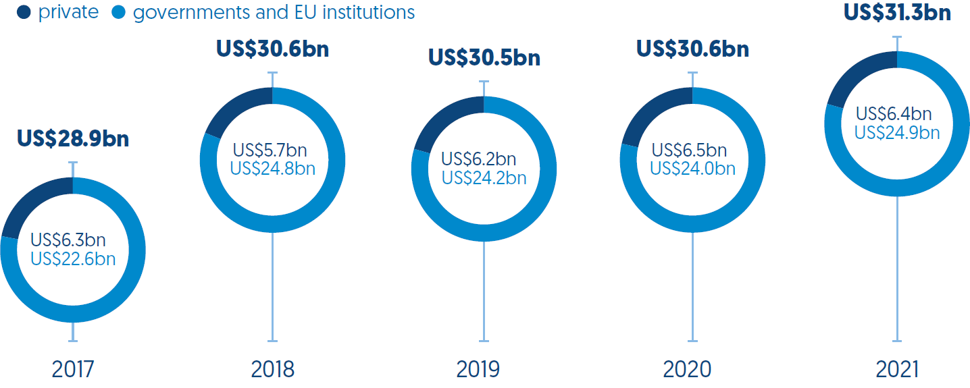

For full source and notes see Figure 2.1.

* In 2021, total international humanitarian assistance increased by US$0.8 billion to US$31.3 billion.
* Between 2012 and 2017, international humanitarian assistance grew annually by more than 10% but it has grown by just 2.6% in the four years since then.

Where does it come from?

Largest five donors by volume, 2021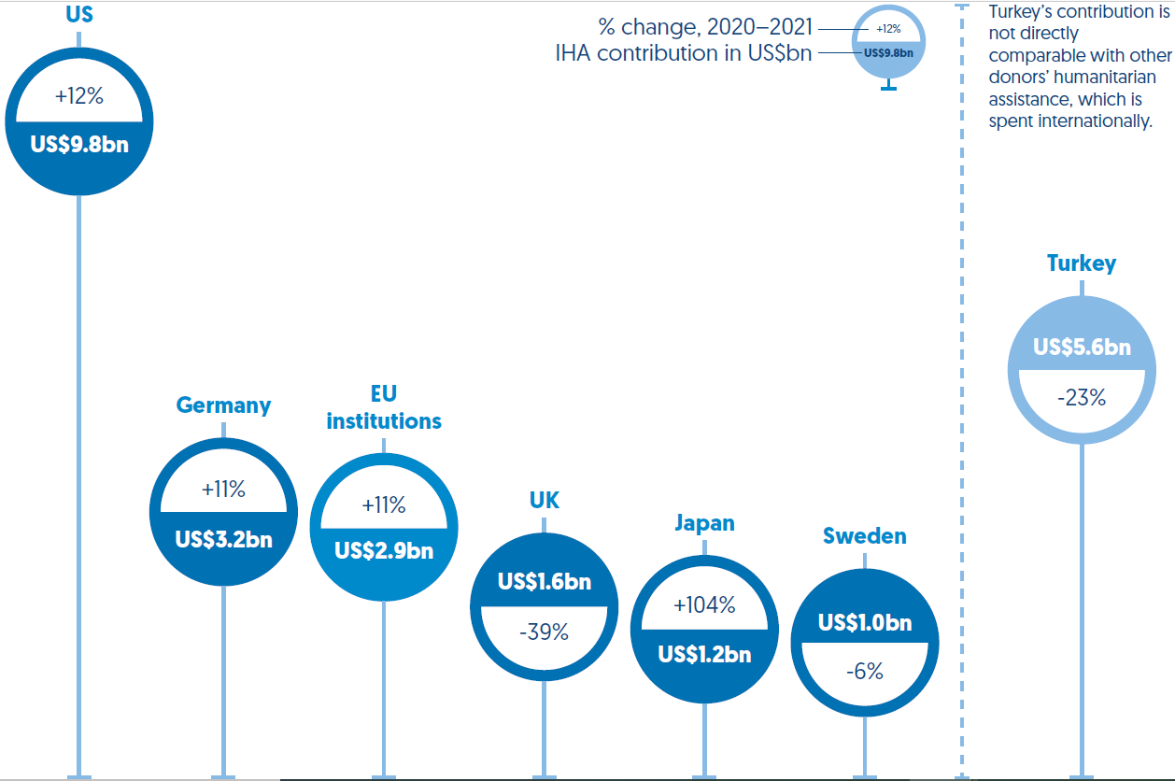

For full source and notes see Figure 3.1.

* Funding from governments and EU institutions rose by US$0.9 billion, from US$24.0 billion in 2020 to US$24.9 billion. Driving this growth were increases in excess of 10% by the two largest donors, the US and Germany, counter-balancing a second large annual reduction in funding from the UK, a decrease of US$1.0 billion to US$1.6 billion, 39% less than in 2020.
* Estimates for 2021 indicate that funding from private donors fell slightly from the highest recorded volume in 2020 of US$6.5 billion to US$6.4 billion.

Where is it going?

Largest five recipients by volume, 2021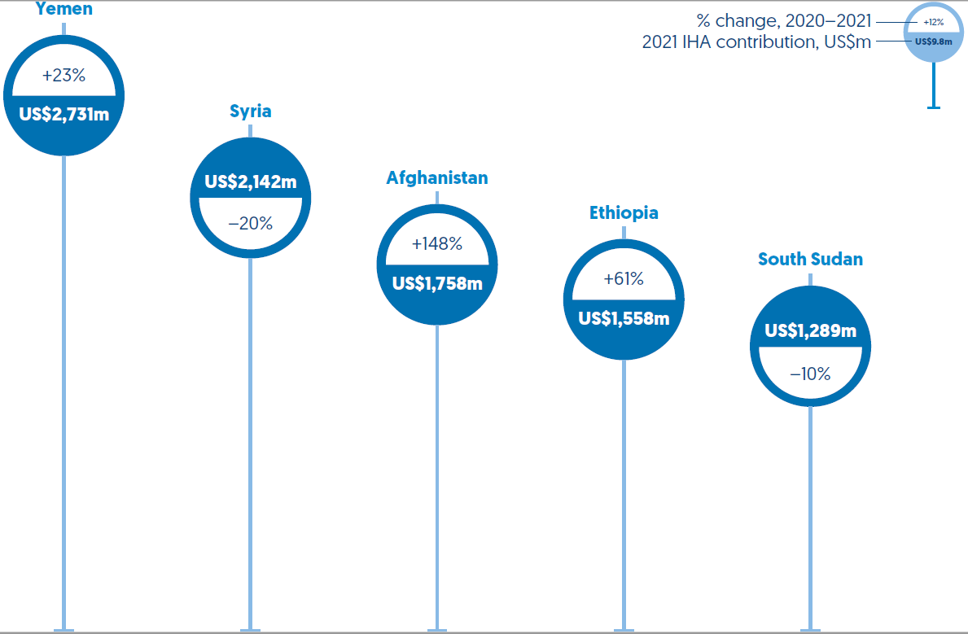

For full source and notes see Figure 4.1.

* Most international humanitarian assistance was allocated to a small number of crises in 2021. The 10 largest recipients received 60% of country-allocable international humanitarian assistance, with Yemen receiving the largest volume of support, US$2.7 billion (12% of all funding).

As humanitarian need has increased, more official development assistance (ODA) has been targeted to countries experiencing crisis but pressures on wider aid budgets are increasing.

* Total ODA from DAC members to countries experiencing protracted crisis has grown by over a third in the past decade, with humanitarian assistance a greater share of total ODA (9.4% in 2012, 14% in 2021).
* Spending on in-country donor refugee costs by DAC members reduced for the fifth consecutive year, to US$8.7 billion in 2021. However, estimates for 2022, as many European donors take in Ukrainian refugees, suggest funding on domestic refugee hosting could be double or triple the previous peak in 2016 of US$17.2 billion.

**Historically high levels of need and shortfalls in funding in 2020 were largely mirrored in 2021.**

Analysis of UN-coordinated appeals indicates the adequacy of funding to meet identified needs.

* In 2021, a total of US$38.4 billion was requested through UN-coordinated appeals in 2021, just US$895 million less than in 2020 but still US$7.9 billion more than in 2019. Funding was requested for 48 UN-coordinated appeals, again lower than 2020 (55 appeals) but still a third higher than 2019 (36 appeals).
* These appeals received only 56% of identified requirements, up from 51% in 2020. This is the second-highest shortfall ever in the volume of funding provided, US$16.9 billion, slightly less than 2020’s US$19.1 billion.

**Gender-related humanitarian funding has grown but still fails to meet needs.**

Gender-related humanitarian needs are considered to have grown rapidly, with the Covid-19 pandemic reported to have reversed previous gains in gender equality and the empowerment of women and girls.

* Funding specifically targeted to gender grew from US$268 million in 2018 to US$587 million in 2021.
* Reporting on gender-based violence, an area of gender programming where data is available on the proportion of funding requirements met, indicates that just 29% of funding was provided in 2021.

Gender-related humanitarian funding, 2018−2021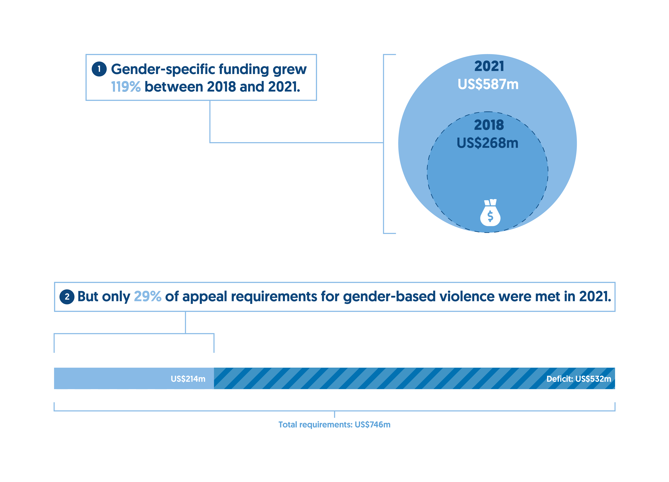For full source and notes see Figure 2.4.

**Developmental and climate-related financing has a potentially important role to play in building resilience to and enabling recovery from crisis.**

As the concentration of poverty in crisis-affected countries grows, multilateral development banks are choosing to target a growing share of resources to these countries through traditional financing and a growing number of crisis-focused instruments and tools.

* The volume of ODA provided by multilateral development banks to the annual largest 20 recipients of humanitarian assistance has doubled since 2015 from US$5.8 billion, to US$11.6 billion in 2020.
* The World Bank in particular is providing more financing through crisis-focused mechanisms, which increasingly intersect with traditional humanitarian response. For instance, in 2021, the International Development Association’s Fragility, Conflict and Violence Envelope provided US$2.3 billion to nine countries with humanitarian response plans.

As the number of climate-driven and climate-related disasters continues to rise, climate finance could present one option for alleviating the pressure on humanitarian systems.

* Climate finance is heavily focused on anticipatory action, and a small proportion of climate finance goes to countries already at risk of multiple crises in fragile and conflict-affected states.
* The 34 countries experiencing protracted crisis in 2020 received a total US$1.6 billion in adaptation funding, less than 3% of their total bilateral ODA funding (US$56.8 billion), and 27% (US$6.0 billion) of climate-relevant ODA for adaptation purposes.
* Only 12% (US$1.3 billion) of disbursed funding from multilateral climate funds (US$10.7 billion) goes to fragile and conflict-affected states.
* No clear financing mechanism yet exists to diminish the climate losses and damages communities face, transferring the costs of disasters to local actors or the humanitarian system.

**The landscape of humanitarian needs is evolving at pace and the need for reform is widely recognised. However, change continues to be slow, with progress evident on only some key issues.**

Despite many years of rhetorical commitments to alter funding behaviour, the patterns of funding from public donors have not changed in the past decade, with only minor shifts evident year-on-year. Funding to multilateral organisations still constitutes the majority of assistance from public donors in 2021.

How does it get there?

Funding channels, 2021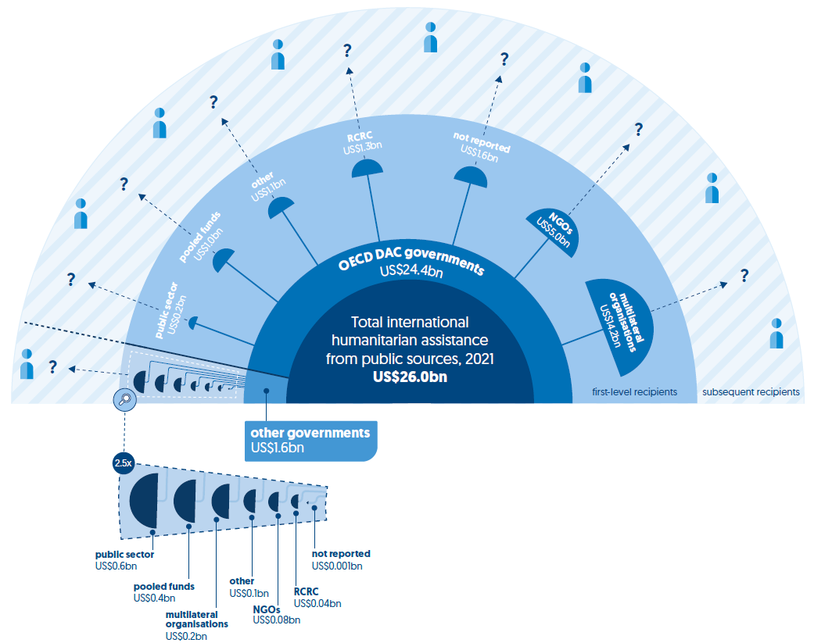

For full source and notes see Figure 4.2.

A second phase of the Grand Bargain process was launched in 2021, to speed reform in the delivery of humanitarian assistance. But progress on priority commitments was, as in previous years, uneven.

* Significantly less funding was provided directly to local and national actors in 2021. Following an increase in 2020, direct funding reduced by almost two thirds, to the lowest volume (US$302 million) and proportion (1.2%) of total international humanitarian assistance seen in the previous five years.

Direct funding to local and national actors, 2017−2021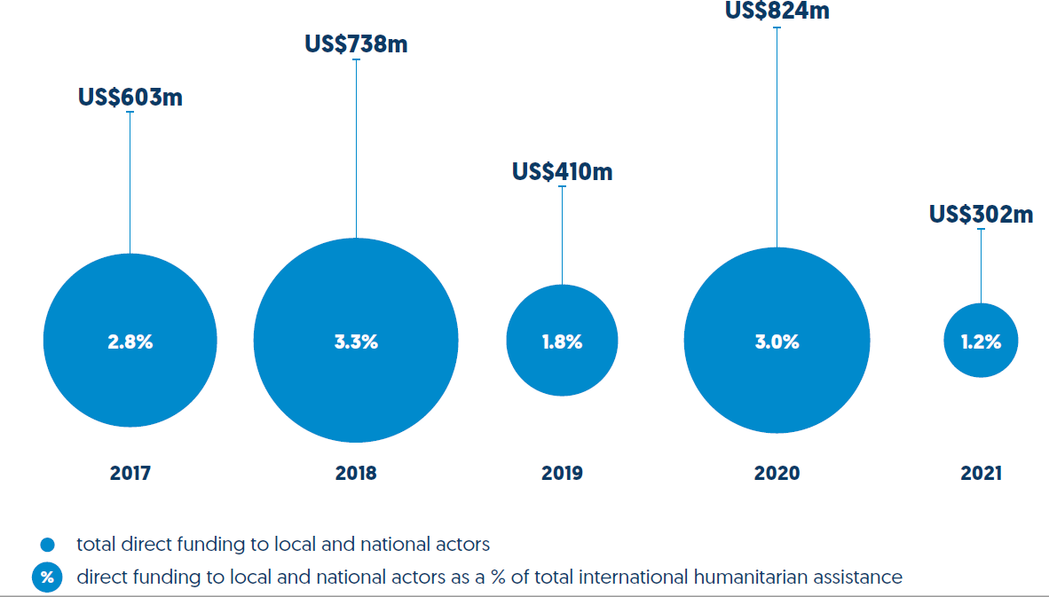For full source and notes see Figure 4.3.

* A central feature of quality funding is flexibility. However, the proportion of unearmarked funding received by nine UN agencies declined to its lowest level in six years of tracking, falling to 13% of total funding received, following an increase in 2020.
* More positively, preliminary data on global humanitarian assistance in the form of cash or vouchers shows that the volume transferred to recipients rose to US$5.3 billion in 2021, an increase of 3.7% from 2020. When final accounts are complete, cash and voucher assistance is likely to have accounted for 21% of total international humanitarian assistance in 2021.

Cash and voucher assistance, 2016−2021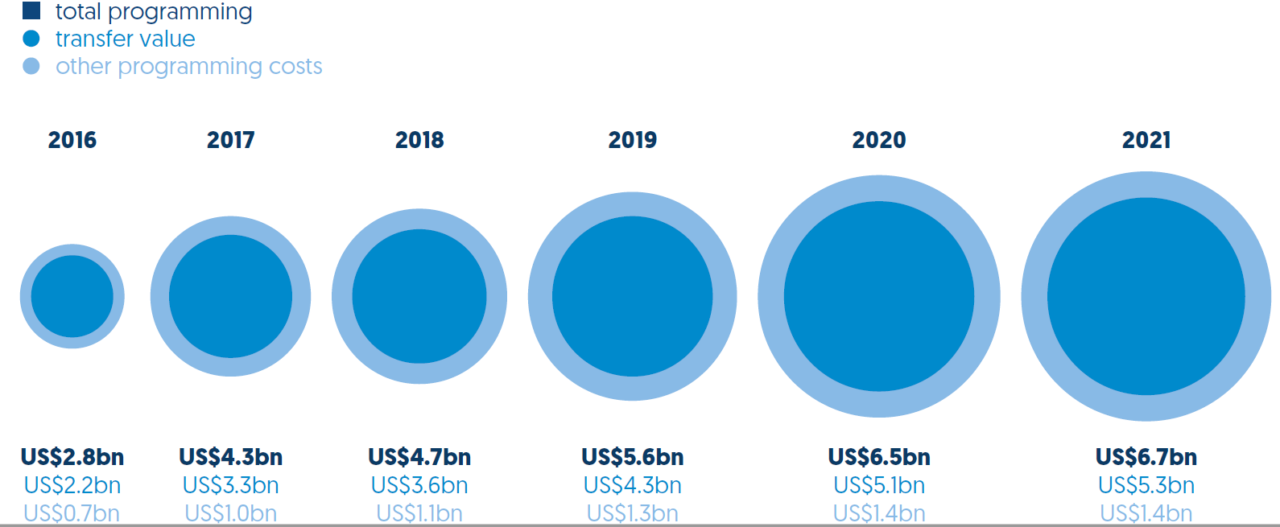

For full source and notes see Figure 4.8.

Chapter 1

People and crisis

In 2021, the number of people in need of humanitarian assistance continued to increase. An estimated 306.0 million people were assessed to be in need, 90.0 million more than in 2019 before the Covid-19 pandemic. Half of those requiring humanitarian support (155.9 million) lived in just nine countries. Long-term crisis is increasingly normal. The number of countries experiencing protracted crisis rose to 36 in 2021, accounting for three quarters (74%) of all people in need.

Covid-19 overlaid other pre-existing and emerging crisis risks, driving need and complicating response. Those experiencing humanitarian crisis have been left behind in efforts to recover from the pandemic, with people experiencing long-term crisis furthest behind. The average Covid-19 vaccination rate is 26% for countries experiencing protracted crisis, compared to 64% for countries without a UN-coordinated humanitarian appeal.

Climate change acts as both driver and multiplier of crisis risks, with those already in need of humanitarian assistance particularly vulnerable. In 2021, half of all people in need (50%, 152.6 million people) lived in countries with high levels of vulnerability to the impacts of climate change. Multiple drivers of crisis intersect, compounding the risk of and exposure to crisis. Two fifths of people in need in 2021 (39%, 119.9 million people) lived in countries facing a combination of high-intensity conflict, high levels of socioeconomic fragility and high levels of vulnerability to the impacts of climate change. The intersection of climate risk with the other two factors is particularly important, as high levels of fragility and conflict limit access to climate resources. High-intensity conflict can increase climate risk, in turn creating more fragility and increasing the risk of further conflict. Almost three quarters (217.7 million, 71%) of people in need of humanitarian assistance live in countries experiencing high-intensity conflict.

Even before the Ukraine crisis, mounting food insecurity has been a notable challenge. In 2020/21, the number of people experiencing food insecurity (crisis, food emergency or famine) grew rapidly, rising to 160.4 million, a third more than in 2019/20. Of all people facing food insecurity, half (52%, 82.9 million people) were in just four countries. Rising food prices in 2022, driven by the conflict in Ukraine, are now posing further threats to food security.

The number of displaced people continued to rise in 2021, increasing to 86.3 million people, 4.7% higher than in 2020. The consolidated picture from 2021 already looks markedly different as the outbreak of war in Ukraine has displaced many millions more. Since February 2022, an estimated 12.8 million people have fled the violence, to neighbouring countries or internally.

## People affected by crisis

Figure 1.1: Many more people, in more countries, continue to be affected by humanitarian crises than in 2019, before the Covid-19 pandemic

People in need, type and severity of crisis, and funding requirements, 2021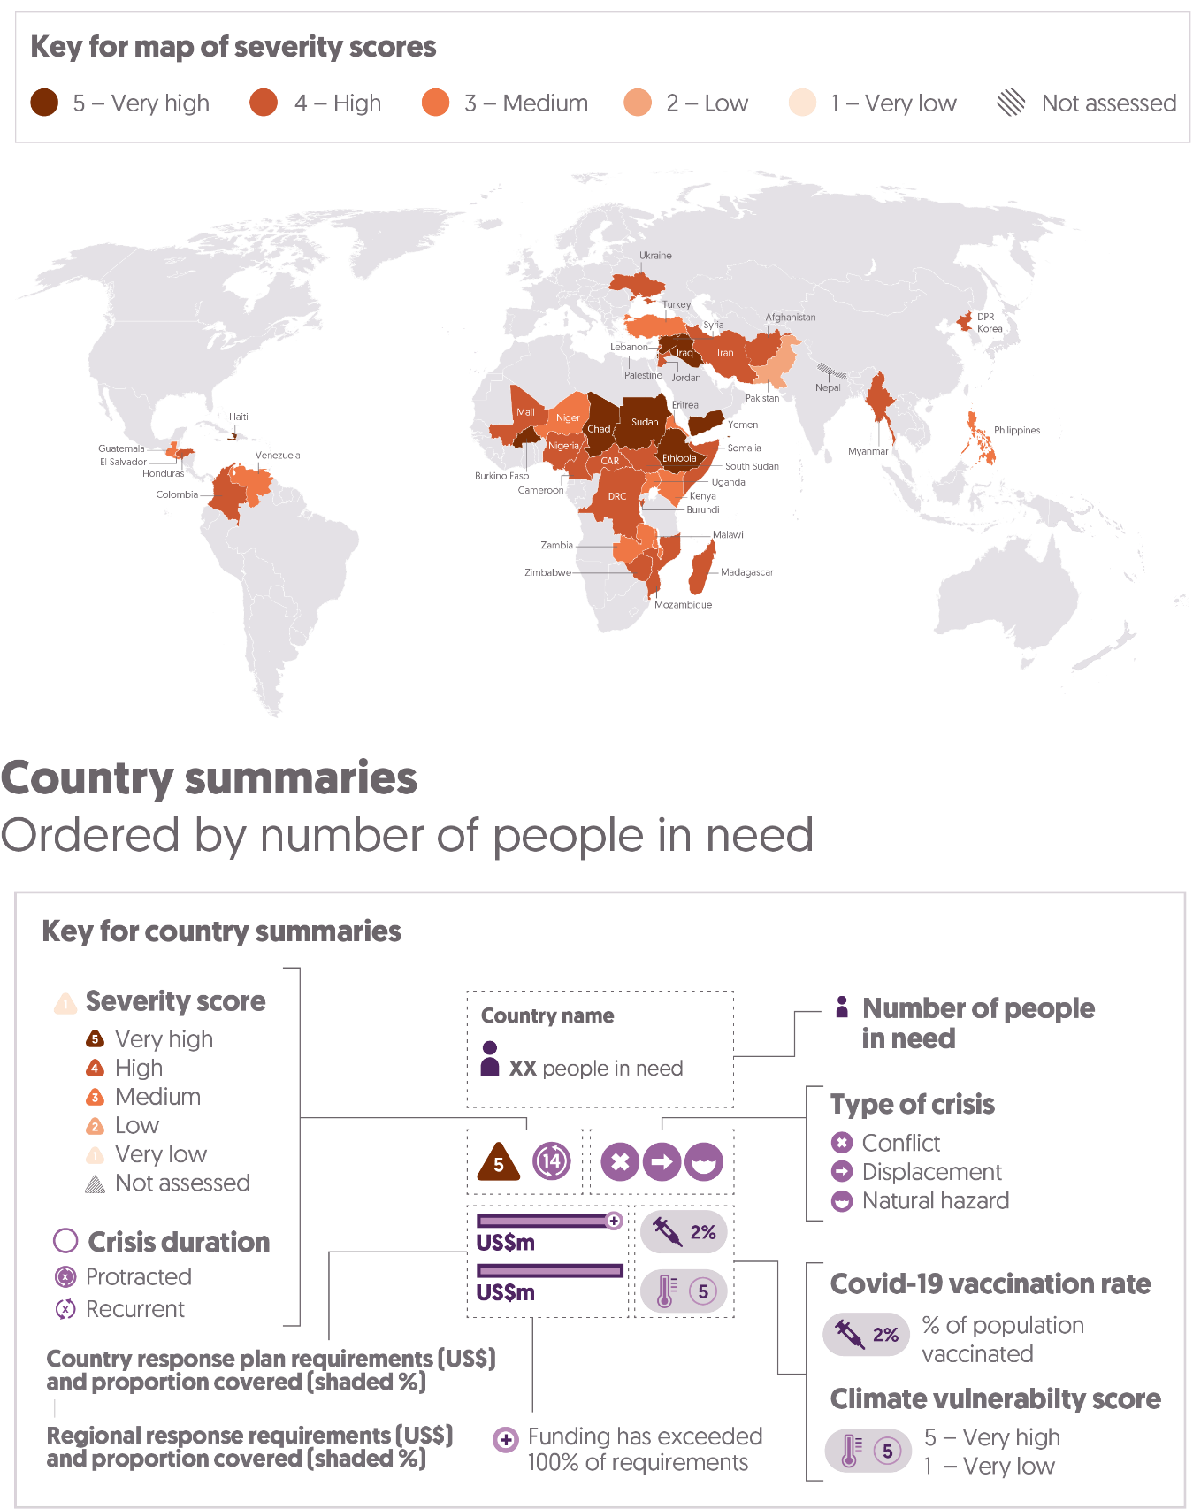

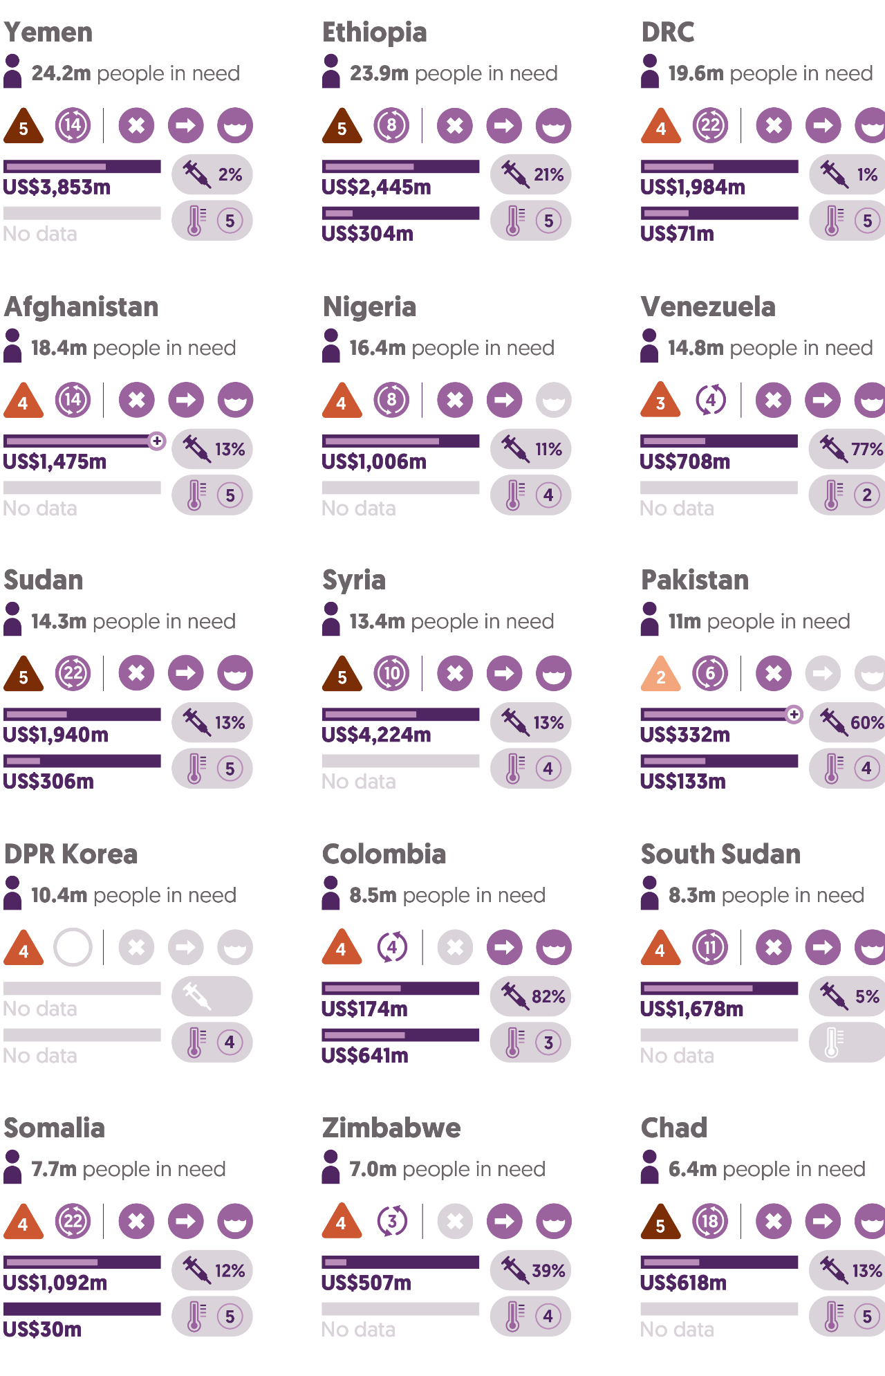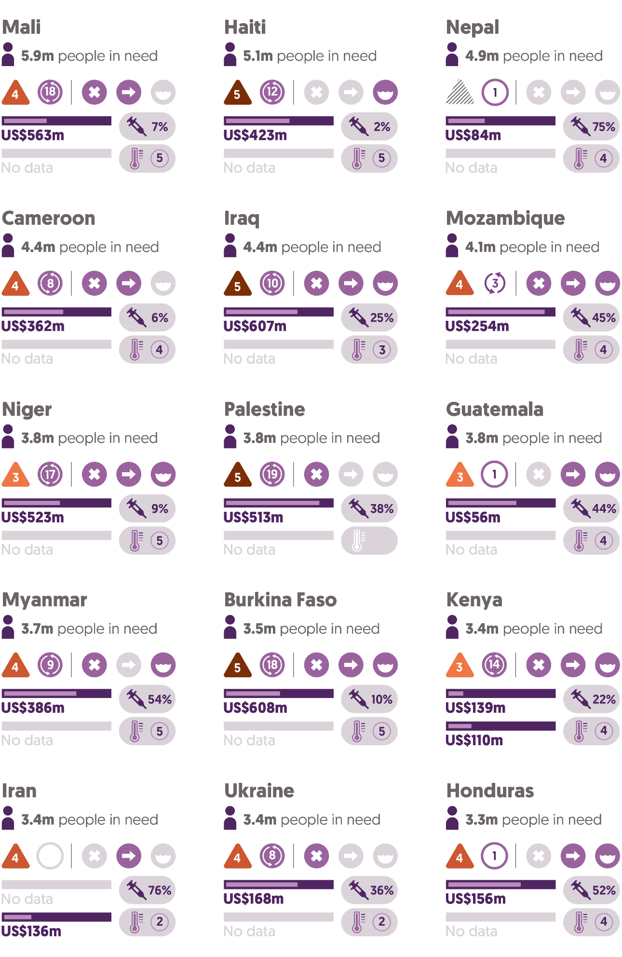

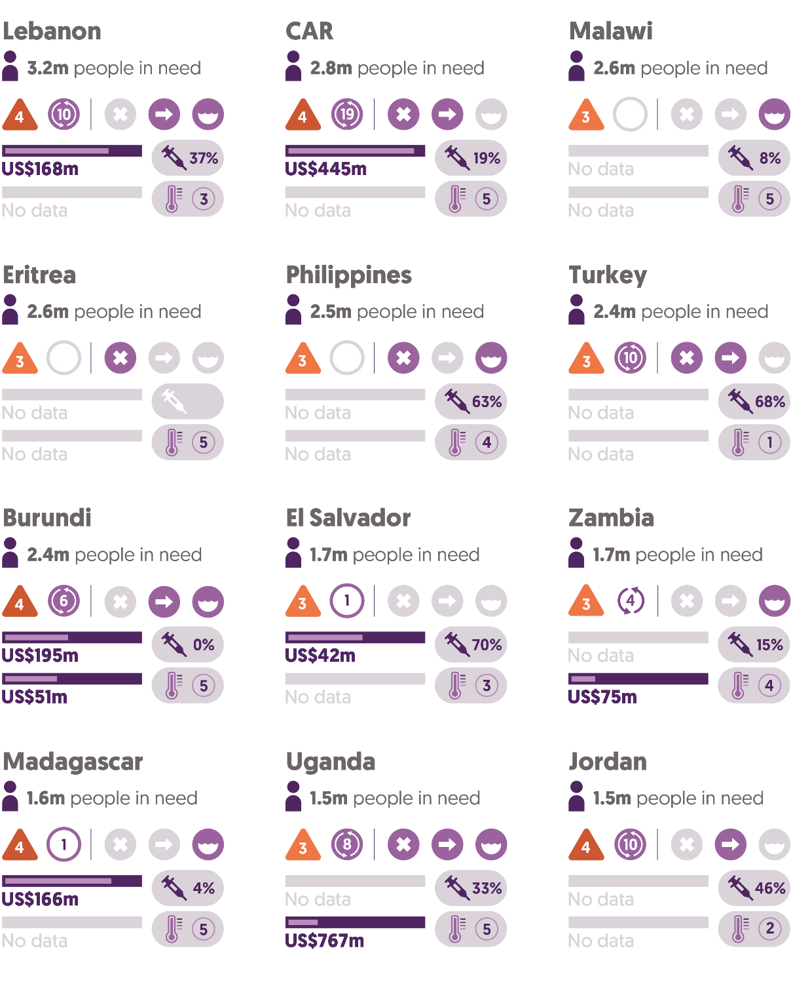

Source: Development Initiatives based on UN Office for the Coordination of Humanitarian Affairs (OCHA) Humanitarian Programme Cycle (HPC), ACAPS, Our World In Data, UN High Commissioner for Refugees (UNHCR), INFORM Index for Risk Management, Integrated Food Security Phase Classification (IPC), Heidelberg Institute for International Conflict Research (HIIK), Notre Dame Global Adaptation Initiative (ND-GAIN), Centre for Research on the Epidemiology of Disasters (CRED) and UN OCHA Financial Tracking Service (FTS) data.

Notes: Countries are selected using UN OCHA and ACAPS estimates of people in need. Countries with fewer than an estimated 1.5 million people in need are not shown. For further information on coding crisis types, see our online ‘Methodology and definitions’, Chapter 5.

In 2021, the numbers of people in need of humanitarian assistance continued to rise rapidly. The far-reaching impacts of the Covid-19 pandemic and increasing threat of climate-driven crises, as well as new and worsening conflicts, are driving a significant growth in the number of countries affected by crisis, the number of countries with high levels of humanitarian need, and the total number of people needing humanitarian assistance.

* In 2021, an estimated 306.0 million people living in 73 countries were assessed to be in need of humanitarian assistance, 90.4 million more than in 2019 before the Covid-19 pandemic. Comparison with 2020 is complicated by the year's upsurge in needs related to Covid-19, and the separation of these needs from other non-Covid-19 related ones is a distinction only made in the data for 2020. Excluding needs related to Covid-19 there were an estimated 243.8 million people in need living in 75 countries in 2020.
* The Covid-19 pandemic drove demand for coordinated international humanitarian responses in more countries in 2020. In 2021, the demand remained high. There were 48 UN-coordinated appeals, 7 fewer than in 2020 but a third more than the 36 appeals in 2019, before the impact of Covid-19 (see Figure 2.2, Chapter 2).
* In 2021, the number of countries with high levels of humanitarian need (identified as having more than one million people in need) increased to 49, from 40 countries in 2020, with the Covid-19 pandemic continuing to compound other political, socioeconomic and climate-related drivers of crisis.

High numbers of people in need continue to be concentrated in a small number of countries.

* More than half (155.9 million) of the total number of people in need in 2021 lived in just nine countries.
* Ten countries had more than 10 million people in need in 2021: Yemen (24.2 million), Ethiopia (23.9 million), the Democratic Republic of the Congo (DRC) (19.6 million), Afghanistan (18.4 million), Nigeria (16.4 million), Venezuela (14.8 million), Sudan (14.3 million), Syria (13.4 million), Pakistan (11.0 million) and the Democratic People’s Republic of Korea (10.4 million). Of these, six countries have consistently had more than 10 million people in need since 2019 (Yemen, Syria, DRC, Afghanistan, Venezuela and the Democratic People’s Republic of Korea).
* In 2021, there was a significant jump in people requiring humanitarian assistance in Ethiopia (increase of 15 million), Pakistan (increase of 8.0 million), Nigeria (increase of 7.0 million) and Afghanistan (increase of 4.4 million).

In many countries, people are experiencing a number of intersecting vulnerabilities, as the ongoing impacts of the Covid-19 pandemic compound conflict- and climate-driven crisis. In particular, the impacts of climate change are increasingly acting as a catalyst for crisis, especially in those states with the lowest levels of resilience (see ‘Humanitarian need and intersecting dimensions of risk’; ‘Climate finance flows’, Chapter 2; and ‘Development financing for disaster risk reduction’, Chapter 3). As these shocks compound existing crises, protracted crises have become more prevalent than ever.

* In 2021, the number of countries experiencing protracted crisis (countries with five or more consecutive years of UN-coordinated appeals) increased to 36, from 34 countries in 2020. A further 20 countries were experiencing recurrent crisis, with appeals in more than one consecutive prior year.
* Most people in need of humanitarian assistance live in countries experiencing protracted crisis: the 36 countries experiencing protracted crisis in 2021 accounted for 74% (227.3 million) of total people in need.
* Of the 36 countries experiencing protracted crisis, 25 were classified as having high or very high climate vulnerability.

The sustained impacts of the Covid-19 pandemic include economic disruption, school closure and increased health needs. These overlap with and compound existing needs in countries experiencing crisis. This disparity is illustrated by accessibility of vaccinations.

* Countries experiencing protracted crisis have lower Covid-19 vaccination rates: an average of 26% in countries experiencing protracted crisis, compared to 53% in other countries with a humanitarian appeal, and 64% in countries without a humanitarian appeal.

## 

## Humanitarian need and intersecting dimensions of risk

Figure 1.2: People in need increasingly face intersecting risks of climate vulnerability, socioeconomic fragility and conflict

##### Dimensions of risks and vulnerabilities facing people in needInfographic showing the intersection of climate vulnerability, socioeconomic fragility, and conflict risks by the number of people in need (in millions) that they affect. Data available as a downloadable Excel file at: https://devinit.org/data/datasets/global-humanitarian-assistance-report-2022/

Source: Development Initiatives based on UN Office for the Coordination of Humanitarian Affairs (OCHA) Humanitarian Programme Cycle (HPC), ACAPS, Notre Dame Global Adaptation Initiative (ND-GAIN), Organisation for Economic Co-operation and Development (OECD) States of Fragility (SoF) and Heidelberg Institute for International Conflict Research (HIIK).

Notes: Numbers of people in need are aggregated by country-level risk, vulnerability and fragility. Conflict risk is based on the presence of high conflict intensity (HIIK); high socioeconomic fragility is based on the top 20% of average social, economic and political fragility score (OECD); high climate risk is based on the top 20% of ND-GAIN score (ND-GAIN). Country dimensions missing data are classified as low vulnerability/hazard.

Systemic shocks like the Covid-19 pandemic and climate change are compounding other risk factors for crises, both sudden and slow-onset, with more countries experiencing protracted, long-term humanitarian need (see ‘People affected by crisis’). Where resilience is low, the likelihood of people experiencing crisis and needing more lifesaving humanitarian assistance, and for longer, is greater. Conflict, socioeconomic fragility and vulnerability to climate change, in isolation or combination, can serve as both drivers and multipliers of a crisis: worsening impacts, lowering resilience and frustrating efforts to provide the longer-term support needed for recovery from crisis. Understanding where people in need are exposed to specific and intersecting risks can help to identify where the likely impacts of shocks may be greatest, and where we need more and better joined-up humanitarian, development, peacebuilding and climate interventions.

Many countries continued to experience complex crises in 2021.

* Among the 73 countries with people in need in 2021, half (37) experienced more than one type of humanitarian crisis, including natural hazards and conflict-related or displacement crises. 16 countries experienced all three types, similar to the previous year.
* Overall, 43 countries experienced disasters associated with natural or technical hazards – with half of all people in need (50%, 152.6million people) living in countries facing high levels of vulnerability to the impacts of climate change – 30 experienced conflict and 47 experienced displacement.
* The severity of existing crises also worsened in 2021: the number of countries with crises classified as ‘very high’ severity doubled to 10, from 5 in 2020. A further 10 countries increased in severity level.

In 2021, most people in need of humanitarian assistance were experiencing at least one of the following three intersecting dimensions: high-intensity conflict, high levels of socioeconomic fragility and high levels of vulnerability to the impacts of climate change.

* 61% of people in humanitarian need (187.4 million people) were living in countries with at least two of the three dimensions.
* Two fifths of people in need (39%, 119.9 million people) were living in countries facing a combination of all three dimensions.

The need for a joined-up approach, addressing immediate humanitarian need as well as building resilience to socioeconomic and climate shocks and addressing underlying developmental and peacebuilding needs in crisis settings, is widely acknowledged.[1] (See also ‘Climate finance flows, Chapter 2; and ‘Multilateral development bank financing to countries experiencing crisis’, ‘World Bank financing in crisis contexts’ and ‘Development financing for disaster risk reduction’, all Chapter 3). However, as the growth in the number of protracted crises illustrates, this has rarely been achieved.

The intersection of conflict and climate vulnerability can be particularly problematic. High-intensity conflict creates operational risks for development projects aimed at decreasing climate vulnerability, which can result in projects being relocated or, in unstable areas, not being accessed at all.[2] Where this happens, a greater reliance on humanitarian rather than development interventions can occur, further exacerbating longer-term vulnerability. It also results in more funding being channelled through multilateral organisations, with less flexibility in quickly evolving situations and decreased local participation.[3]

Addressing conflict is critical to preserve life, reduce humanitarian need and enable sustainable development. But it is also important as a means to reduce climate risk. In 2021, almost three quarters (217.7 million, 71%) of people in need were living in countries currently experiencing high-intensity conflict. In these contexts, people are less likely to receive resources related to climate adaptation, but conflict itself can also pose an increased climate risk. International law forbids specific threats to the natural environment but, from 1946 to 2010, conflict was the single most important predictor of declines in certain wildlife populations. This affects ecosystems’ ability to mitigate the worst effects of climate change, limiting the contribution they can make to reducing rises in global warming.[4] Degraded environments also make it more difficult for communities to adapt to the risks presented by climate change.[5]

Figure 1.3: Global levels of food insecurity are rising and concentrated in just a few countries

Food insecurity – 10 largest populations reported 2019/20–2020/21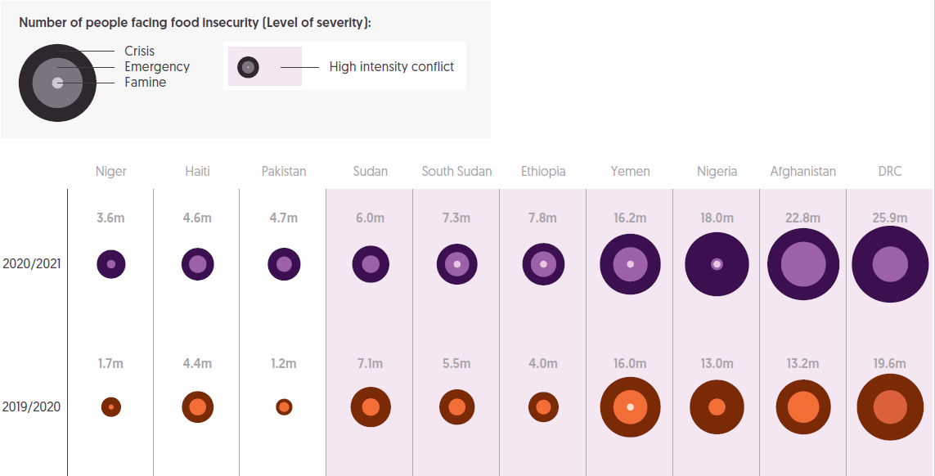

Source: Development Initiatives based on Integrated Food Security Phase Classification (IPC), and Heidelberg Institute for International Conflict Research (HIIK).

Notes: Acute food insecurity numbers and phases are as reported/projected by the year's closest IPC survey. People living in 'Crisis' (phase 3) or with higher food insecurity are shown. Because IPC survey coverage varies between years, only surveys that mapped ±25% of the 2020/2021 survey population share were used for comparison. 2019/2020 data for Yemen is based on the 2018 survey. Bubble scaling is not precise.

Food insecurity has become an increasingly important driver of humanitarian need and is likely to be even more significant as the conflict in Ukraine, supply-chain issues and a severe drought in the Horn of Africa drive up food prices. As with other dimensions of risk, there is an overlap between food insecurity and areas experiencing high-intensity conflict.

* Between 2019/20 and 2020/21, the number of people experiencing crisis or higher levels of food insecurity (food emergency and famine) increased by over a quarter (28%, from 124.9 million to 160.4 million people).[6]
* Of these 160.4 million people, 33.9 million (22%) were experiencing emergency-level food insecurity, and 0.6 million people (0.4%) in four countries (Ethiopia, Nigeria, Yemen and South Sudan) were experiencing famine.
* A small number of countries accounted for a large proportion of those facing food insecurity. Just four countries were home to half (52%, 82.9 million people) of all people facing crisis or higher levels of food insecurity: DRC (25.9 million), Afghanistan (22.8 million), Nigeria (18.0 million) and Yemen (16.2 million).
* There is a notable overlap between people experiencing high levels of food insecurity and people living with conflict. Of the 10 countries with the highest levels of food insecurity, the top 7 were all also experiencing high-intensity conflict in 2021.
* In 2020/21, the severity of food insecurity[7] increased for five of the largest populations experiencing food insecurity. Ethiopia, South Sudan and Afghanistan experienced the largest increases in the severity of food insecurity. Along with Yemen, South Sudan and Afghanistan also experienced the highest levels of severity in 2019/20.

## Forced displacement

Figure 1.4: The number of people forcibly displaced grew for the tenth consecutive year in 2021

20 countries with the largest forcibly displaced populations, 2020−2021

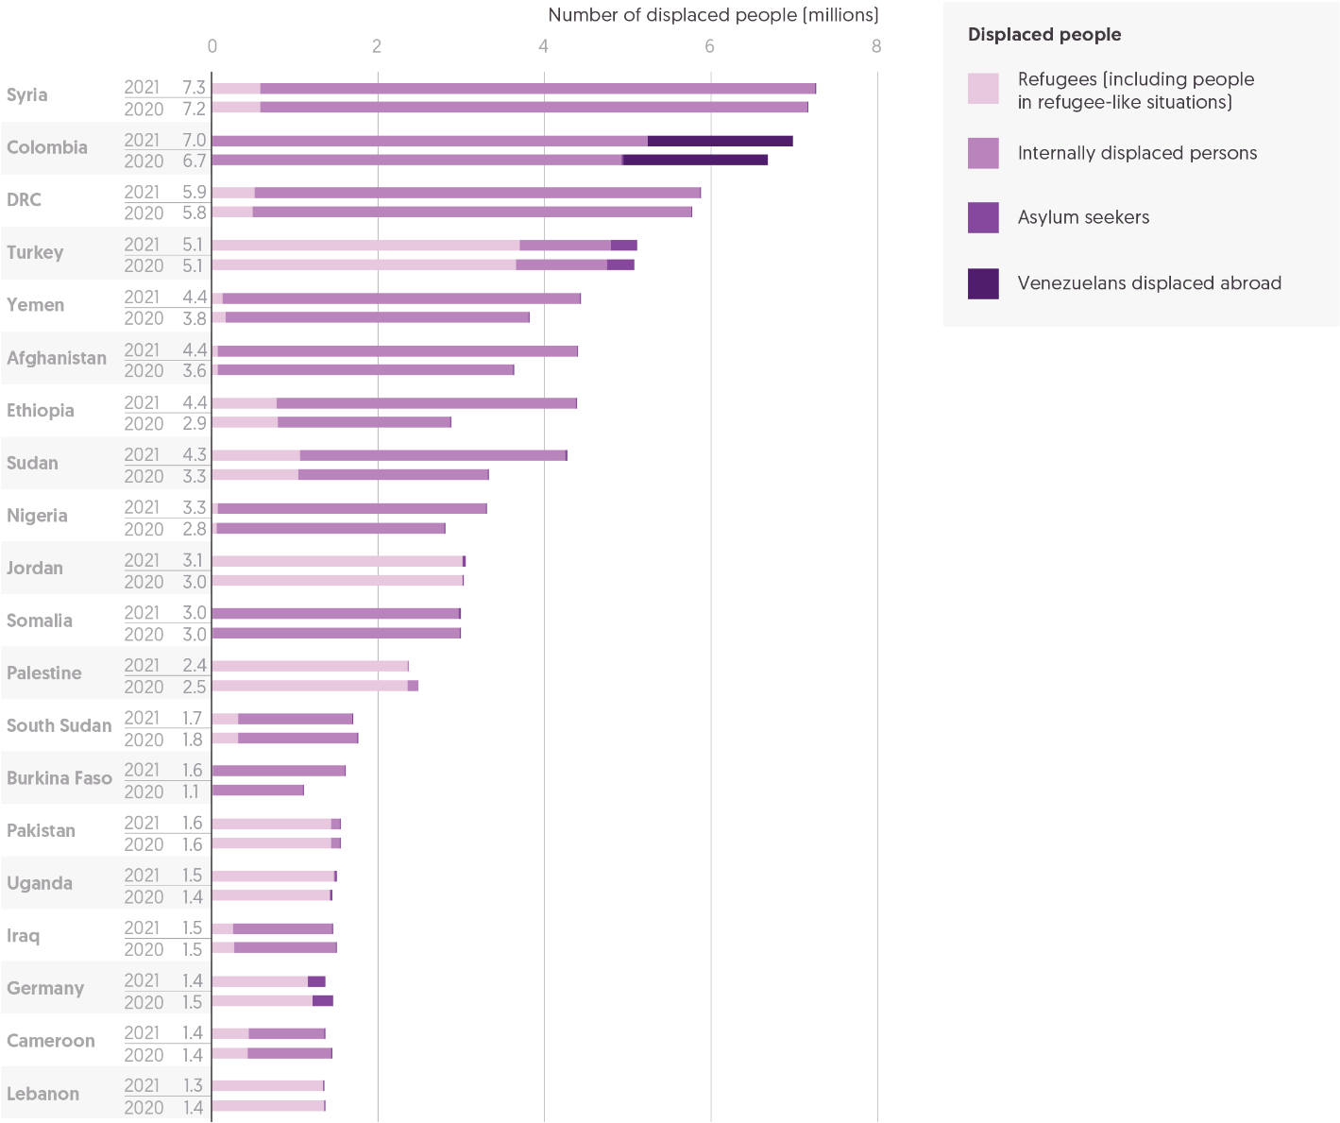Source: Development Initiatives based on data from UN High Commissioner for Refugees (UNHCR), UN Relief and Works Agency for Palestine Refugees in the Near East (UNRWA) and Internal Displacement Monitoring Centre (IDMC).

Notes: DRC = Democratic Republic of the Congo. The 20 countries are selected based on the size of displaced populations hosted in 2020. 'Displaced population' includes refugees and people in refugee-like situations, internally displaced persons (IDPs), asylum seekers and other displaced populations of concern to UNHCR. ‘Other displaced populations of concern to UNHCR’ includes Venezuelans displaced abroad. IDP figures refer to those forcibly displaced by conflict, and exclude those internally displaced due to climate or natural disaster. Data is organised according to UNHCR's definitions of country/territory of asylum. According to data provided by UNRWA, registered Palestine refugees are included as refugees for Jordan, Lebanon, Syria and Palestine. UNHCR data represents 2021 mid-year figures, and UNRWA data for 2021 is based on internal estimation.

The numbers of people forcibly displaced from their homes continued to grow in 2021. An escalation in conflict, including in Ethiopia, Afghanistan, Sudan and Yemen, drove a large portion of the increase, while many people continue to be displaced by economic hardship, including in Venezuela. The increase in shocks related to climate change has also driven up the numbers of people forced from their homes.[8] The consolidated picture from 2021 already looks markedly different as the outbreak of war in Ukraine has displaced many millions more. Since February 2022, an estimated 12.8 million people have fled the violence in Ukraine, both to neighbouring countries and internally.[9]

* In 2021, the total number of displaced people increased to 86.3 million, representing a 4.7% increase from 82.4 million people in 2020.
* As in recent years, most displaced people were displaced internally, within countries (62%, 53.2 million people), while just under a third were refugees (30%, 25.9 million people). In addition, there were 3.9 million Venezuelans displaced abroad (a 2.1% increase), and a slight fall in the total number of asylum seekers, from 4.1 million people in 2020 to 3.3 million in 2021.
* The increase in the number of displaced people was driven by a significant growth in the number of internally displaced persons (IDPs), an increase of 11%, or 5.1 million people.

Escalating violence and conflict in a number of contexts drove the overall increase in IDPs.

* Ethiopia saw the largest increase in forcibly displaced people, by 53%, or more than 1.5 million people, due to the ongoing war in the Tigray region. A deterioration in the security situation saw other notable increases in the number of displaced people, including in Sudan (28% increase, 0.9 million people), Afghanistan (21% increase, 0.8 million people) and Yemen (16% increase, 0.6 million people). These were nearly all driven by increases in IDPs fleeing conflict.
* Escalating violence also drove large rises in the numbers of IDPs in Burkina Faso (46% increase, 0.5 million people) and in Nigeria (18% increase, 0.5 million people).

Continuing the trend of previous years, a small number of countries continue to host the majority of forcibly displaced people. These countries face complex and intersecting risks. The Covid-19 pandemic has contributed to existing challenges of displacement, conflict and economic hardship, and displaced people are especially affected by the unequal availability of vaccines.[10]

* In 2021, 10 countries hosted over half (54%) of all displaced people globally and the 20 largest hosting countries hosted 77%. This has intensified, with all 10 largest hosting countries seeing an increase in the number of forcibly displaced people.
* The largest hosting countries are Syria, Colombia, DRC and Turkey, all hosting over 5 million displaced people each.
* The 20 largest countries hosting displaced populations had an average Covid-19 vaccination rate of 26% in 2021, markedly lower than the global goal of vaccinating 40% of people by the end of 2021.
* Two of the largest hosting countries have vaccination rates below 15%: Yemen (2%) and Syria (13%).
* Nearly half (9) of the 20 largest hosting countries are classified as low-income countries.

The largest numbers of displaced people are increasingly concentrated in sub-Saharan Africa.

* In 2021, the Sub-Saharan Africa region hosted over 32.4 million displaced people, the largest of any region in the world, accounting for 38% of the global total. This represents a significant growth since 2020 up 12%, building on similar growth (11%) in 2020. Most of these people (25.1 million) are displaced internally in the region due to conflict, and in 2021 Sub-Saharan Africa hosted 47% of the total global number of IDPs.
* The largest proportion of refugees is hosted in the Middle East and North Africa region (8.8 million people), accounting for 34% of all refugees globally. Overall numbers of displaced people in the Middle East and North Africa region remained largely similar to those in 2020.
* South Asia has seen a growing number of displaced people, with an 11% increase (0.8 million people) in 2021. This was driven by increases in people displaced both internally and regionally by the Afghanistan conflict. In total, South Asia accounted for 9.3% of the displaced population globally.

Chapter 2

volumes of humanitarian and wider crisis financing

This chapter examines the scale of funding and need, analysing trends in international humanitarian assistance in the second year of the Covid-19 pandemic and the wider context of total development funding. It explores the sufficiency of funding compared with identified need, how much funding is being targeted towards gender-related responses and the intersection between humanitarian and climate finance.

In 2021, total international humanitarian assistance increased by 2.5% (US$0.8 billion) to US$31.3 billion. Between 2018 and 2021, total assistance has plateaued, with marginal growth of just 2.6% over this four-year period, despite needs continuing to rise. This compares with annual growth of more than 10% between 2012 and 2018.

As the number of countries experiencing protracted crisis has grown, these countries have received a growing share of official development assistance, from 9.4% in 2012 to around 14% in the five years to 2021. However, as humanitarian need continues to grow, governments are faced with increasingly difficult choices related to their wider aid budgets. These challenges have been exacerbated in 2022 by the conflict in Ukraine, with clear risks including: de-prioritisation of humanitarian spending in other crisis contexts; development funding drawn to in-country refugee expenditure; and reduced overall aid budgets as demand for other expenditure, including military assistance, grows.

A total of US$38.4 billion was requested through UN-coordinated appeals in 2021. This was 2.3% (US$895 million) lower than in 2020 but still US$7.9 billion more than in 2019. Funding was requested for 48 UN-coordinated appeals, compared with 55 in 2020 and 36 in 2019.

The gap between needs and requirements narrowed slightly but remained large. In 2021, 56% of identified funding requirements were covered, up from 51% in 2020. This represents the second-highest shortfall ever in the volume of funding provided: US$16.9 billion, less than 2020’s US$19.1 billion. The overall pattern of funding to individual clusters has remained largely unchanged over the past four years, despite some year-on-year fluctuation. Food security has consistently received the largest volume of funding: US$6.0 billion in 2021, almost four times the next-largest cluster.

Funding specifically targeted to gender grew from US$268 million in 2018 to US$587 million in 2021. In 2021, total reported gender-relevant funding accounted for 3.4% of total international humanitarian assistance.

As the number of climate-driven and climate-related disasters continues to rise, climate finance could present one option for alleviating pressure on humanitarian systems. Climate finance is heavily focused on anticipatory action, and a small proportion of climate finance goes to countries already at risk of multiple crises in fragile and conflict-affected states. The 34 countries experiencing protracted crisis in 2020 received a total US$1.6 billion in adaptation funding, less than 3% (2.8%) of their total bilateral official development assistance funding (US$56.8 billion), and 27% (US$6.0 billion) of climate-relevant official development assistance for adaptation. Only 12% (US$1.3 billion) of disbursed funding from multilateral climate funds (US$10.7 billion) goes to fragile and conflict-affected states. No clear financing mechanism yet exists to diminish the climate losses and damages communities face, with these costs borne by local actors or the humanitarian system.

## International humanitarian assistance

Figure 2.1: Growth in total international humanitarian assistance has stalled

Total international humanitarian assistance by governments, 2017–2021

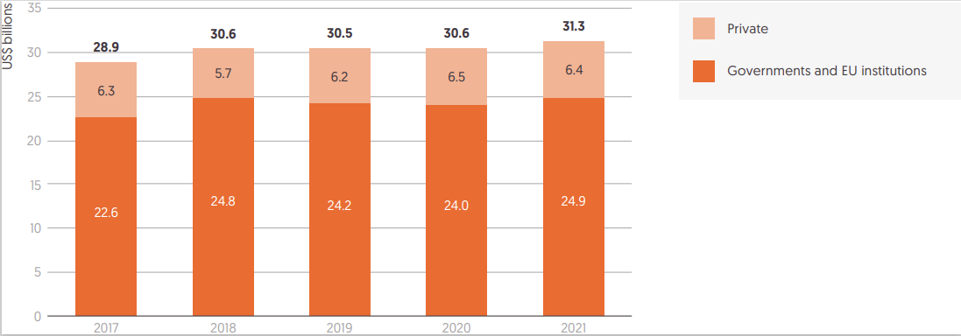 Source: Development Initiatives based on Organisation for Economic Co-operation and Development (OECD) Development Assistance Committee (DAC), UN Office for the Coordination of Humanitarian Affairs (OCHA) Financial Tracking Service (FTS), UN Central Emergency Response Fund (CERF) and our unique dataset for private contributions.

Notes: Figures for 2021 are preliminary estimates. Totals for previous years differ from those reported in previous Global Humanitarian Assistance reports due to deflation and updated data. Data is in constant 2020 prices.

Total international humanitarian assistance, from public and private donors, grew slightly in 2021. However, the increase in the volume of assistance provided over the past four years has been marginal, following the period of sustained and rapid growth in assistance before 2018.

* In 2021, total international humanitarian assistance from governments and EU institutions and estimated contributions from private donors was US$31.3 billion, an increase of US$0.8 billion (a 2.5% rise) from 2020.
* Between 2018 and 2021, total international humanitarian assistance has plateaued, with marginal growth of just 2.6% over this four-year period. From 2012 to 2018, total assistance grew each year by an average of more than 10%, rising to US$14.2 billion and almost doubling over that period (86% increase).

The proportion of total international humanitarian assistance provided by government and EU institutions has remained relatively stable. Estimates for the volume of assistance from private donors in 2021 suggest a similar amount to 2020, as previous growth levels off.

* In 2021, funding from governments and EU institutions accounted for 79% of total international humanitarian assistance. This is consistent with the pattern over the past five years: assistance from public donors accounted between 78% and 81% of total contributions.
* In 2021, funding from governments and EU institutions rose by US$0.9 billion, from US$24.0 billion in 2020 to US$24.9 billion. This represents growth of 3.6% and follows two years of consecutive falls in funding from governments and EU institutions.
* Estimates for 2021 indicate that funding from private donors fell very slightly from the highest recorded volume in 2020 of US$6.5 billion to US$6.4 billion.

As humanitarian need continues to grow (see ‘Volumes of assistance compared with appeal requirements’), and in the context of slowing economic growth in many donor countries and the same small group of countries sustaining the donor base (see ‘International humanitarian assistance: largest donors’, Chapter 3), those governments providing significant volumes of official development assistance (ODA) are faced with increasingly difficult choices. In 2022, the conflict in Ukraine has exacerbated these challenges for many donor governments, particularly those receiving large numbers of refugees (see ‘International humanitarian assistance: largest donors’, Chapter 3).

There are clear risks of development funding to developing countries being diverted to support humanitarian response in Ukraine, and in-country refugee expenditure, including in countries experiencing crisis where such funding is critical to long-term recovery. Humanitarian spending may be de-prioritised in other crisis contexts, and total ODA expenditure may decrease with growth in other demands, including for military assistance.

ODA has increased over the past decade, with a greater proportion provided to countries experiencing protracted crisis, as the number of these countries has grown rapidly. Total ODA from members of the Development Assistance Committee (DAC) of the Organisation for Economic Co-operation and Development grew by just over a third in the past decade, with volumes levelling off in recent years following years of more rapid growth.

* Between 2012 and 2021, net disbursements of total ODA from DAC donors increased from US$123 billion to US$168 billion (an increase of 36%).
* Total ODA from DAC members grew by 3.3% (US$5.3 billion) between 2020 and 2021, an increase driven primarily by DAC members’ continued support for Covid-19 activities in 2021, largely in the form of vaccine donations. Excluding the cost of vaccines, ODA grew by only 0.6% in real terms from 2020 to 2021[11].
* The possibility of reporting surplus vaccines from domestic supplies of DAC members as ODA when provided to ODA-eligible countries has created additional pressures on ODA budgets. DAC members reported US$2.2 billion of surplus vaccines as ODA in 2021, amounting to 1.3% of total ODA that year; 81% of this was reported by only six donors (Germany, France, Spain, Italy, Japan and the UK), ranging between 0.9% and 7.6% of the respective donors’ ODA budgets. Coupled with expected increases in costs of in-country refugee hosting (see ‘International humanitarian assistance: largest donors’, Chapter 3]), this risks a reduction in the volume of ODA to humanitarian crisis countries and least developed countries.

While ODA has grown over the past decade, the volume allocated to humanitarian assistance has increased at a faster rate.

* The proportion of total humanitarian assistance[12] provided by DAC members from within total ODA has increased from 9% in 2012 to 14% in 2021. Most of this increase occurred between 2012 and 2014 (9% to 13%), with levels remaining close to 14% in the five years to 2021.

## Volumes of assistance compared with appeal requirements

Figure 2.2: Funding requirements reduced only marginally from historic high in 2020, with the shortfall in funding by volume the second highest ever in 2021

Funding and unmet requirements, UN-coordinated appeals, 2012–2021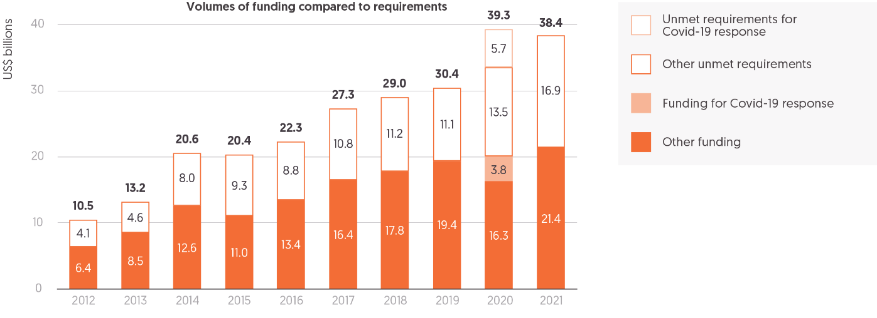

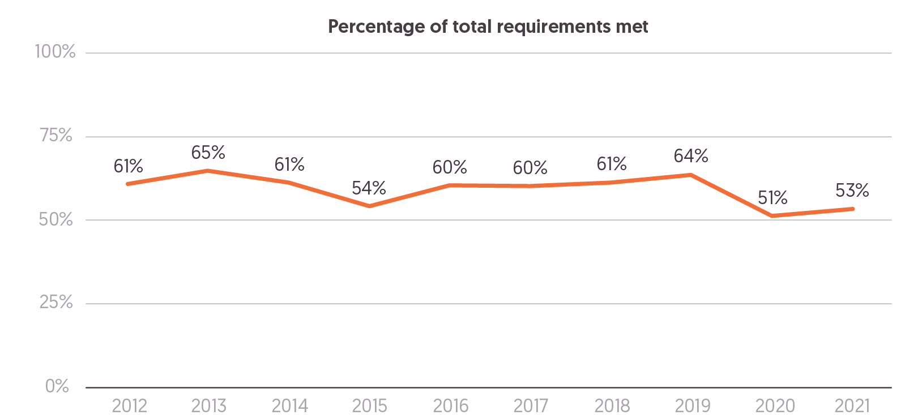

Source: Development Initiatives based on UN Office for the Coordination of Humanitarian Affairs (OCHA) Financial Tracking Service (FTS), Syria Regional Refugee and Resilience Plan (3RP) dashboards and UN High Commissioner for Refugees (UNHCR) data.

Notes: Data from 2012 onwards includes regional response plans for Afghanistan, Burundi, the Central African Republic (CAR), the Democratic Republic of the Congo (DRC), Nigeria, South Sudan, Syria and Yemen, as well as Regional Refugee and Migrant Response Plans for Europe and for refugees and migrants from Venezuela coordinated and tracked by UNHCR. Data is in current prices, last updated on 22 June 2022. Funding and requirement totals for the Syria Regional Refugee and Resilience Plan (3RP) are sourced from 3RP reports and dashboards in 2018−2021. Requirements and funding for Covid-19 response in 2021 were for almost all response plans included as part of total requirements and funding and therefore not tracked separately that year.

UN humanitarian appeals seek to provide a coordinated, strategic approach to the provision of international assistance to a humanitarian crisis. Over the past decade, the number of UN-coordinated appeals has grown rapidly, with these appeals now capturing the majority of funding requirements identified by humanitarian agencies.

The systemic global shock of the Covid-19 pandemic drove an unprecedented rise in funding requirements within UN-coordinated humanitarian appeals in 2020, when the number of appeals rose to the highest ever: 55 (including country and global response plans, flash appeals and refugee response plans). However, only 51% of those funding requirements were fulfilled, with the highest-ever shortfall in funding of US$19.1 billion. In 2021, needs reduced very slightly and funding increased marginally, but the overall pattern of severe underfunding remained unchanged.

* A total of US$38.4 billion was requested through UN-coordinated appeals in 2021.
* This funding was to meet needs identified in 48 UN-coordinated appeals: 7 fewer than the 55 in 2020, when several were launched in response to the Covid-19 pandemic. The Global Humanitarian Response Plan to Covid-19, in place in 2020, was discontinued in 2021. There was only one country appeal specifically for needs related to Covid-19, in Nepal. Needs relating to Covid-19 were not disaggregated within appeals but addressed through other clusters.[13]
* Despite the slight decrease in the number of appeals in 2021, the number remains a third higher than the 36 coordinated appeals operating in 2019.
* In 2021, there were 4 countries (El Salvador, Guatemala, Honduras and Madagascar) with UN-coordinated appeals that did not have appeals in 2020, while 15 countries with appeals in 2020 (the majority specifically to respond to Covid-19) did not have appeals in 2021.
* Most countries with UN appeals are experiencing protracted or recurrent crises. In 2021, 36 of 67 countries had had UN-coordinated appeals for five or more consecutive years.

### Appeal requirements

In 2020, the onset of the Covid-19 pandemic drove a rapid increase in total funding requirements for UN-coordinated appeals. Total appeal requirements in 2021 remained historically high, only slightly below the total amount requested in 2020.

* Funding requested through UN appeals reduced by 2.3% (US$895 million) in 2021, the first decrease since 2015.
* With Covid-19 continuing to exacerbate need and complicate response, unresolved protracted crisis in many countries and worsening large-scale crises, for instance in Afghanistan and Ethiopia, total funding requirements were still over a quarter (26%) greater in 2021 than in 2019, and nearly four times (265%) higher than a decade ago in 2012.
* Looking forwards, at the time of writing, appeal requirements for 2022 were over US$47 billion, driven in part by the conflict in Ukraine, indicating that the slight reduction evident in 2021 may be reversed.
* The scale of requirements to respond to crises in Syria and Yemen continued to dwarf other appeals. In 2021, the Syrian Refugee Regional Response Plan (3RP) (requirements of US$5.6 billion), Syria Humanitarian Response Plan (HRP) (US$4.2 billion) and the Yemen HRP (US$3.9 billion), had collective funding requirements of US$13.7 billion, accounting for over a third (36%) of total appeal requirements.
* This represents a settled pattern, with the Yemen and Syria crises having the highest level of funding requests and accounting on average for 41% of total appeal requirements since 2015.
* With the Taliban take-over of Afghanistan, funding requirements grew with the launch of a Flash Appeal in addition to the pre-existing HRP, increasing total requirements in 2021 to US$15 billion, from US$1.1 billion in 2020.
* Appeal requirements for countries experiencing protracted crisis, with five or more years of consecutive appeals, decreased on average by 15%.

### Funding commitments to appeals

Funding committed towards UN-coordinated appeals grew slightly in 2021. Combined with the marginal fall in appeal requirements, the gap between funding and need narrowed slightly. However, the shortfall in funding, both by volume and as a proportion of total requirements, remained at levels not seen before 2020.

* Funding towards UN appeal requirements grew for the sixth consecutive year, rising to US$21.4 billion in 2021, an increase of US$1.3 billion from 2020.
* With this rise in funding, the volume of funding requirements unmet in 2021 reduced slightly to US$16.9 billion, from US$19.1 billion in 2020. Before 2020, the largest shortfall in funding was of US$11.2 billion in 2018.
* The gap between needs and requirements narrowed slightly but remained historically large. In 2021, 56% of identified funding requirements were covered. This compares to an average, in the decade up to 2020, of 60%.

As in previous years, the proportion of funding requirements met varied significantly between individual appeals. Chronic underfunding, where appeals received less than a quarter of their requested assistance, affected fewer contexts in 2021 than 2020.

* In 2021, almost half of appeals received less than half of their requested funding (23 of 48 appeals). And coverage varied greatly, with the difference between the best-funded appeal, the Afghanistan Flash Appeal (187% funded), and the worst, the Nepal Response Plan (7%), particularly stark.
* Of total appeals, 11 (23%) received more than 75% of their requirements, while 6 (13%) were funded at less than 25% (Nepal, Myanmar, Zimbabwe, Kenya, South Sudan Regional RRP, Democratic Republic of the Congo Regional RRP), many fewer than the 15 funded at this level in 2020.
* The appeals that received the highest amount of funding were for the Yemen HRP (US$2.4 billion, 62% of total requirements), the Syria HRP (US$2.0 billion, 47%) and the Syria Regional Refugee and Resilience Plan (US$1.9 billion, 32%).

### Funding inside and outside appeals

Over the past decade, the proportion of total humanitarian assistance captured within UN-coordinated appeals has increased. However, a significant volume of finance continues to be provided outside these appeals, not least in countries with humanitarian need but no UN appeal.

* In 2021, more than two thirds (71%) of all country-allocable international humanitarian assistance was provided within UN-coordinated appeals. This represents a notable increase from the 42% provided in 2012, with the proportion of funding within appeals appearing relatively stable at close to 70% in four of the five years between 2017 and 2021.
* The largest 10 recipients of international humanitarian assistance in 2021 had more than four fifths (82%) of funding captured within UN appeals. Funding outside appeals in the largest crises flowed predominantly to Red Cross Red Crescent organisations, as well as to UN agencies, non-government organisations and some private sector companies.
* In 2021, the proportion channelled within UN appeals to smaller recipients of international humanitarian assistance was significantly lower, at 55%, than that to the largest recipients.
* In relative terms, the volume of funding going to individual countries without a UN-coordinated appeal was small. In 2021, the largest volume of funding to a country without a UN appeal was to India, which saw a rapid rise in international humanitarian assistance, increasing 818% to US$172 million.
* Only three other countries without UN-coordinated appeals received more than US$20 million: Bosnia and Herzegovina (US$100 million, a 313% increase from 2020), Iran (US$78.0 million, a 24% decrease) and Thailand (US$50.3 million, a 24% increase).

### Red Cross Red Crescent appeals

The International Red Cross and Red Crescent Movement sets out its requirements separately from UN-coordinated appeals. In 2021, the International Federation of Red Cross and Red Crescent Societies (IFRC) appeal requirements decreased by a quarter, while the funding shortfall continued to increase. This contrasts with the International Committee of the Red Cross (ICRC), which had record high coverage of its appeal requirements in 2021.

IFRC emergency appeals relate mostly to disasters associated with natural hazards.

* In 2021, IFRC appeal requirements shrank to US$762 million, a record decrease of 25% from 2020 (US$1.0 billion).
* Due to lower funding requirements, funding to the IFRC dropped by 32%: from US$584 million in 2020 to US$396 million in 2021.
* Despite the decrease in appeal requirements, the coverage of IFRC appeals decreased to a record low of 52% (from 58% in 2020), well below the average coverage of 72% from 2017 to 2020.

ICRC appeals respond mainly to conflict-related situations.

* The ICRC received US$1.9 billion in 2021 (up 4% from 2020), continuing the pattern of sustained growth over the five years from 2017 to 2021, which have seen funding rise by 13%.
* ICRC was able to cover 94% of its US$2.0 billion appeal requirements. Since 2017, coverage has averaged 92%.

Figure 2.3: Food security received almost four times as much funding as any other sector in 2021, while nutrition was the best funded

Funding and unmet requirements, selected clusters 2018–2021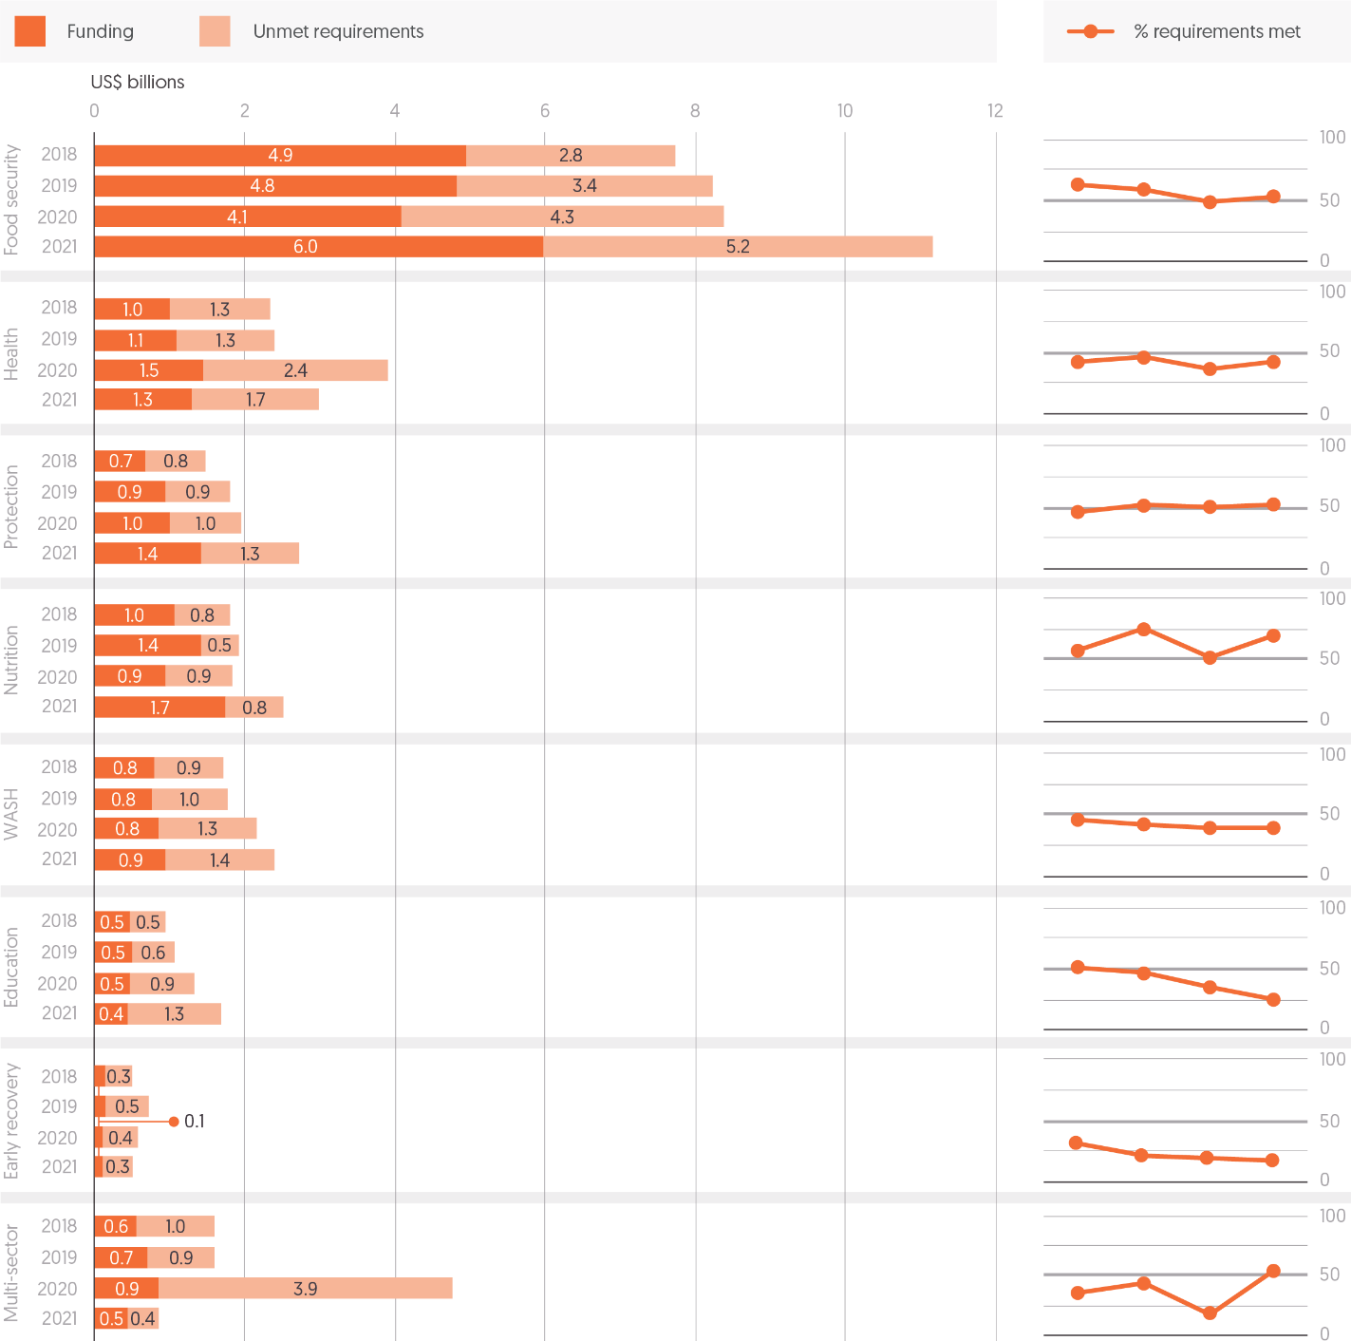

Source: Development Initiatives based on UN Office for the Coordination of Humanitarian Affairs (OCHA) Financial Tracking Service (FTS).

Notes: WASH = water, sanitation and hygiene. Selected clusters shown. Requirements and funding for appeal clusters are aligned to Inter-Agency Standing Committee (IASC) global clusters using Development Initiatives (DI) mapping. Data is for all appeals tracked by UN OCHA, excluding regional response plans; therefore, totals do not match the annual appeals totals on FTS’s overview pages. Data is in current prices.

Humanitarian programming provides assistance to meet a wide, and increasing, range of needs of people experiencing acute and protracted crisis. UN coordination of humanitarian response has been organised around a system of clusters – groups of organisations collectively targeting specific areas of humanitarian need – since 2005. This approach seeks to ensure needs-driven coordination of responses in the main areas of humanitarian response, promoting leadership and accountability, enabling effective prioritisation and helping to define roles and responsibilities. Clusters identify the total number of people in need within a crisis context. In formulating HRPs, each cluster determines how many of these people they will seek to provide humanitarian assistance to. This informs the total amount of funding required (see ‘Volumes of assistance compared with appeal requirements’).

Due to limited resources, across all clusters only a proportion of the identified people in need are targeted within an appeal. The proportion chosen to be targeted varies greatly between clusters.

* In 2021, the food security cluster targeted the largest number of people (see Figure 1.3), seeking to reach 113.1 million out of 158.3 million people identified as requiring food-security assistance. This represented the highest proportion (71%) targeted, of the total identified as in need, of any cluster.
* The early recovery cluster sought to target the least number of people, just 5.5 million out of 28.7 million, seeking to provide assistance to just 19% of those identified as being in need of early recovery support in 2021.

Funding requirements are set against the number of people in need within each cluster that are selected to be targeted, of which typically a sizable proportion, in excess of a third, is not provided. Over the past decade, shifts in funding to individual clusters are evident, in terms of both the size of requirements and volume of funding committed. However, the overall picture of scale and targeting to areas of humanitarian response has changed relatively little. The food security sector received by far the largest volume of funding in 2021, as it has consistently for the last decade.

* In 2021, the food security sector accounted for just under half of all requirements within UN-coordinated appeals, requesting US$11.1 billion. Towards these requirements, it received US$6.0 billion, almost four times as much as the next-largest sector, nutrition, which received US$1.7 billion.
* Food security has received the largest volume of funding of any cluster every year for the past decade, typically having close to the average level of funding requirements met across all clusters, in each year.
* Reporting on requirements for food security indicate a sharp rise in 2021 from 2020 levels. This was partly driven by increases to food security needs in large response plans for Syria and Ethiopia. However, the increase is likely to appear more pronounced as data on sector requirements for Yemen, which had the largest requirements within the cluster in 2021, was not broken down by cluster in 2020.

Early recovery was the worst-funded sector, both by volume and in terms of proportion of funding requirements met.

* The early recovery cluster – which seeks to support sustainable recovery from crises, strengthen resilience and lay the foundations for longer-term development – received the smallest volume of funding and had the lowest level of requirements met in 2021.
* Despite increased focus on the importance of transitioning from humanitarian assistance to longer-term development, evident in the higher profile in recent years of discussions on the humanitarian­–development–peacebuilding nexus, underfunding to the early recovery cluster has in fact worsened. The proportion of funding requirements met has fallen from a high of 40% in 2015 (still far below the average across all clusters) to just 17% in 2021.

Across other clusters, other notable shifts are evident in health, nutrition and education.

* Requirements for the health sector grew sharply to US$2.4 billion in 2020, a 62% increase. Funding also increased markedly, but at a slower rate (33%), resulting in the lowest level of requirements met in the past decade (37%). In 2020, there was also a specific Covid-19 cluster, affecting where health-related requirements and funding were recorded.
* The nutrition sector has seen the most marked improvements in the extent to which funding requirements have been met. With the exception of 2020, the proportion of funding requirements met for nutrition has increased every year since 2014, rising from 20% in 2014 to 67% in 2021.
* The education sector has seen underfunding worsen over the past four years. The proportion of funding requirements met has fallen year-on-year from a peak in 2018 of 51%, to 25% in 2021.

The peak of ‘multi-sector’ funding and requirements seemingly evident in 2020 is mostly attributable to cluster reporting within the Yemen HRP. Extremely limited cluster requirement and funding information for 2020 was reported. All funding to the Yemen HRP in 2020 was reported as either ‘Covid’ or ‘non-Covid’, with the large volumes of ‘non-Covid’ funding captured in this analysis under ‘multi-sector’. As the HRP with the largest requirements and volumes of funding in that year, this significantly impacts what is seen within those two sectors. With detailed Yemen cluster funding absent in reporting in 2020, and then re-appearing in 2021, the changes evident over this period across clusters appear more pronounced than they actually were.

## Gender-relevant funding

Figure 2.4: Reported gender-specific funding more than doubled between 2018 and 2021

Global volumes of gender-relevant international humanitarian funding, 2018–2021, split by GBV, other gender-specific and gender-mainstreamed funding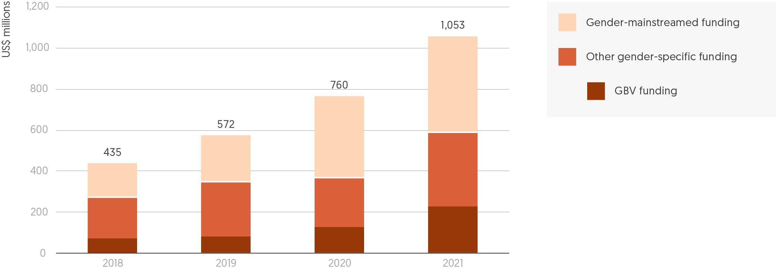

Source: Development Initiatives based on UN Office for the Coordination of Humanitarian Affairs (OCHA) Financial Tracking Service (FTS).

Notes: GBV = gender-based violence. Data was updated to constant 2020 prices and US$ millions, and was last downloaded on 6 May 2022.

Gender-related needs are considered to have grown rapidly, with the Covid-19 pandemic reported to have reversed previous gains in gender equality and the empowerment of women and girls.[14] There have been a number of commitments in recent years to channel more funding for gender-related humanitarian responses.[15] However, beyond reporting on funding and requirements on gender-based violence (GBV) within the protection cluster, there is no easily accessible reporting from which to estimate volumes of funding and therefore the extent to which commitments are being fulfilled.

Analysing data from the Financial Tracking Service of the UN Office for the Coordination of Humanitarian Affairs using a key-word search methodology, it is possible to estimate volumes for gender-specific funding (which has a key focus on addressing gender-related needs and advancing gender equality) and gender-mainstreamed funding (which seeks to implement funding in a way that considers gender-related needs). For more detail, see our online ‘Methodology and definitions’ (Chapter 5) and Chapter 3, ‘Largest donors of gender-relevant humanitarian funding’).[16]

Reported gender-specific funding, which includes funding targeting GBV, more than doubled between 2018 and 2021.

* Total gender-specific funding grew from US$268 million in 2018 to US$587 million in 2021.
* Assistance targeting GBV accounted for a growing proportion of this funding, increasing from US$67 million (25%) to US$224 million (38%).

Figures for gender-mainstreamed funding, where an element of an identified programme addresses gender-related needs, show that assistance has grown significantly.

* Total gender-mainstreamed funding more than doubled between 2018 and 2021, rising from US$167 million to US$466 million.

Total gender-relevant funding, combining gender-specific and gender-mainstreamed assistance, had grown to over US$1 billion by 2021. However, despite this growth, it still represents a very small proportion of total international humanitarian assistance.

* In 2021, total reported gender-relevant funding accounted for just 3.4% of total international humanitarian assistance.
* Gender-specific funding, for programmes with a primary focus on gender-related humanitarian needs, made up just 1.9% of total assistance.

While many recent reports have highlighted the insufficiency of funding for gender-related needs, there is presently no certain way to identify the volumes of funding required for all areas of humanitarian programming relating to gender equality and the empowerment of women and girls. Funding requirements for GBV are, however, the exception. Reporting on GBV requirements indicates that underfunding has worsened, as increases in need have outpaced rises in funding.

* In 2021, just 29% of GBV funding requirements were met, the lowest proportion reported over the previous four years, and down from 32% in 2020.
* While funding for GBV increased almost fourfold over the four-year period to 2021, funding requirements increased more than fivefold, from US$146 million in 2018 to US$747 million in 2021.

Improvements in reporting and the collation of data on gender-related funding are needed. Analysis of funding and requirements for all areas of humanitarian response related to gender equality and the empowerment of women and girls is currently challenging. Over the period covered by this analysis, the increased profile of gender in humanitarian response, particularly efforts to promote improved responses to GBV, are likely to have driven improvements in reporting, which may partly account for the identified rises in funding. Moreover, current gender markers on the Creditor Reporting System of the Organisation for Economic Co-operation and Development DAC and the Financial Tracking Service of the UN Office for the Coordination of Humanitarian Affairs are not consistent and do not currently allow for the accurate tracking and detailed analysis of funding flows.[17] And, the nature of programming, especially where a programme may contain elements focusing on gender within a wider approach, or where core funding may support gender-mainstreamed programmes, make tracking flows inherently complex.

## Climate finance flows

Figure 2.5: Climate adaptation funding was a small percentage of total ODA in 2020

ODA for humanitarian assistance with climate change adaptation objectives, 2020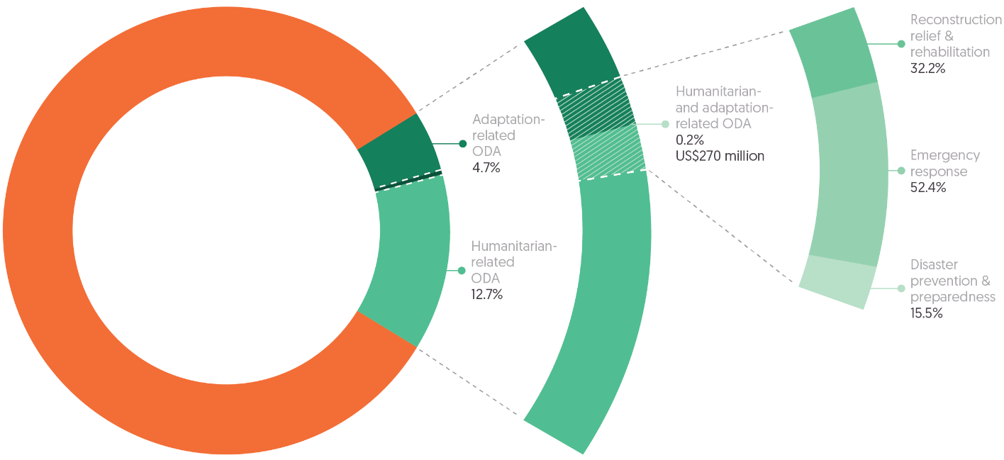

Source: Development Initiatives based on Organisation for Economic Co-operation and Development (OECD) Development Assistance Committee (DAC) Creditor Reporting System (CRS).

Notes: Proportions based on gross ODA disbursements 2020. ‘Humanitarian’ is defined here as the sum of ODA reported under the humanitarian OECD DAC sector codes. ‘Adaptation-related’ is defined here as the sum of ODA marked as having adaptation as either a principal or significant policy objective with the climate change adaptation policy marker.

Climate-related and climate-driven crises are increasingly intersecting with, and compounding, existing vulnerabilities in countries already experiencing crisis, particularly in those states with the lowest levels of resilience. In 2021, half of the 306 million people in need of humanitarian assistance lived in areas facing high levels of vulnerability to the impacts of climate change (see ‘Humanitarian need and intersecting dimensions of risk’, Chapter 1).

As climate change exacerbates existing crises and drives new ones, already stretched humanitarian resources will become increasingly insufficient. UN humanitarian appeals requirements linked to extreme weather in 2020 were eight times higher than they were 20 years ago, and experienced significant levels of underfunding.[18] To address this growing funding gap and alleviate the effects of protracted crises, we need better understanding of: the mechanisms and objectives of climate finance, how it intersects with other finance, and how it alleviates the severity of a crisis.

### What is climate finance?

‘Climate finance’ is a broad term that encompasses a range of different financing structures and instruments, some of which are tracked and mobilised through the UN Framework Convention on Climate Change (UNFCCC).[19] It includes a mix of local, national and international resources, including ODA and non-ODA funding, that come from public and private sources. Most climate finance that is tracked is invested domestically.[20] Most international climate finance is provided in the form of loans from public finance, which therefore carry risks of debt for the recipients. Countries experiencing multiple, protracted crises are often ineligible for lending.[21]

Climate finance supports a range of initiatives. Most global climate finance is targeted to alleviate the severity of climate change through emissions-reduction activities (‘mitigation’ finance) and promoting the transition to less carbon-intensive economies. The remaining finance is used to help communities adapt to the impacts of climate change (to reduce disaster risk and communities’ vulnerability to environmental changes driven by climate change).[22] Unlike humanitarian financing, climate finance is not targeted at disaster response, but rather disaster prevention, seeking behavioural change from individuals, communities, corporations and governments.

Figure 2.6: Most international climate finance is focused on averting and minimising climate risk

Climate finance flows, a conceptual diagram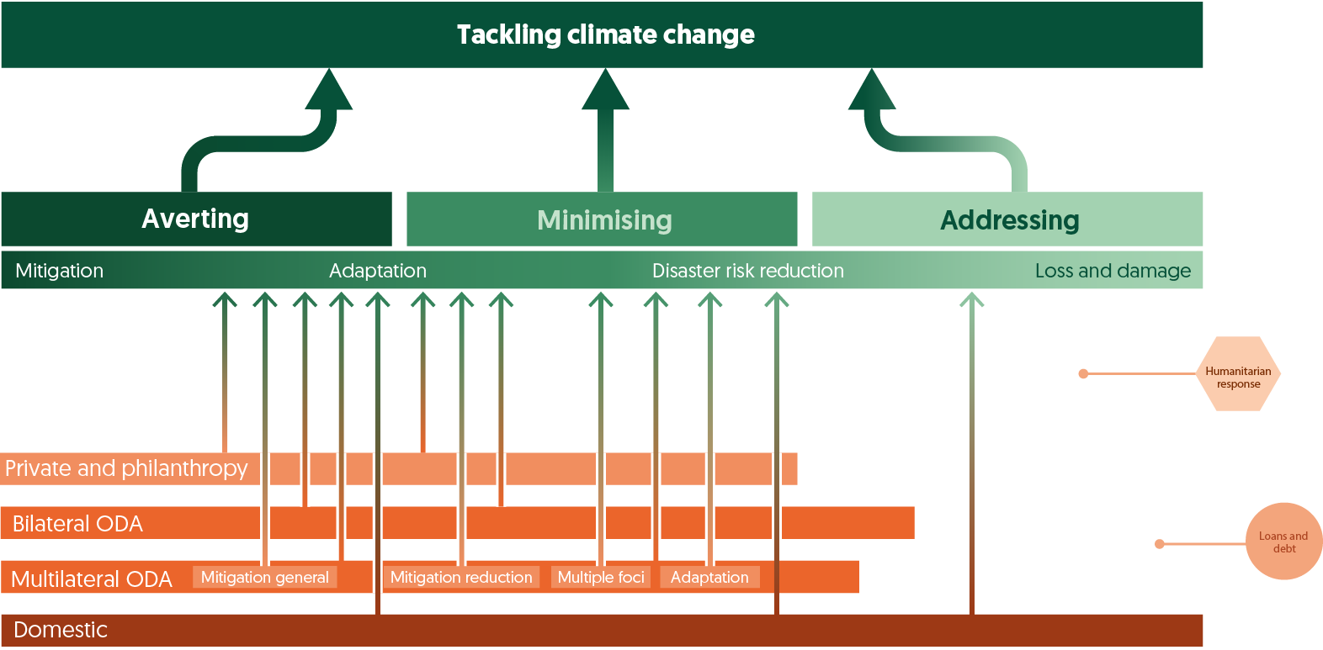

Source: Development Initiatives based on United Nations Climate Change (UNFCCC) Introduction to Climate Finance, UK Parliament House of Commons Library and Climate Policy Initiative’s Global Landscape of Climate Finance 2021.

Following international recognition of the need for support for climate action in developing countries, an international climate finance target was agreed at the 2009 conference of the UNFCCC. Developed countries – in accordance with the principle of common but differentiated responsibilities and respective capabilities – committed themselves to a goal of jointly mobilising US$100 billion a year by 2020 to address the mitigation and adaptation needs of developing countries. This focused particularly on those most likely to be vulnerable to climate change – the least developed countries and small island developing states. This goal was not met and has been extended to 2025.[23]

The UNFCCC also recognises the importance of ‘averting, minimising and addressing’ the worst effects of climate change through an additional type of financing called ‘loss and damage’ (L&D). The UNFCCC considers ‘averting and minimising’ to be covered by mitigation and adaptation funding, but there is currently no finance to address losses and damages. Civil society is currently advocating for L&D finance to compensate vulnerable communities experiencing losses and damages related to extreme weather events and slow-onset climate-related disasters (see Box 2.1, ‘Loss and Damage’).[24]

### Climate-relevant finance to vulnerable countries

Climate adaptation funding, disaster risk reduction and insurance are particularly critical to building the resilience of people and places by managing risk and adapting to change. Where people are experiencing protracted crises, these tools reduce vulnerability to the impacts of climate change, and so reduce the risks of climate change events driving or exacerbating crises. While similar in principle, they differ by implementation, emerge from different global processes, are managed by different actors and governed by different reporting processes.[25]

A significant amount of international bilateral climate finance from government donors to development and crisis contexts is taken from ODA budgets, and ODA remains an important mechanism for climate funding going to developing countries, despite being severely underfunded overall.[26] Climate finance provided as grant ODA has particular potential to support efforts in countries at risk of multiple and protracted crises by supporting key sectors, building institutional capacity to deal with climate-related risks and leveraging other forms of finance. This finance is also potentially a key resource in the prevention of, and response to, humanitarian crises, including to climate-related disasters.

Importantly, there is a clearly defined expectation that tracked ODA climate finance should be additional to other, pre-existing ODA commitments, including humanitarian assistance.[27] At present, existing aid classification indicators are insufficient to distinguish whether this activity is truly additional.[28] Nevertheless, looking at bilateral climate-relevant ODA provides a useful way to track how much climate finance is flowing to developing countries and crisis contexts, and how this money is spent. The amount of funding allocated to humanitarian crises tagged with climate relevance is small.

* In 2020, 8.9% of all bilateral ODA (US$10.8 billion)[29] was disbursed to programmes and interventions with climate-related objectives, according to projects tagged with the Rio marker system. Of this amount, 45.1% (US$4.9 billion) was for mitigation activities, 37.1% (US$4.0 billion) for adaptation activities, and 17.8% (US$1.9 billion) for activities with dual mitigation/adaptation objectives.

While all climate finance should be additional, some adaptation funding is reported as both humanitarian and climate adaptation.

* Of the US$6 billion of ODA with the purpose of adaptation (including dual mitigation/adaptation objectives), US$270 million (4.5%) was spent on humanitarian interventions. This volume was equal to 1.7% of total humanitarian ODA, or 0.2% of total ODA that year, and represents the volume of all projects for humanitarian purpose and tagged as relevant for adaptation. In addition, humanitarian assistance is also spent responding to the impacts of climate change, including extreme weather events, but reporting does not allow for this funding to be disaggregated from wider response.
* Most of the US$270 million of ODA for the purpose of adaptation also spent on humanitarian interventions was spent on emergency response activities like emergency food assistance. A further 15.5% (US$47 million) was spent on disaster prevention and preparedness, which is directly related to climate adaptation objectives.

Countries experiencing protracted crisis are among the most vulnerable and least able to adapt to the impacts of climate change. International funding support is critical to enabling them to manage and adapt to the impacts of climate change, and to limit climate change driving and exacerbating crisis. These countries receive a small proportion of their total ODA for climate adaptation and a relatively small share of total ODA for climate adaptation.

* The 34 countries[30] experiencing protracted crisis in 2020 received a total US$1.6 billion in adaptation funding, less than 3% (2.8%) of their total ODA funding (US$56.8 billion) and 27% (US$6.0 billion) of climate-relevant ODA for adaptation purposes.
* The top 20 recipients of ODA for adaptation purposes received US$2.4 billion in 2020 (41% of total adaptation funding). Among this group of 20 countries, the 10[31] experiencing protracted crisis received US$977 million (16.4% of total adaptation funding).

Further to bilateral climate-relevant ODA, climate finance is allocated via multilateral climate funds. Climate Funds Update data gives an initial picture of broader climate finance flows via the major UNFCCC climate funds.[32] This data highlights the inadequate volumes of climate finance going to help vulnerable communities adapt in the face of climate change.

* Most climate finance dispersed by major climate funds is spent on mitigation activities, with only 28% (US$2.9 billion) of the US$10.7 billion dispersed funding being spent on adaptation purposes.
* Only 12% (US$1.3 billion) of disbursed funding (US$11 billion) goes to fragile and conflict-affected states (FCASs), despite these states being most in need of international support to respond to climate change.
* While FCASs do receive a higher proportion of their total funding for adaptation purposes (46%, US$600 million), this represents only 5.6% of total funding dispersed. FCASs receive a smaller amount of funding (36%, US$ 471 million) for mitigation, which covers infrastructure investments and deforestation activities related to emissions reduction.
* Over one third (38%) of the approved funding from multilateral climate funds is in the form of concessional loans. FCASs, however, receive most of their finance from multilateral climate funds (90%) in the form of grants.

The data on bilateral ODA for climate adaptation purposes and on multilateral climate funding in FCASs suggests that there is insufficient climate funding directed toward and successfully addressing sudden and slow-onset humanitarian disasters that result from climate change, especially in the most vulnerable places. This leaves local actors and the humanitarian sector to bear the costs of responding to climate-related disasters.[33]

Further, mechanisms like disaster risk reduction, adaptation finance and insurance may become less effective as the number of disasters increases and when the dimensions of risk multiply.[34] Communities experiencing multiple dimensions of risk are less likely to receive adaptation funding, and more likely to experience the accumulated risks of protracted crises (see ‘Humanitarian need and intersecting dimensions of risk’, Chapter 1; and ‘Development financing for disaster risk reduction’, Chapter 3).[35]

Box 2.1: Loss and damage

The UNFCCC has committed to ‘averting, minimising and addressing’ loss and damage (L&D) – the impacts of climate change that have not or cannot be adapted to by those least responsible for climate change. Communities are already bearing the costs of losses and damages and, when crises occur, those costs are largely borne at household and national levels, with a small amount of support from an already overstretched humanitarian system.[36] The escalating discussion around addressing loss and damage indicates that a particular type of need is not being met by climate finance.

While averting and minimising L&D are considered accounted for by mitigation and adaption financing, action to address L&D under the UNFCCC is conceived as a climate mechanism – not a humanitarian one – for response to the negative impacts of climate change, designed not only to enable countries to recover and develop after a crisis and address slow-onset impacts, but also to compensate people for what they have lost as a result of climate change impacts.[37] The concept of L&D is rooted in the principles of climate justice: that those who have done the least to contribute to rising temperatures should not bear the costs associated with addressing it.

Current climate finance mechanisms are geared towards averting and minimising L&D through mitigation and adaptation funding. At the 2021 UN Climate Change Conference (COP26) in Glasgow, the majority of the world (the G77 and China) proposed creation of an L&D finance facility to address loss and damage, but this was not supported by wealthier nations, and instead only a dialogue on L&D finance was agreed.[38]

If created, a new L&D finance facility could provide an important oversight function to ensure support for L&D, including insurance, humanitarian relief, social protection and other longer-term assistance for the migration and relocation of people likely to be displaced.[39] New and additional finance to address L&D from subnational governments, some philanthropists, and the multilateral Least Developed Countries Fund is not currently captured through ODA reporting mechanisms.

Chapter 3

donors of humanitarian and wider crisis financing

The need to widen the donor base for humanitarian assistance, and to target finance to countries experiencing crisis to address the underlying developmental and climate-related drivers of crisis, is long recognised. This chapter examines the behaviour in 2021 of donors, public and private, looking at all humanitarian funding, as well as that targeted specifically to gender-related interventions. And, beyond humanitarian assistance, it explores the role of key World Bank crisis-financing mechanisms and development funding for disaster risk reduction (DRR).

In 2021, the three largest donors accounted for 59% of all public humanitarian assistance, a similar proportion to previous years. Yet change was evident in individual funding patterns, as increases in excess of 10% from the two largest donors, the US and Germany, counter-balanced a second large annual reduction in funding from the UK, a decrease of US$1.0 billion to US$1.6 billion, 39% less than in 2020. Japan was the fourth-largest donor, with assistance doubling (up 104%) to US$1.2 billion. Funding targeting gender is also concentrated among a small group of donors. The 10 largest donors of gender-specific funding accounted for 88% of all gender-specific funding from public donors in 2021.

Spending on in-country donor refugee costs was US$8.7 billion in 2021, the fifth consecutive reduction in spending since the 2016 peak of US$16.8 billion. Estimates for 2022, as many European donors take in Ukrainian refugees, suggest funding on domestic refugee hosting could be double or triple that of 2016.

In 2020, total international humanitarian assistance from private donors increased by 5%, from US$6.2 million in 2019 to a record US$6.5 billion, with estimates for 2021 indicating a similar volume, US$6.4 billion. In 2020, the most recent year for which a breakdown of data on private donors is available, funding from individuals fell slightly from 2019 levels to US$4.5 billion (68% of all private assistance).

The volume of official development assistance (ODA) provided by multilateral development banks to the annual largest 20 recipients of humanitarian assistance has grown significantly, doubling since 2015 from US$5.8 billion, to US$11.6 billion in 2020. The World Bank in particular is providing more financing through crisis-focused mechanisms that increasingly intersect with traditional humanitarian response. For instance, in 2021, the Fragility, Conflict and Violence Envelope of the World Bank’s International Development Association (IDA) provided finance totalling US$2.3 billion to nine countries with humanitarian response plans.

Funding for DRR is a potentially important anticipatory element of existing approaches to limit the impact of climate change in contexts vulnerable to, or experiencing, humanitarian crises. Between 2018 and 2020, ODA with the primary purpose of DRR increased 45%, from US$1.6 billion to US$2.4 billion, with Japan and the UK being the largest donors over this period.

## International humanitarian assistance: largest donors

Figure 3.1: The US and Germany increased contributions in 2021 and account for a growing share of all international humanitarian assistance from public donors

20 largest public donors of humanitarian assistance in 2021 and percentage change from 2020

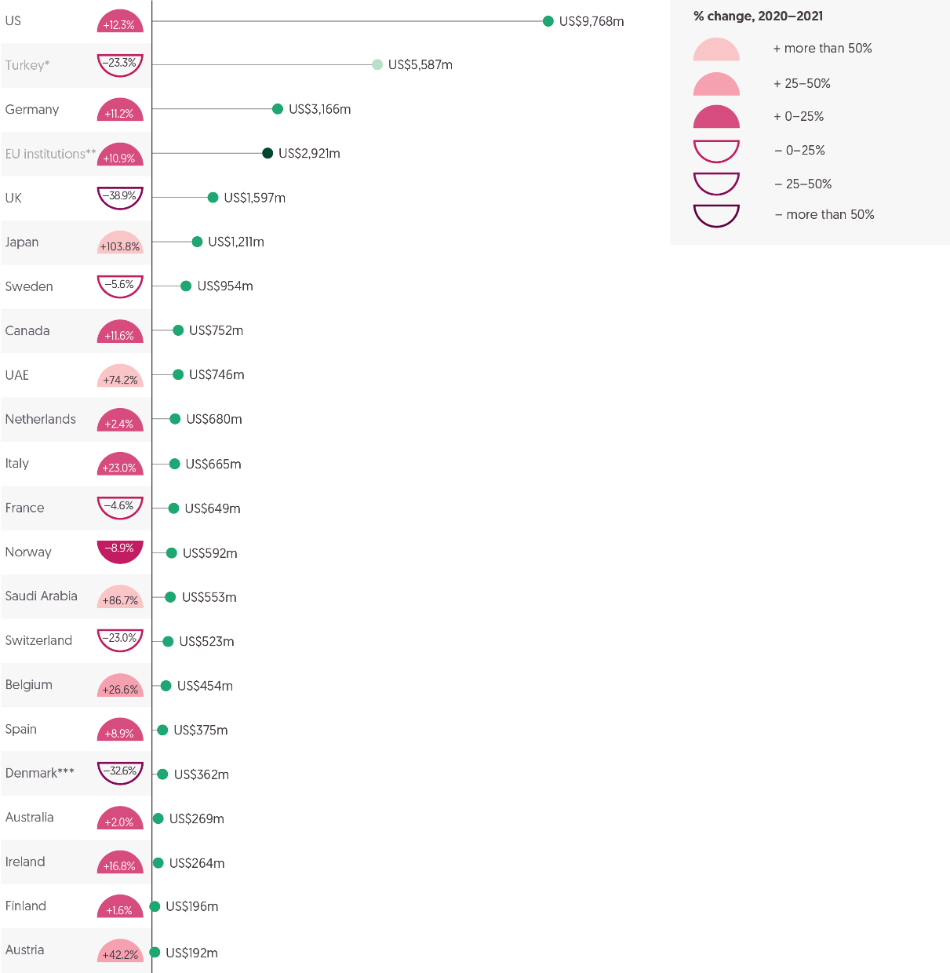

Source: Development Initiatives based on Organisation for Economic Co-operation and Development (OECD) Development Assistance Committee (DAC), and UN Central Emergency Response Fund (CERF) data.

Notes: GNI = Gross national income. 2021 data for OECD DAC is preliminary. *Turkey is shaded differently because the humanitarian assistance it voluntarily reports to the DAC is largely expenditure on hosting Syrian refugees within Turkey, and so not strictly comparable with the international humanitarian assistance from other donors in this figure. **EU institutions are also included separately for comparison and are shaded differently to distinguish from government donors. ***Preliminary 2021 figures for Denmark have only been partially reported to the OECD DAC and will be revised upwards in final reporting at the end of 2022. 2020 figures differ from the Global Humanitarian Assistance Report 2021 due to final reported international humanitarian assistance data.

The impacts of the Covid-19 pandemic have led to rapid growth in humanitarian need over the past two years, accelerating rises over the previous decade. This has placed an ever-greater strain on the aid budgets of donor countries. This situation is being compounded by pressures on the global economy and domestic responses to Covid-19. In 2022, effects of the war in Ukraine, including increased expenditure to support the hosting of Ukrainian refugees among many of the largest donors of humanitarian assistance, have placed further pressure on donor budgets.

Against this backdrop, the donor landscape remained largely unchanged in 2021, with the same small number of donors providing nearly all international humanitarian assistance. As noted in ‘International humanitarian assistance’ (Chapter 2), total international humanitarian assistance from public donors grew from US$23.5 billion in 2020 to US$24.7 billion in 2021. While assistance provided by the UK declined significantly, accelerating further the pace of reductions seen in 2020, further rises in contributions from the US and Germany cushioned the impact of the UK decrease.

* In 2021, the funding base remained unchanged, with no shifts towards greater burden-sharing and diversification. As in previous years, the 20 largest donors in 2021 provided nearly all public international humanitarian assistance, accounting for 97% of all allocations.
* The US, Germany and the UK have been the three largest donors every year for the past decade. In 2021, these three donors collectively accounted for 59% of public international humanitarian assistance, down slightly from 60% in 2020.
* Despite its decrease in contributions, the UK remained one of the three largest donors and has recently announced a new three-year international development strategy, which suggests levels of funding will stabilise but at lower levels than 2020.[40]

As in previous years, contributions from individual donors fluctuated greatly.

* Allocations of international humanitarian assistance increased from 14 countries among the 20 largest donors, with 10 seeing rises of more than 10%.
* The US and Germany, the two donors providing the largest volumes of assistance, were among those allocating 10% more in 2021 than in 2020. The US provided US$9.8 billion (up 12%), while Germany allocated US$3.2 billion (up 11%), the first increase from Germany since 2017.
* With these increases, and the decline in UK contributions, the US and Germany accounted for a growing proportion of all public assistance: 52% in 2021, up from 49% in 2019.
* Among other donors increasing the volume of assistance provided in 2021, most notable was the increase in contributions from Japan, which more than doubled from 2020 to US$1.2 billion (up 104%), the highest level of Japanese assistance since 2015.
* The trend of large fluctuations in assistance from the United Arab Emirates (UAE) and Saudi Arabia continued in 2021, with two years of respective declines reversed, and volumes increasing by around three quarters to US$745 million (up 74%) for the UAE and to US$553 million (up 87%) for Saudi Arabia.
* The reduction in assistance from the UK dwarfed all others, with UK international humanitarian assistance declining in 2021 by US$1.0 billion, a 39% decrease from 2020, to US$1.6 billion. This follows a 16% reduction between 2019 and 2020.

### Spending on in-country refugee hosting

Donor countries also continued to provide financial support for hosting refugees and asylum seekers in 2021. According to preliminary data from the Organisation for Economic Co-operation and Development (OECD) Development Assistance Committee (DAC), 2021 presented the fifth consecutive annual decrease in ODA for hosting refugees in-country.

* In 2021, the preliminary volume of total ODA spent on in-country refugee hosting costs by DAC members decreased slightly, by 0.3% to US$8.72 billion, from US$8.75 billion in 2020. This is more than half the total spending in 2016, peaking at US$17.2 billion. DAC directives were subsequently clarified in 2017 on what in-country refugee hosting costs could be counted as ODA.[41]
* The largest increase of expenditure from 2020 to 2021 was seen for the UK (up 42% to US$1.1 billion). This is against the backdrop of declining humanitarian assistance and total ODA[42] provided by the UK in 2021, meaning the proportion of the UK’s in-country refugee assistance out of the UK’s total ODA almost doubled (from 4.2% in 2020 to 7.5% in 2021).
* Other countries with notable increases of US$100 million or more in 2021 were Italy (up 131% to US$528 million) and Austria (up 74% to US$234 million).

This overall picture of declining spending on in-country donor refugee hosting is likely to be reversed in 2022, as DAC members across Europe take in substantial numbers of refugees fleeing the conflict in the Ukraine. The extent of expenditure and impact of other areas of ODA spending is not yet clear, and the publication of more up-to-date, near real-time information (rather than waiting for delayed retrospective reporting of costs to the OECD DAC) will be important for transparency and accountability, and ensuring that ODA is safeguarded for the most vulnerable populations.

* At the time of writing,[43] the UN High Commissioner for Refugees (UNHCR) estimates that around 5.3 million refugees from Ukraine have so far been recorded across Europe since 24 February 2022. This is around 75% of all refugees hosted in European countries recorded by UNHCR at the end of 2021.
* Some donors – including Sweden, Norway and Denmark – have already announced decisions to make cuts in their ODA budgets and reallocate this funding to support arriving Ukrainian refugees. Germany has announced a revision to its ODA budget that represents a mix of additional funding for direct support to the Ukraine crisis and to mitigate consequences of the global food crisis on low- and middle-income countries, partly offset by cuts in other areas.[44]
* How high in-country refugee hosting costs will end up being in 2022 for donor countries hosting Ukrainian refugees, and the knock-on effect on ODA budgets, including humanitarian assistance, remains unclear. Current estimates, partly based on in-country refugee hosting costs from the 2016 influx of refugees in Europe, vary between US$30 billion[45] and US$47 billion.[46] This would imply double-to-triple in-country refugee-hosting costs compared to the previous peak for DAC members in 2016 (US$17.2 billion).

Figure 3.2: Four donors provide more than 0.1% of GNI as humanitarian assistance

20 donors providing the most humanitarian assistance as a percentage of GNI, 2021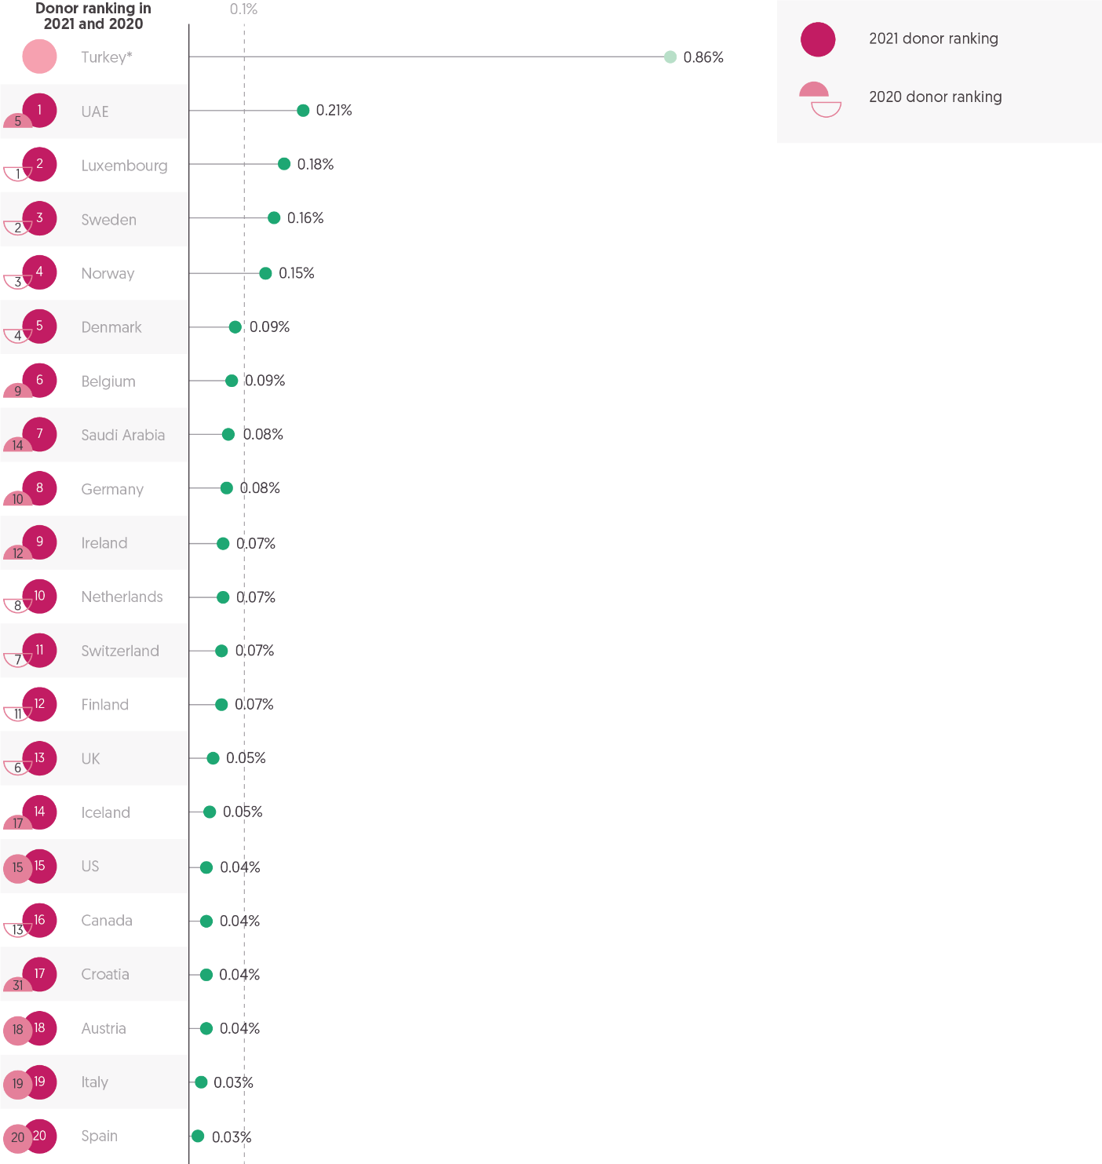

Source: Development Initiatives based on Organisation for Economic Co-operation and Development (OECD) Development Assistance Committee (DAC), and UN Central Emergency Response Fund (CERF) data.

Notes: GNI = Gross national income; UAE = United Arab Emirates. 2021 data for OECD DAC is preliminary. *Turkey is shaded differently because the humanitarian assistance it voluntarily reports to the DAC is largely expenditure on hosting Syrian refugees within Turkey, and so not strictly comparable with the international humanitarian assistance from other donors in this figure. Ranking for 2020 differs from GHA Report 2021 due to final figures for GNI and international humanitarian assistance (IHA).

The need for more donors to provide greater volumes of international humanitarian assistance has been long recognised.[47] The humanitarian system, as noted in

‘International humanitarian assistance’ (Chapter 2), remains precariously reliant on a small number of donors. As humanitarian needs continue to grow (see Figure 1.1, Chapter 1), the current configuration of the donor base looks increasingly inadequate. The extent to which individual donors prioritise humanitarian response, relative to other needs and the size of their domestic resource base, is illustrated by the proportion of gross national income (GNI) committed to humanitarian assistance.[48]

In 2021, among the 20 largest donors of international humanitarian assistance by volume, a third increased the proportion of GNI provided as humanitarian assistance. Stark differences seen in previous years, in the proportion of GNI allocated, were again evident in 2021.

* Four donors allocated more than 0.1% of their GNI to humanitarian response (the UAE, 0.21%; Luxembourg, 0.18%; Sweden, 0.16%; and Norway, 0.15%). This is two fewer than in 2020.
* Turkey also reported international humanitarian assistance representing a high proportion of GNI: 0.86% in 2021, a decrease from 1.02% in 2020. Turkey’s reported contributions are not directly comparable with those of other donors, however, as the assistance voluntarily reported to the OECD DAC largely comprises spending on hosting Syrian refugees within Turkey.
* Seven donors increased the proportion of GNI provided as international humanitarian assistance. Among those donors, all increases were driven by assistance rising more than GNI, with the exception of the UAE and Saudi Arabia, where assistance still grew but GNI decreased.
* Six countries saw the proportion of GNI provided as humanitarian assistance decrease. In one country, Luxembourg, the volume of humanitarian assistance grew but at a slower rate than GNI. In the other five, humanitarian assistance decreased while GNI grew.
* The most notable decreases in assistance as a proportion of GNI were from Denmark and the UK. Denmark’s assistance reduced from 0.15% of GNI in 2020 to 0.09% in 2021. Despite this fall, Denmark remained among the five largest donors measured by GNI, down from fourth to fifth place.
* The UK’s assistance accounted for 0.05% of GNI in 2021, down from 0.1% in 2020, placing it 13th, down from 6th in the previous year.

Effective immediate and long-term support to people at risk of, experiencing or recovering from crisis, requires a combination of types of finance including humanitarian assistance but also development, peacebuilding and climate interventions (see ‘Humanitarian need and intersecting dimensions of risk’, Chapter 1; ‘International humanitarian assistance, Chapter 2; ‘Climate finance flows, Chapter 2; and ‘Development financing for disaster risk reduction’). More funding for humanitarian assistance is needed. But this should not come at the expense of other financing provided to those experiencing poverty or crisis (see Figure 3.1). Assessing the behaviour of the 20 largest donors, who contribute nearly all international humanitarian assistance, indicates where changes in policy could generate greater volumes of resourcing. The greatest impact would be made by those countries with the largest economies.

* The US, while the largest donor of international humanitarian assistance by volume, has the world’s highest GNI, of which 0.04% was for humanitarian response in 2021, placing it 15th among other countries.
* Other countries with high GNI already among the largest donors, where increases in the proportion of GNI provided could mobilise significant volumes of assistance, include Spain (13th-highest GNI, providing 0.03%), Italy (8th-highest GNI, providing 0.03%) and Canada (10th-highest GNI, providing 0.04%).

Outside this group of 20 donors, there are other countries with large, developed economies that currently provide a relatively small proportion of their GNI as international humanitarian assistance.

* Notable high-income countries currently allocating relatively small proportions of GNI to humanitarian assistance in 2021 include: Japan (3rd-highest GNI, providing 0.02%), France (5th-highest GNI, providing 0.02%), South Korea (11th-highest GNI, providing 0.01%) and Australia (14th-highest GNI, providing 0.02%).

## Largest donors of gender-relevant humanitarian funding

Figure 3.3: Gender funding is concentrated among a few donors, but proportions of total funding for gender vary significantly

10 largest donors of gender-specific international humanitarian assistance (GBV and other gender-specific funding), 2021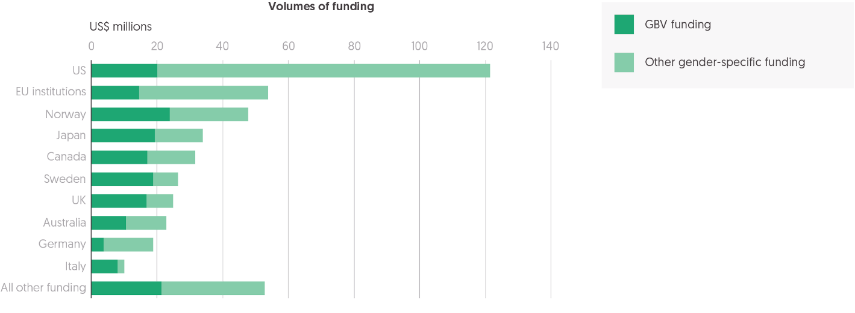

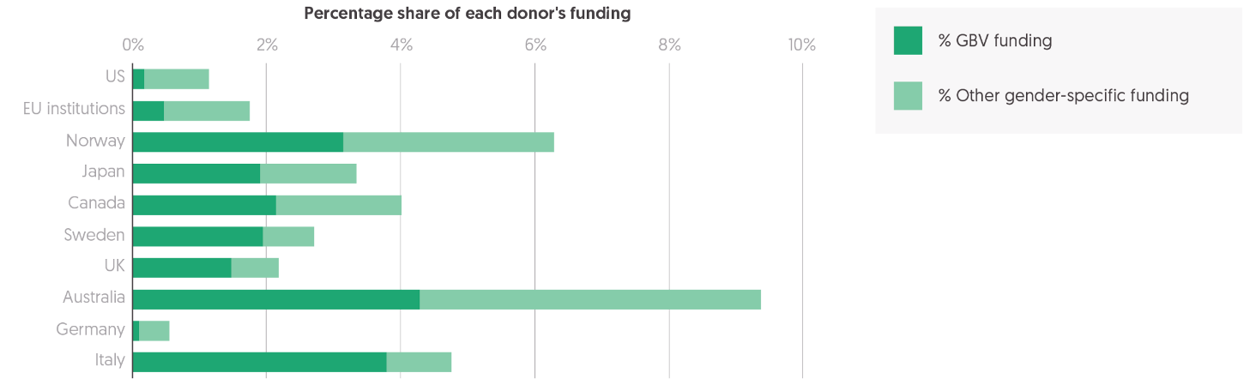

**Source**: Development Initiatives based on the UN Office for the Coordination of Humanitarian Affairs (OCHA) Financial Tracking Service (FTS).

Notes: GBV = gender-based violence. Data is in constant 2020 prices and US$ millions, and was last downloaded on 6 May 2022. Totals in this chart include only funding from donor countries and government agencies. EU institutions includes funding from the European Commission’s Humanitarian Aid and Civil Protection Department, the European Commission’s Directorate-General for International Partnerships (formerly EuropeAid DEVCO) and the European Commission’s EU Facility for Refugees in Turkey.

As noted in ‘Gender-relevant funding’ (Chapter 2), gender-related needs are perceived to have grown rapidly, with the Covid-19 pandemic reported to have reversed previous gains in gender equality and the empowerment of women and girls. There has been an increasing focus on gender-related humanitarian needs that has been accompanied by growing volumes of funding, although these increases are failing to keep pace with rising need. Gender-related funding is not consistently reported. With some interventions mainstreamed within programmes, sometimes supported by core funding, it is not possible to assess accurately the scale and impact of these mainstreamed programmes. [Recent analysis](https://devinit.org/resources/funding-for-gender-relevant-humanitarian-response/) by Development Initiatives has begun to unpack gender-related funding, identifying the broad scope of mainstreamed funding as well as pinpointing more focused gender-specific programming, which has gender-related needs as a primary objective. Most of this gender-specific funding is provided by a small group of donors.

* The 10 largest donors of gender-specific funding accounted for 88% of all gender-specific funding from public donors in 2021.
* The largest donors by volume were the US (US$122 million), EU institutions (US$54 million) and Canada (US$48 million). Alone, the US provided 27% of all gender-specific funding from public donors in 2021.

The proportion of total funding provided by donors that is for gender-specific programmes varies significantly.

* Four donors allocated 4% or more of their total assistance to gender-specific programmes: Australia (9.4%), Norway (6.3%), Italy (4.8%) and Canada (4.0%).

While the US and EU institutions contributed the largest volumes of gender-specific assistance in 2021, this accounted for less than 2% of the total volume of humanitarian assistance they each provided. Germany, the second-largest donor of international humanitarian assistance in 2021, allocated 0.5% to gender-specific projects.

## Private donors of humanitarian assistance

Figure 3.4: The proportion of private funding from foundations, and companies and corporations grew notably in 2020

Sources of private international humanitarian assistance, 2016–2020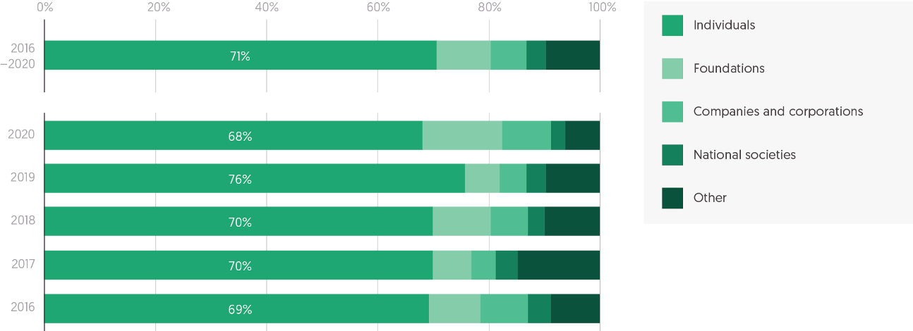

Source: Development Initiatives based on our unique dataset of private contributions.

Note: Data is in constant 2020 US prices.

Private donors play an important role in financing humanitarian response. The outbreak of the Covid-19 pandemic in 2020 (the latest year for which a breakdown by donor type is available) saw contributions significantly increase from foundations, companies and corporations, offsetting a slight decrease from individuals.

* In 2020, total international humanitarian assistance from private donors increased by 5%, from US$6.2 billion in 2019 to a record US$6.5 billion in 2020 (see Figure 2.1, Chapter 2).
* Individuals are the largest source of private funding for humanitarian response. After a sizeable jump in individual giving in 2019 to US$4.7 billion, from US$4.0 billion, 2020 saw funding fall to US$4.5 billion. This drop, and the increase in funding from other private donors, drove down the proportion of total private funding donated from individuals, from 76% in 2019 to 68% in 2020, returning to pre-2019 levels.
* This slight decrease in funding from individuals was offset by significant increases in funding from other private donors engaging strongly with the Covid-19 response. Funding from trusts and foundations more than doubled, from US$0.4 billion in 2019 to US$0.9 billion in 2020, and the overall proportion of private funding grew from 6% to 14%. This marks a significant increase in funding from the previous four-year average of US$0.5 billion.
* Funding from the private sector also doubled, from US$0.3 billion in 2019 to US$0.6 billion in 2020, accounting for 9% of total funding in 2020, from 5% in 2019.
* Funding for humanitarian response is also raised through national societies at country level, including the Red Cross National Societies. Funding from national societies has remained consistent throughout the past five years at US$0.2 billion. While the exact breakdown is not known, donors to national societies include the private sector, foundations and individuals.

Funding from private donors is channelled primarily to non-governmental organisations (NGOs), with only a small proportion directed to multilateral agencies. Public donors, in contrast, provide most of their assistance to multilaterals (see Figure 4.2, Chapter 4). In 2020, there was a shift, with relatively more private assistance going to multilaterals and less to NGOs.

* In 2020, 78% (US$5.1 billion) of assistance from private donors was provided to NGOs. This represents a smaller proportion than in 2019 (85%, US$5.3 billion) and less than the average over the past five years (also 85%).
* With relatively less funding to NGOs in 2020, more was directed to multilateral agencies. In 2020, the proportion of total private funding provided to multilateral agencies grew from 12% (US$740 million) in 2019, to 19% (US$1.2 billion).
* The International Red Cross and Red Crescent Movement typically receives only a small proportion of private funding: 3% in 2020 (US$219 million).

Box 3.1: How is private humanitarian assistance provided?

Private donors provide significant contributions of international humanitarian assistance and are also a critical source of flexible funding for humanitarian organisations. Funding from private donors, including individuals, trusts and foundations, and companies and corporations, is generally less restrictive than funding from public donors. While defining, improving and monitoring quality funding from public donors is the focus of much current policy debate, there is little information or scrutiny around the characteristics of funding from private donors. Research on this in our briefing, ‘[Private funding for international humanitarian assistance’](https://devinit.org/resources/private-funding-for-international-humanitarian-assistance/), found that, in 2019, 40% of humanitarian funding from trusts and foundations, and 57% of funding from companies and corporations, was provided as unearmarked or softly earmarked funding, while nearly all the funding raised from individuals is unrestricted funding.[49] Most individual giving is also not restricted to a certain timeframe, or, if donated to a specific appeal, is valid within the lifespan of that crisis. Our research found variation in funding flexibility between different philanthropic foundations and corporations: from those offering unrestricted funding with light-touch reporting requirements, to those with grant-management processes more akin to those of public donors. However, generally, funding from foundations and corporations is perceived to be more flexible than that from public donors, with less intensive reporting requirements.

Overall, funding from private donors provides significantly more flexibility than funding provided by public donors (see Figure 4.7, Chapter 4), and allows an organisation to fund crises or projects that may be difficult to fundraise for through other channels, rather than being led by donor priorities. Private funding can allow organisations to set their own programming practices, for instance in relation to the provision of overhead costs to downstream partners, as opposed to having to follow donor regulations. With accountability structures different from those of public donors, foundations and companies and corporations can also be willing to fund projects that more traditional donors may not fund. Some foundations see their added value as being able to take risks on innovative projects in order to build an evidence base that facilitates and incentivises the entry of public donors.

## Multilateral development bank financing to countries experiencing crisis

Figure 3.5: IDA (the World Bank) drives growth in funding from multilateral development banks to countries experiencing humanitarian crisis

ODA funding from multilateral development banks to the top 20 humanitarian recipients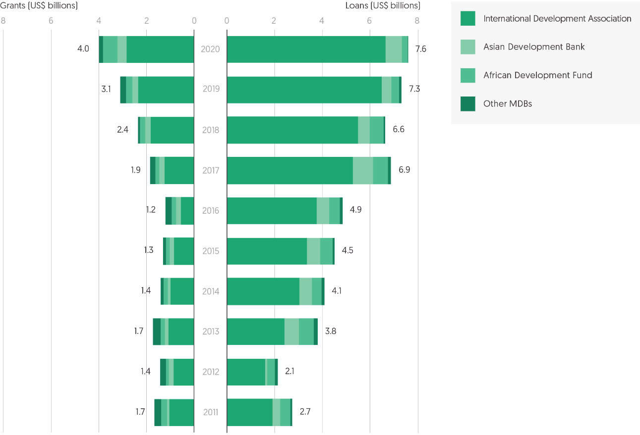

Source: Development Initiatives based on Organisation for Economic Co-operation and Development (OECD) Development Assistance Committee (DAC) Creditor Reporting System (CRS).

Notes: Totals include official development assistance (ODA) in the form of grants and loans from multilateral development banks (MDBs) that report their funding to the OECD DAC CRS. The top 20 recipients of humanitarian assistance vary each year. Humanitarian assistance ODA is that reported under the CRS purpose codes: 720 Emergency response; 730 Reconstruction, relief and rehabilitation; and 740 Disaster prevention and preparedness. Data is in constant 2020 prices.

Over the last decade, multilateral development banks (MDBs) have become increasingly active in crisis contexts. As the concentration of poverty in crisis-affected countries grows, MDBs are choosing to target a growing share of resources to these countries (see Figure 3.5). This is through traditional MDB financing, as well as a growing number of crisis-focused instruments and tools (see ‘World Bank financing in crisis contexts’). Support from MDBs to crisis contexts is primarily in the form of loans, with the aim of protecting social and economic development gains made by supplying long-term financing to governments and the private sector to support long-term recovery. Overall, volumes of development ODA to countries experiencing crisis far exceed humanitarian assistance (see Chapter 2, ‘Volumes of assistance compared with appeal requirements’) and, while the degree and scale of engagement differs between crisis context and MDB, there is a need to ensure greater understanding and coherence between development and humanitarian actors.

* The volume of MDB ODA disbursements to the annual largest 20 recipients of humanitarian assistance has significantly grown, doubling since 2015 from US$5.8 billion, to US$11.6 billion in 2020. Growth in ODA to crisis contexts has outpaced disbursements elsewhere and the share of total ODA from MDBs being channelled to the 20 largest recipients of humanitarian assistance has increased from 27% in 2011 to 38% in 2020.
* MDBs provide the majority of financing to countries in crisis as concessional loans, although the grant component has risen in recent years. Over the last decade, loans have made up at least 60% of MDB ODA to crisis contexts, which steadily increased to a peak of 80% in 2016. In 2017, the share of grants as a proportion of total ODA from MDBs to crisis contexts was 20%, but this has steadily increased since then, to 34% in 2020. This reflects a weaker trend seen more broadly in MDB behaviour; total MDB ODA provided as grants has grown from 23% in 2016 to 29% in 2020.
* Nearly all ODA from MDBs to countries experiencing crisis is reported as development assistance. Just 4% of ODA to the annual 20 largest humanitarian recipients was reported as humanitarian assistance between 2011 and 2020, consistent throughout the period.

The largest MDB donor to countries experiencing crisis is the World Bank’s IDA, followed by the Asian Development Bank (AsDB) and the African Development Fund (ADF).

The AsDB promotes poverty reduction and the social and economic development of its member states. Through its focus on fragile and conflict-affected situations and small island developing states, the AsDB provides flexible processes for member countries experiencing fragility, including Afghanistan and Myanmar.[50] Cumulative loans and grant disbursements from the AsDB to Afghanistan total US$2.91 billion,[51] and US$2.18 billion to Myanmar.[52] The Disaster and Pandemic Response Facility also provides assistance for emergency response and reconstruction including disasters triggered by natural hazards. More recently, policy changes were approved to enable the AsDB to support disaster and emergency response more efficiently, including proposals to expand the Disaster and Pandemic Response Facility to cover conflict-related humanitarian emergencies and public health emergencies.[53]

The ADF is the concessional window of the African Development Bank. Support is provided to member countries in fragile settings through the Transition Support Facility financing mechanism. This is a flexible disbursement mechanism, which provides support for state-building efforts, capacity-building and arrears-clearance. Addressing fragility and improving resilience is a key priority of the ADF, and ADF-14 saw a 13% increase in resource allocation to the Transition Support Facility.

* Between 2011 and 2020, IDA has provided 76% of total MDB ODA disbursements to the annual largest 20 humanitarian recipient countries.
* The AsDB and the ADF both channelled just under 10% each of total ODA from MDBs to countries in crisis in the same period.
* While being the largest provider of ODA to countries in crisis, IDA has consistently provided the lowest share of grants among its disbursements since 2016, although this share increased from 13% in 2016 to 30% in 2020.
* The ADF has seen a significant jump in the proportion of funding provided as grants to crisis contexts, from 21% in 2017 to 72% in 2020.
* As noted above, very small proportions of ODA disbursed from MDBs to countries affected by crisis have been provided as humanitarian assistance. Since 2012, IDA has provided an average of 3% as humanitarian assistance, peaking in 2019 at 6%. Since 2013, the ADF and the AsDB have provided all ODA to countries in crisis as development assistance.

While MDB ODA disbursements to countries experiencing crisis have increased overall, countries in crisis have not been equally supported, with MDBs channelling most funding to countries with more established private sectors and state structures. Many countries experiencing acute crisis are unable to access MDB support. For example, regular assistance to Afghanistan from the AsDB has been placed on hold since August 2021, and going forward AsDB support is being channelled through the UN.[54]

* The countries from the largest 20 humanitarian recipients across the period 2011 to 2020 that received the largest volumes of MDB ODA were Ethiopia (21%) and Pakistan (12%).
* Other countries affected by crisis that have consistently been among the top 20 recipients of humanitarian assistance over the past decade have received notably less funding. For example, Yemen has received just 3.2% of total MDB ODA funding, South Sudan 0.6%, Somalia 1.2%, Iraq 0.2% and Syria 0.01%.

## World Bank financing in crisis contexts

Figure 3.6: World Bank financing in crisis contexts

Selection of World Bank funds providing support to countries affected by humanitarian crises



Source: Development Initiatives based on World Bank data.

There is growing intersection between work supported by the World Bank and traditional humanitarian response (see ‘Multilateral development bank financing to countries experiencing crisis’). Over the past decade, the World Bank’s strategy has pivoted from focusing mainly on post-conflict reconstruction, towards providing specific support to fragile contexts, with an expanded range of tools and financing mechanisms for crisis prevention, response, mitigation and resilience-building.[55] Shifts in the number and duration of protracted crises have also brought the World Bank increasingly into proximity with humanitarian actors. This is evident in the strengthened partnership the Bank has developed with the United Nations and other actors across the humanitarian–development–peace nexus.

Relevant resources cut across the World Bank’s expansive financing architecture, including: IDA country allocations and its thematic envelopes and windows; emergency mechanisms embedded in development policy loans; and mechanisms leveraging public and private resources such as financial intermediary funds and trust funds (see ‘Multilateral development bank financing to countries experiencing crisis’). The following section provides an overview of World Bank financing in fragile, conflict and violence-affected settings by focusing on seven of the main channels and tools available from four sources.

These instruments were selected based on their relevance for humanitarians, the volumes of financing available, and the public availability of information. Greater understanding of the scales, ways of working and types of interventions this financing provides is a first step towards improved coordination and efficiency between humanitarian and development actors. The many interventions complementary to traditional humanitarian responses include large-scale infrastructure projects, strengthened access to basic services, and immediate pandemic and disaster responses.

* Financing from the selected instruments is frequently allocated to countries with humanitarian response plans (HRPs) or regional refugee response plans (RRRPs), however it is not equally spread across all humanitarian crisis settings. Over the past few years, IDA financing has prioritised displacement, conflict and climate-related crises in Africa, while the Syrian and Venezuelan displacement crises have been targeted through specific Financial Intermediary Funds.
* In most cases, financing is provided as loans to governments for their long-term national responses (see ‘Multilateral development bank financing to countries experiencing crisis’).[56] The overall volumes of financial transfer therefore appear high and provide significant amounts of capital in comparison to volumes of humanitarian grants. As loans must be repaid, the World Bank works with recipients of lending to manage debt effectively, through its Sustainable Development Finance Policy.[57]
* There is regular engagement between the World Bank and the United Nations to support policy, diplomatic, strategic and operational dialogue and collaboration through bilateral, inter-agency and inter-governmental engagement. The World Bank – United Nations Partnership Framework for Crisis-Affected Situations lays out operational commitments to leverage complementarities and mandates. In some circumstances, UN agencies and non-government actors implement programmes on behalf of the World Bank. However, the extent to which World Bank financing in countries experiencing crises is coordinated and aligned with humanitarian action implemented by non-UN actors is unclear.

### International Development Association (IDA)

The International Development Association (IDA) is one of the World Bank’s main financing channels for low-income countries, providing zero- or low-interest loans, as well as grants, to governments. Loan repayments are stretched over 30­–40 years. However, countries at high risk of debt distress receive financing in the form of grants; in 2021, a third of all IDA financing was committed as grants.[58] IDA is financed by contributions from high- and middle-income partner countries, transfers from other World Bank Group institutions, borrowers’ repayments of earlier IDA credits, and funding raised in capital markets. Typically, every three years, IDA’s objectives are reassessed and its available funding is replenished. Total funding for the 19th replenishment of IDA (IDA19) was US$82 billion, 29% of which was enabled by donor contributions. In December 2021, IDA20received a total replenishment of US$93 billion.[59]

IDA makes general disbursements to countries; around 80% of financing was channelled directly through country allocations in 2021.[60] The rest of the financing is allocated through envelopes and five dedicated financing windows,[61] of which the Crisis Response Window (CRW) and the Window for Host Communities and Refugees are most relevant to crisis response. The share of IDA resources going to countries facing challenges related to fragility, conflict and violence has increased fivefold since 2010, reflecting the World Bank’s strategy to increase support in this area.[62]

#### IDA Fragility, Conflict and Violence Envelope

##### Objective

Under the 19threplenishment of IDA funds, covering July 2020 to June 2022, a new envelope of allocations was created specifically for countries facing acute risks of fragility, conflict and violence (FCV). The FCV Envelope aims to support the prevention of conflict, uphold engagement during conflict, and build resilience in countries emerging from crises.

##### Financing

FCV Envelope financing is provided in the form of grants and loans at concessional rates.

* 9% (US$7.5 billion) of IDA19 was allocated to the FCV Envelope.[63]
* This proportion has remained stable for the 20th replenishment covering fiscal years 2023 to 2025, with US$8.8 billion allocated to the FCV Envelope.[64]

##### Eligibility

Financing through the FCV Envelope is channelled through three allocations.[65] The Prevention and Resilience Allocation scales up preventative approaches for countries at risk of falling into high-intensity conflict or large-scale violence. The Remaining Engaged during Conflict Allocation is for countries experiencing high-intensity conflict with extremely limited government capacity. The Turn Around Allocation supports countries emerging from a period of conflict, social/political crises or disengagement, through resilience-building.

Relevance for humanitarian responders

**Locations:** In 2021, the FCV Envelope provided US$2.3 billion to nine eligible countries: Burkina Faso, Mali, Mozambique, Niger, the Central African Republic, Somalia, South Sudan, Sudan and Yemen, all of which had HRPs in 2021.[66]

**Types of programming**: In 2021, projects included: water, sanitation and hygiene programmes, cash transfers for food security, and support for basic education for conflict-affected populations in Yemen; pandemic response in South Sudan; cash programming in crisis-affected regions in Niger; support for primary healthcare and education facilities in Mozambique.[67]

**Implementation:** In general, borrower governments implement projects with technical assistance and support from the World Bank. However, under the Remaining Engaged during Conflict Allocation, in certain limited circumstances (including government capacity constraints, added value to capacity-building and project sustainability), funding can be provided directly through NGOs and UN agencies.[68] In 2021, in Yemen and South Sudan, funding was implemented by UN agencies, the International Committee of the Red Cross, and NGOs such as Save the Children, World Vision and Care International.[69]

#### IDA Crisis Response Window (CRW)

Figure 3.7: IDA Crisis Response Window financing has supported several protracted humanitarian crises

International Development Crisis Response Window, Top 10 recipient countries, 2017−2021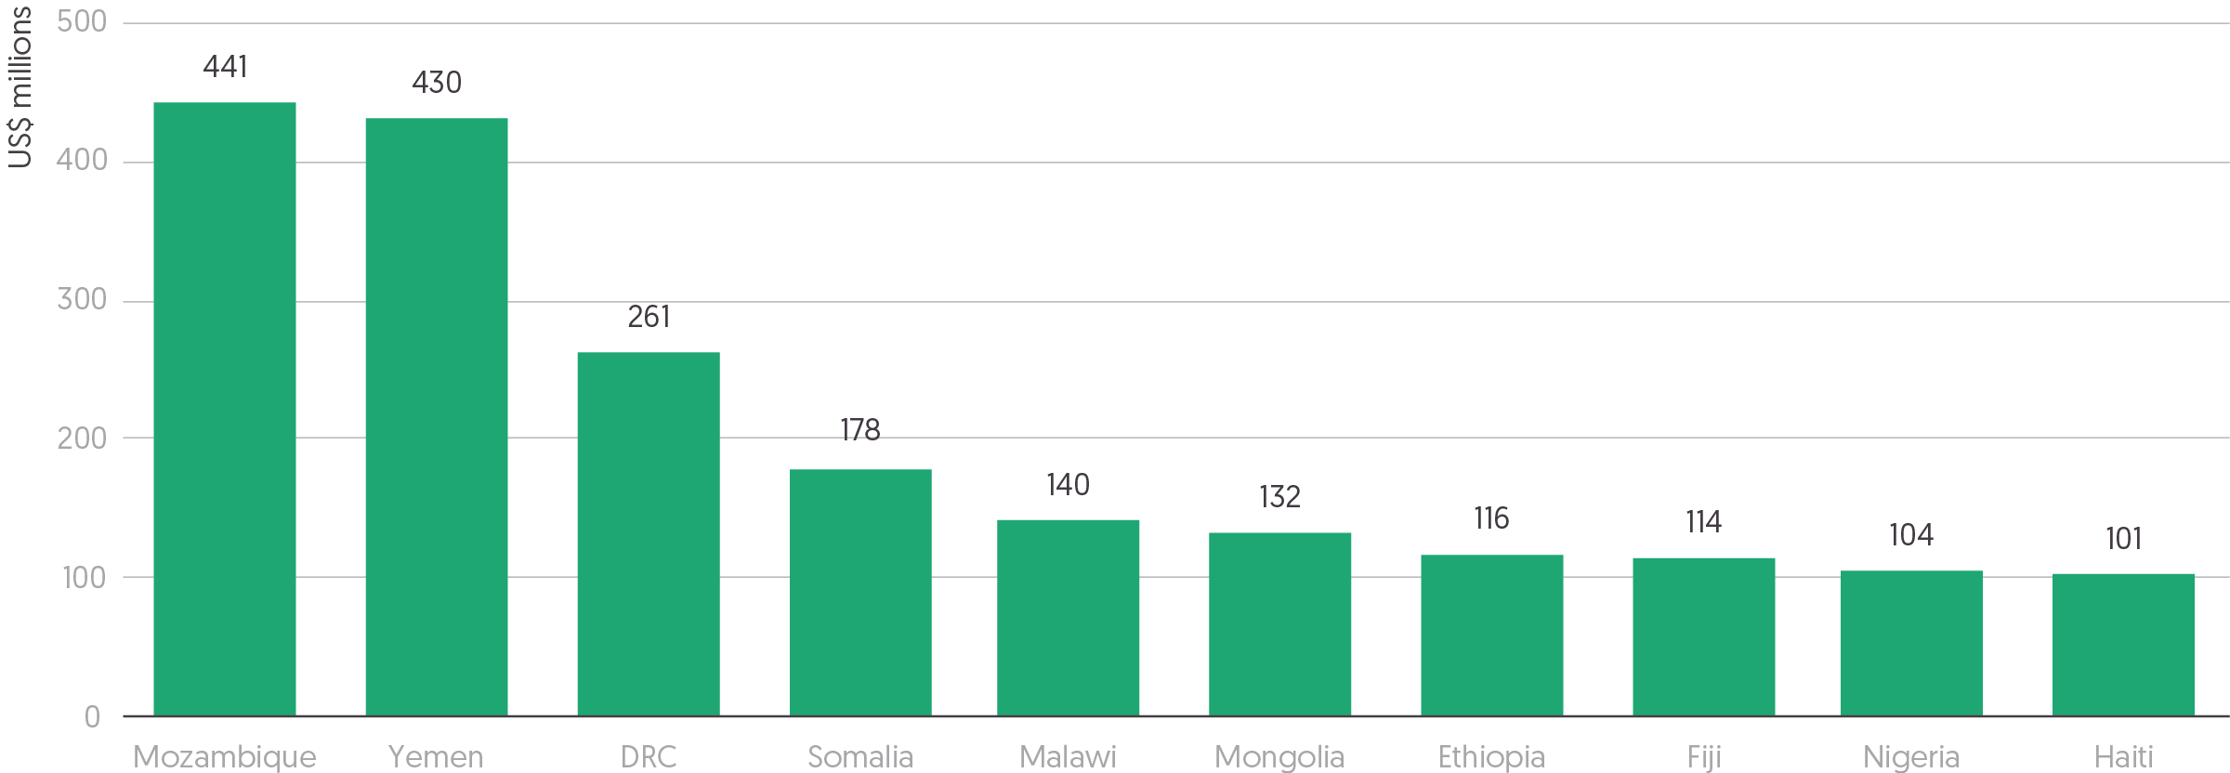

Source: Development Initiatives based on World Bank data. International Development Association (IDA) country allocations for financial year (FY) 2021; IDA country allocations for FY20; IDA country allocations for FY19; IDA country allocations for FY18; IDA country allocations for FY17.[70], [71], [72], [73], [74]

Notes: DRC = Democratic Republic of the Congo. Data is in current prices.

##### Objective

The CRW provides rapid resources to countries experiencing severe crises and contributes to coordinated international responses.[75] It aims to prevent emergencies from diverting finances away from work to achieve longer-term development goals, as well as to avert and mitigate future crises.The CRW was piloted under IDA15 to address the repercussions of the global financial crisis. Under IDA16 in 2010, it was formally established, and natural disasters were included under its remit; in 2014, following the Ebola outbreak, it was further expanded to cover public health emergencies.[76] Since IDA19, the CRW has been equipped with an early-response financing mechanism to cover slower-onset crises such as disease outbreaks and food insecurity.

##### Financing

CRW financing is provided in the form of grants and loans at concessional rates. The total volumes available for the CRW, capped at 5% of IDA financing,[77] have risen from US$1 billion[78] for IDA16, to US$2.5 billion under IDA19 (with up to US$1 billion for the early response financing framework)[79] and US$3.3 billion allocated for IDA20 (US$1 billion for early financing).[80]

##### Eligibility

All IDA countries are eligible for CRW support, but allocation is based on the magnitude of the crisis. Eligibility for early-response financing to slower-onset crises depends on countries having in place (or confirming they will develop) credible preparedness plans. IDA’s board of executive directors approves financing requests.The CRW stands out among World Bank financing tools as a rapid mechanism (see [Figure 3.5 in the *Global Humanitarian Assistance Report 2021*](https://devinit.org/c1ed3e#f85f92c8)), as it allocates and disburses funds faster than the regular IDA allocation framework, with an average time from concept note review to first disbursement below six months.[81]

Relevance for humanitarian responders

**Locations:** In 2021, CRW financing was provided to 20 countries. Nine of these (Afghanistan, Cameroon, the Central African Republic, Ethiopia, Mozambique, Nigeria, Somalia, South Sudan and Yemen) had humanitarian response plans in the same year and two (Uganda and Zambia) were part of RRRPs.[82]

**Types of programming:** CRW financing is directed at borrower governments. However, in some cases, humanitarian actors can implement projects. For example, in 2015 during the Ebola response, the CRW supported the UN International Children’s Emergency Fund, the World Health Organization, the UN Population Fund and the World Food Programme, to carry out contact tracing and food deliveries.[83]

**Coordination**: The World Bank sits on the Senior Steering Group of the Global Network Against Food Crises, an alliance of humanitarian and development actors focused on tackling the root causes of food security crises and preventing and mitigating food security crises. The network facilitates data-sharing, the mainstreaming of food-security crisis preparedness in countries receiving CRW Early Response Financing, and the strengthening of coordination between humanitarian assistance and longer-term development outcomes.

#### IDA Window for Host Communities and Refugees

Figure 3.8: Uganda and Bangladesh have received approximately US$500 million respectively over the past 4 years for their refugee responses

International Development Association Window for Host Communities and Refugees, Top 10 recipient countries 2018−2021

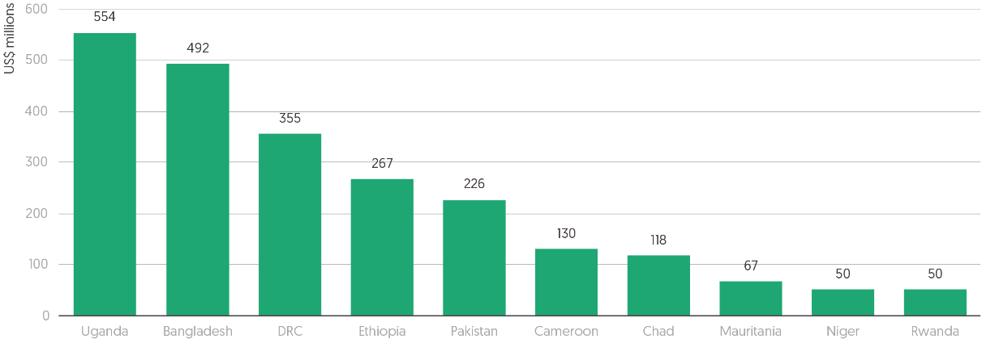Source: Development Initiatives based on World Bank data. Data compiled from financial years (FYs) 2018−2021 International Development Association (IDA) commitments by country and windows.[84]  
Notes: DRC = Democratic Republic of the Congo. Data is in current prices.

##### Objective

The Window for Host Communities and Refugees (WHR) aims to create long-term development opportunities in countries hosting refugees. Introduced in 2017, the window promotes inclusive growth for refugees and host communities in protracted situations, responds to new displacement flows and supports policy changes for refugee protection, integration and/or other relevant durable solutions. The window was established during the formation of the Global Compact on Refugees and marked new strategic collaboration between the World Bank and UNHCR on displacement.[85]

##### Financing

WHR financing is available as either grants or loans, depending on the country’s risk of debt distress.

* US$2 billion was allocated to the window under IDA18 (2.6% of total IDA).[86]
* US$2.2 billion was allocated under IDA19 (2.7% of total IDA).[87]
* Under IDA19, a dedicated sub-window of US$1 billion was included for programming responding to the impacts of the Covid-19 pandemic.
* US$2.4 billion has been allocated for IDA20 (2.6% of total IDA).[88]

##### Eligibility

WHR funding is available for IDA countries that: (1) host at least 25,000 refugees, or at least 0.1% of the country’s population; (2) adhere to a framework for the protection of refugees (assessed in coordination with UNHCR); and (3) have an action plan involving the strengthening of the policy and institutional environment for refugees and host communities.

Relevance for humanitarian responders

**Locations:** In 2021, Burundi, Chad, the Democratic Republic of the Congo, Djibouti, Ethiopia, Rwanda and Uganda received resources from the WHR. All of these countries are covered by an HRP or RRRP. To date, countries in South Asia, the Middle East and Africa have received Refugee Sub-Window (the predecessor to the WHR) and WHR financing, and there are currently 17 eligible countries.

**Types of programming:** Operations supported focus on medium- to long-term development challenges, with support to health and education services, energy infrastructure and livelihoods. Examples from 2020 and 2021 include investments in education, health, water and sanitation in Burundi, improvements to informal housing in areas hosting refugees in Djibouti,[89] cash programming and livelihood opportunities in Chad.[90]

**Coordination:** UNHCR supports the assessment of national refugee protection frameworks, and evaluates progress made on providing access to fundamental rights such as movement, education and housing, enabling the World Bank to identify opportunities for reform. The window has successfully supported policy changes for strengthened refugee protection across several contexts.[91]

### Emergency mechanisms and instruments

The World Bank provides what it terms ‘development policy loans’ to the general budgets of national governments, to support policy reforms and institutional reform processes, rather than specific projects.[92] Tools and features, such as the Catastrophe Deferred Drawdown Option (discussed below) and the Contingent Emergency Response Component, are built into these loan arrangements, so that when an emergency arises, financing from these development policy loans can be re-purposed or rapidly disbursed to support an immediate response.

#### Catastrophe Deferred Drawdown Option (Cat DDO)

##### Objective

The Catastrophe Deferred Drawdown Option (Cat DDO) enables countries to seek rapid financing proactively, before a natural or health-related disaster hits. CAT DDOs are aimed at developing and enhancing the capacity of borrowers to manage natural hazard risk, while providing a source of immediately available liquidity that could serve as bridge financing while other sources are being mobilised following a natural disaster. Financing is disbursed only once a drawdown trigger (such as the declaration of a state of emergency) is activated. Resources then become available within weeks or even days of activation, enabling countries to respond to immediate humanitarian needs before mobilising longer-term financing for reconstruction and rehabilitation, and without compromising funding for longer-term development goals.

##### Financing

Cat DDOs are options pre-agreed in development policy loans, released only in the event of a catastrophe. IDA countries can secure budget support of up to US$250 million, or 0.5% of GDP (whichever is lower).[93]

##### Eligibility

Cat DDOs were initially created in 2008 for middle-income countries for seismic and hydro-meteorological events, but were expanded to cover low-income countries and public-health-related shocks in IDA18. To be eligible, countries must have an adequate macroeconomic policy framework and a disaster risk management programme. Financing is available for three to six years.

Relevance for humanitarian responders

Locations: Cat DDOs were disbursed throughout 2020 to support countries in their Covid-19 responses,[94] but comprehensive data on where Cat DDOs operate is not publicly available. Some examples: in late 2021, the Philippines received US$80 million to respond to Typhoon Rai; and in early 2022, Tonga received US$8 million following the eruption of the Hunga Tonga volcano, from a pre-arranged line of credit through the Cat DDO.[95]

### Financial intermediary funds

Separate from the IDA financing system, the World Bank also hosts several financial and partnership platforms to provide global public goods or tackle broad themes (such as climate change, health, education and crisis response). These platforms, known as financial intermediary funds (FIFs), support projects implemented by several actors, including multilateral development banks and/or UN agencies. The World Bank often hosts FIF secretariats, as well as providing financial, investment and technical services.[96]

#### Global Concessional Financing Facility

Figure 3.9: US$1 provided through the Global Concessional Financing Facility can leverage US$5 in concessional loans

Global Concessional Financing Facility, Project Funding, June 2021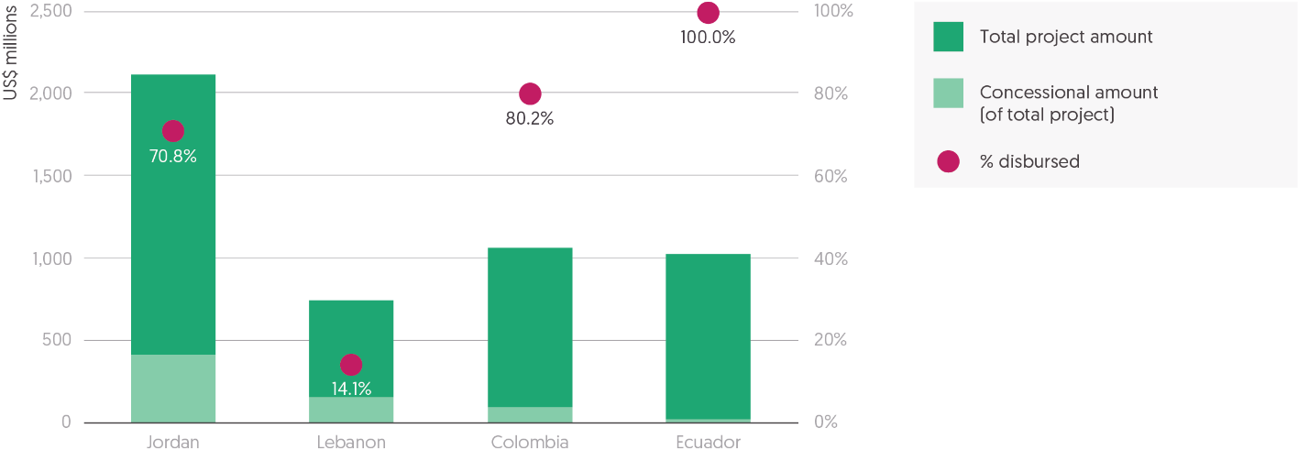

Source: Development Initiatives based on World Bank data. Data compiled from Global Concessional Financing Facility (GCFF) 2020 annual report.[97]  
Notes: Data is in current prices.

##### Objective

One of the relevant FIFs for crisis response is the Global Concessional Financing Facility (GCFF), which provides development financing for middle-income countries affected by refugee crises. The GCFF was launched in 2016 in response to the growing Syrian refugee crisis, and expanded in 2019. Funds are intended for development projects that benefit refugees and host communities.

##### Financing

The GCFF fills an important gap for countries often unable to access loans at concessional rates traditionally reserved for lower-income countries, and that may be unable to spend national resources or take on additional debt to support refugees. Donor contributions reduce the cost of borrowing to highly concessional levels. In exceptional cases, the facility can also provide grant funding, and a private sector funding modality is also currently being piloted in Jordan.

* Since 2016, total contributions to the GCFF have amounted to US$831 million,[98] of which US$773 million has been allocated to support lending on concessional terms.[99]
* This has leveraged over US$5 billion in concessional financing[100] (US$1 dollar from donors can leverage US$5 dollars in concessional loans).

##### Implementation

The World Bank provides trustee and secretariat services, and manages GCFF financing alongside the Islamic Development Bank, the European Bank for Reconstruction and Development, the European Investment Bank and the Inter-American Development Bank. Canada, Denmark, the European Commission, Germany, Japan, the Netherlands, Norway, Sweden, the United Kingdom and the United States provide the grants that unlock concessional financing. Allocation decisions are made by the GCFF steering committee.

Relevance for humanitarian responders

**Locations:** Since the GCFF launch in 2016, loans have been provided in response to the Syrian refugee crisis in Jordan and Lebanon, the Venezuelan displacement crisis in Colombia and Ecuador, and most recently the Ukrainian refugee crisis in Moldova. All five countries are included in RRRPs.

**Types of programming:** Support has been allocated to capacity-building of wastewater, healthcare, education and electricity infrastructure in Jordan, and of roads, public transport and healthcare in Lebanon, to deal with rising needs due to the rapid influx of Syrian refugees.In Colombia, financing has been provided to regularise the status of over 260,000 Venezuelan migrants and refugees, enabling them access to the job market.[101]

**Coordination:** The steering committee provides a platform for humanitarian–development coordination, bringing together participating countries, donors, implementing agencies and the UN, in particular UNHCR, the UN Development Programme and the relevant UN Resident Coordinators.

#### Global Risk Financing Facility

##### Objective

Another relevant FIF is the Global Risk Financing Facility (GRiF), set up in 2018 to support countries in managing climate risks and shocks. The facility, supported by the United Kingdom and Germany, promotes the development of pre-arranged financing instruments, such as insurance, derivatives, catastrophe bonds, contingent finance and budget reserves. While the GRiF does not directly disburse funding for these financing instruments, it provides grants and technical expertise and leverages private sector support, and therefore lowers the barriers that prevent countries from accessing them. It also supports countries to include financial planning and climate risk management in their development agendas.

##### Financing

* In financial year (FY) 2021, US$238 million was contributed to the facility, US$204 million of which was allocated to projects.[102] There are 38 projects currently in development.
* Seven of these projects deal with risks arising in fragile, conflict-affected or violent situations.

##### Eligibility

Application for GRiF grants is led by World Bank country teams. Up to US$200,000 in preparation funds are available for the scoping phase of the project, after which a concept note can be prepared. GRiF grants are endorsed by the steering committee (led by the World Bank, Germany and the United Kingdom) and awarded by its secretariat.[103]

Relevance for humanitarian responders

**Locations:** Country projects have been awarded to nine countries, of which three have HRPs (Burkina Faso, the Democratic Republic of the Congo and Mozambique) and one is covered by an RRRP (Rwanda) in 2021.[104]

**Types of programming:** Examples of GRiF projects include financing and technical assistance worth US$8 million, provided in 2019 to Mozambique to strengthen its resilience to disasters. In 2021, US$8.5 million was approved for Rwanda, co-financing a US$150 million World Bank operation, to provide insurance to low-income farmers against climatic shocks.

**Funding for humanitarian actors:** The GRiF also provides support to humanitarian actors engaging in climate crises. For example, in 2021, the GRiF issued a grant to the Start Network, to support the design of the Start Financing Facility which provides risk financing for humanitarian NGOs.[105] The GRiF has catalysed work on early financing with Red Cross Red Crescent national societies in Southeast Asia and with the World Food Programme.

### Trust funds

Resources relevant for crisis response can also be found in the World Bank’s portfolio of trust funds (529 active accounts in 2021).[106] Trust funds are financing arrangements hosted by the World Bank in which one or multiple donors pool contributions, with the intention of scaling up grant funding for coordinated action.[107] They are used for individual crises and countries, and for catalysing global public goods. Programmes include tackling climate change, promoting equitable growth and supporting infrastructure. Among the largest World Bank trust funds are the Afghanistan Reconstruction Trust Fund (which disbursed US$3.9 billion between FY2017 and FY2021), the Global Financing Facility, Carbon Finance and the Global Facility for Disaster Reduction and Recovery.[108] In 2021, US$3.8 billion was disbursed from World Bank trust funds.[109]

#### State and Peacebuilding Fund

**Figure 3.10: A third of new State and Peacebuilding Fund projects in 2020 overlapped with coordinated humanitarian responses**

State and Peacebuilding Fund, New projects activated in 2020 with a humanitarian focus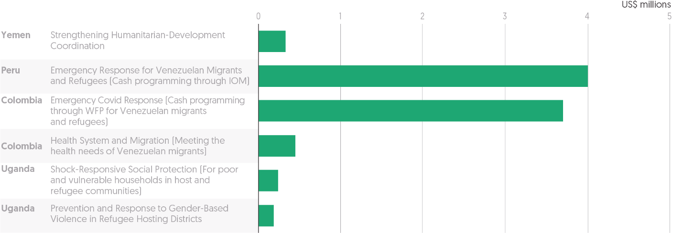

Source: Development Initiatives based on World Bank data. Data compiled from State and Peacebuilding Fund (SPF) annual report 2020.[110]

Notes: IOM = International Organization for Migration; WFP = World Food Programme. Data is in current prices.

##### Objective

The State and Peacebuilding Fund (SPF) is the World Bank’s largest global multi-donor trust fund supporting the implementation of its FCV strategy. The SPF focuses on four priorities: preventing violent conflict and interpersonal violence; remaining engaged during conflict and crisis situations; helping countries transition out of fragility; and mitigating the effects of fragility, conflict and violence.[111] The SPF’s cross-cutting priorities are supporting the most disadvantaged and vulnerable people, and systematically addressing gender-based inequalities.

##### Financing

Funding is provided as grants for either full-scale projects or project components. The SPF is supported by nine donors (Australia, Denmark, France, Germany, the Netherlands, Norway, Sweden, Switzerland and the United Kingdom) and the International Bank for Reconstruction and Development.

* The total fund value of the SPF since 2009 has been US$376.4 million.
* The current total active portfolio stands at US$43.5 million.
* 20 new grants totalling US$15.3 million were added to the SPF portfolio in 2020.
* 25 grants were approved in 2021.[112]

##### Eligibility

All developing countries and territories facing challenges related to FCV are eligible. This means that SPF funding is available for countries with no access to IDA or International Bank for Reconstruction and Development financing or that are in arrears (breach of contractual obligation to repay loans). For example, in 2020, Sudan had no IDA funding due to being in arrears but was able to access US$7 million in seed funding for the Sudan Emergency Covid-19 Health Response project through the SPF.[113]

The SPF secretariat supports the development of proposals, which are elaborated by World Bank task teams and approved on a rolling basis by the technical advisory committee in five business days. Emergency approval can be provided for rapid assessments of disasters and reconstruction needs in three days. This rapid mechanism was used to process financing for a rapid damage and needs assessment following the explosion in Beirut in 2020.[114]

Relevance for humanitarian responders

**Locations:** Of the 19 new projects activated in 2020, 12 were in countries with an HRP or RRRP.

**Types of programming:** Six of the new projects in 2020 had a humanitarian focus or response, including: cash programming for improving the health of Venezuelan migrants and refugees in Colombia and Peru; and prevention of and response to gender-based violence in refugee-hosting districts in Uganda.

**Implementation:** Activities are executed directly by governments (42% of the total volume of SPF grants) or by UN agencies, regional organisations, NGOs and academic institutions (30%). The SPF also provides grants specifically for the World Bank to execute, for assessments, partnership-building and policy dialogue (21%).[115]

## Development financing for disaster risk reduction

Figure 3.11: **The top five donors account for the largest share of disaster risk reduction (DRR) funding, but other donors were responsible for large increases**

Largest donors to DRR and disaster preparedness, 2018–2020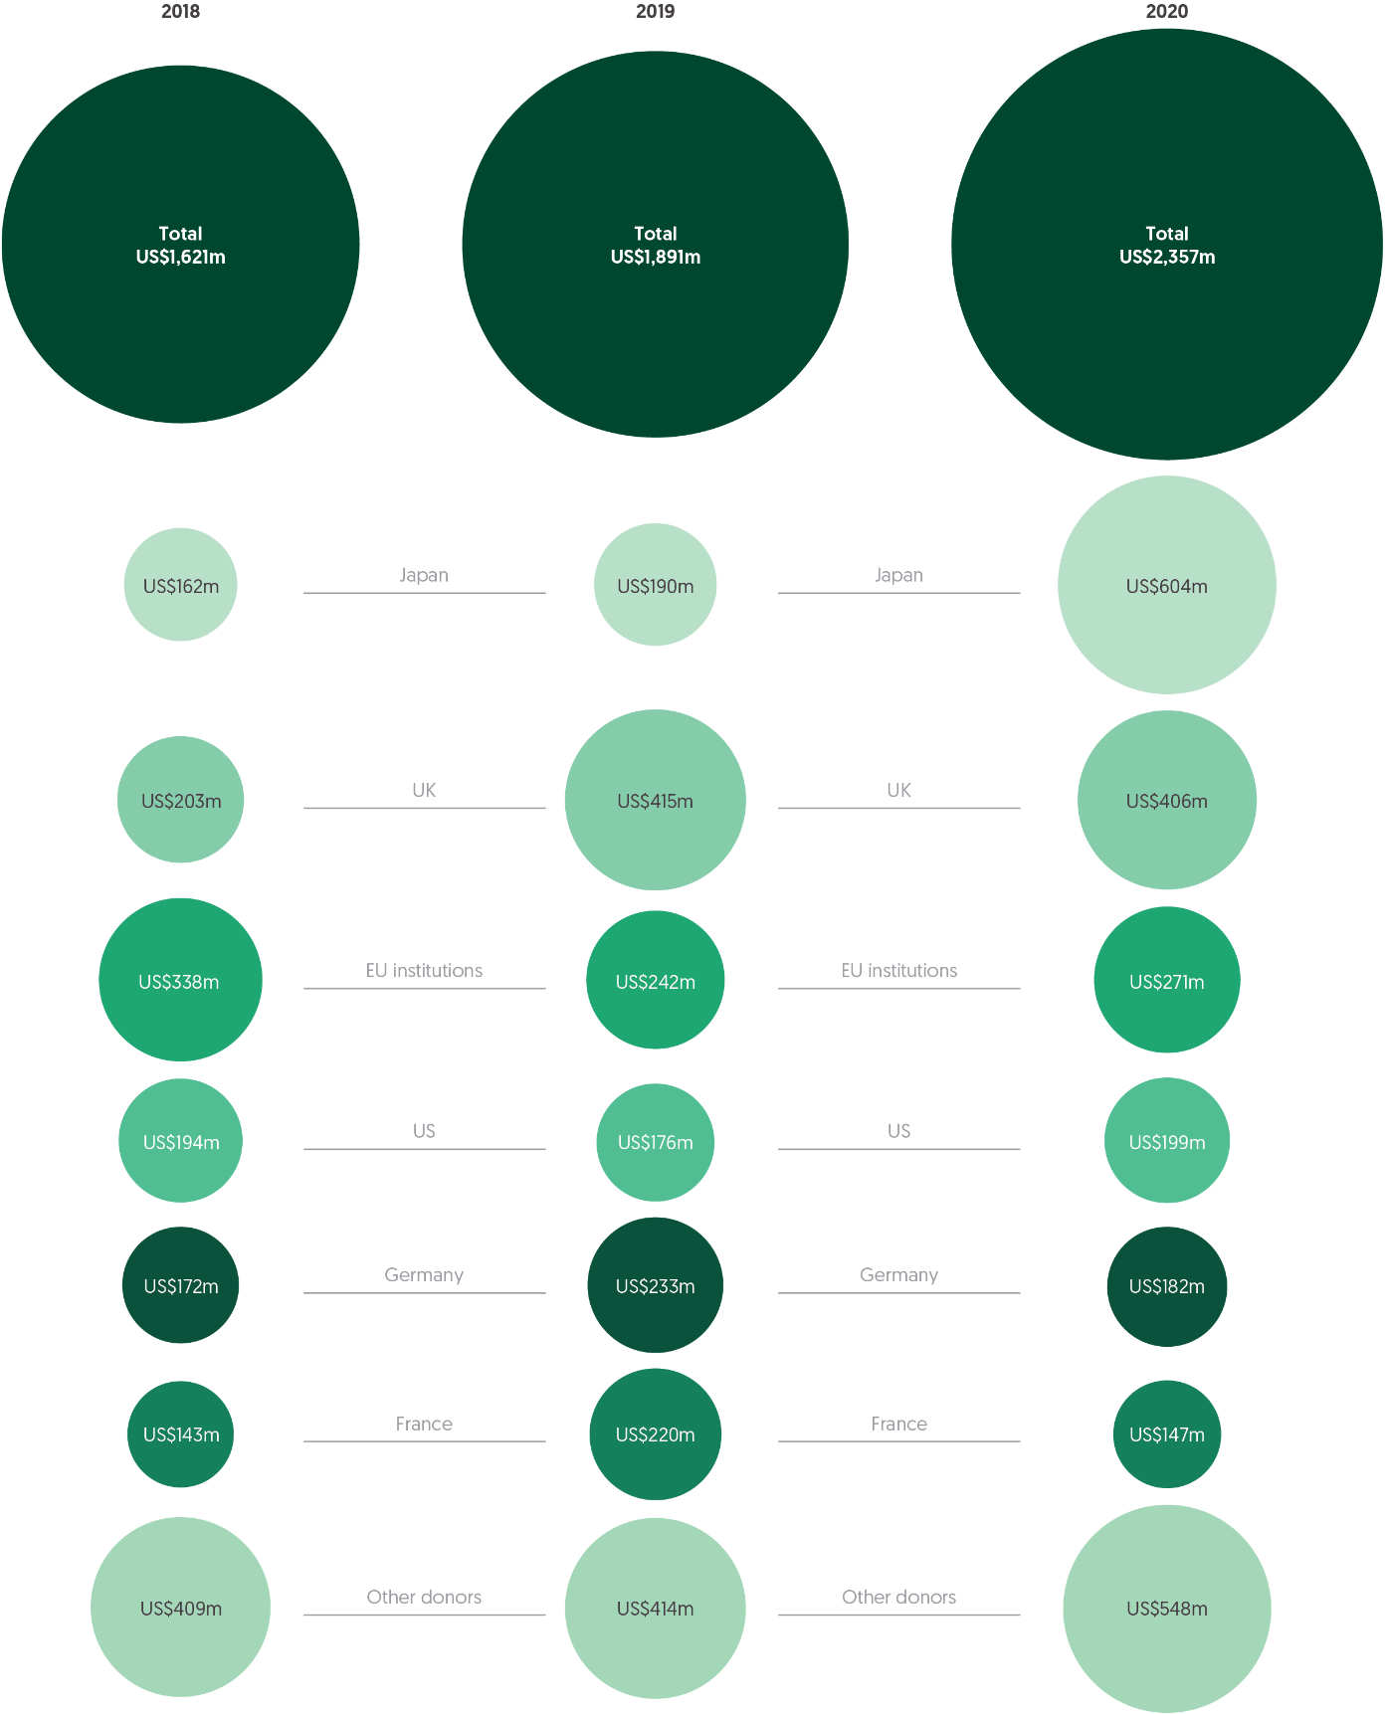

Source: Development Initiatives based on Organisation for Economic Co-operation and Development (OECD) Development Assistance Committee (DAC) Creditor Reporting System (CRS).

Notes: Official development assistance (ODA) totals are calculated from projects under the disaster risk reduction (DRR) purpose code, marked as 'principal focus' with the DRR marker, or identified by a tailored keyword search. Figures include country-allocable ODA only. Excludes ODA targeted to Covid-19. Data is in constant 2020 prices.

Disaster risk reduction (DRR) aims to substantially decrease the impacts of a potential disaster by increasing the existing capability of a country to respond, regardless of whether the disaster is small- or large-scale, frequent or infrequent, sudden or slow-onset, caused by natural or human-made hazards, or classified as environmental, technological or biological.[116] DRR funding is specifically focused on reducing hazard exposure or vulnerability to a disaster, increasing preparedness and response across sectors, and strengthening resilience. It does this through developing infrastructure (such as early-warning systems), mapping risk and providing training on disaster management.

In 2021, half of all people in need of humanitarian assistance were living in countries with high levels of vulnerability to the impacts of climate change (see ‘Humanitarian need and intersecting dimensions of risk’, Chapter 1). DRR is conceived as a wider developmental intervention, and reaching populations in need of humanitarian assistance is not a specific objective. However, it is a potentially important anticipatory element of existing approaches to limit the impact of climate change in contexts vulnerable to, or experiencing, humanitarian crises.

DRR funding can be delivered through targeted interventions or mainstreamed as secondary elements of wider programmes. Data on all DRR funding is not consistently or widely reported, nor is it easy to identify the types of interventions this funding supports. However, there has been an increased focus on DRR in recent years.[117] 2020 was an important evaluation milestone for the UNDRR Sendai Framework commitments for DRR national strategies and, since 2018, it has been possible to report to the OECD DAC, using a specific marker, projects which have DRR as a primary objective. There is therefore an emerging picture of donor trends related to ODA funding with the primary purpose of DRR, likely to become more complete as the marker becomes institutionalised.[118]

Between 2018 and 2020, there was a significant rise in the volume of ODA with the primary purpose of DRR, and an overall pattern of growth has been sustained by funding from a consistent group of donors. Fluctuations in the amounts from the largest donors in the past two years have been compensated for by increased contributions from a handful of smaller donors.

* Between 2018 and 2020, ODA with the primary purpose of DRR increased 45% from US$1.6 billion to US$2.4 billion, with a total of US$5.9 billion over three years.
* The UK was the largest donor of ODA with the primary purpose of DRR between 2018 and 2020, responsible for 18% (US$1.0 billion) of total funding, US$69 million more than the second-highest donor, Japan, in the same period.
* In 2020, Japan provided the highest amount of ODA with a primary purpose of DRR (26% of the total, US$604 million), almost tripling the volume of assistance provided (an increase of 218%, or US$414 million). In 2020, Japan gave 49% ($198 million) more in funding than the second-highest donor, the UK ($406 million). Almost two thirds of Japan’s funding went to just two countries, Indonesia and the Philippines, driving very large increases and accounting for nearly all DRR funding received by these countries. Japanese funding to Indonesia increased between 2019 and 2020 from US$20 million to US$324 million (accounting for 94% of the total US$346 million received), and to the Philippines from US$42 million to US$121 million (accounting for 83% of the total of US$145 million received).
* The top six donors accounted for over half (55%, US$1.8 billion) of all ODA with the primary purpose of DRR between 2018 and 2020. During this period, the six largest donors have remained constant: the UK, Japan, Germany, EU institutions, the US and France.
* Between 2019 and 2020, 16 donors increased the amount of ODA with the primary purpose of DRR. Australia and Canada showed the second- and third-highest increases in volume, with rises of US$51 million (442%) and US$31 million (259%), respectively. Other countries saw large proportional increases, including Finland, (462%, from US$2.5 million to US$14 million), Poland (212%, from US$1.4 million to US$4.5 million) and Hungary (12,530%, from US$245,000 to US$31 million).
* Between 2019 and 2020, 12 donors decreased the amount of ODA with the primary purpose of DRR. These donors included France (decrease of US$73 million) and Germany (decrease of US$51 million), both among the six largest donors of 2018–2020.

There is growing recognition of the need to join up complementary commitments to reduce climate vulnerability and build the resilience necessary to reduce the negative impacts of climate change, which in turn drive or worsen humanitarian crises.[119]

Where DRR funding is targeted is potentially significant for humanitarian response. Where natural disasters occur and drive wider crisis, humanitarian assistance will be drawn to meet these impacts. Initial analysis suggests that the countries receiving large amounts of DRR are at high risk from natural disaster.[120] The absolute risk of natural disaster may not necessarily need to be high for a natural disaster to have a significant impact – where there is a lack of coping capacity and infrastructure to respond, plus wider political and socioeconomic fragility. The overall risk of crisis is therefore important when considering where ODA with the primary purpose of DRR is targeted, and its potential contribution to lessening the need for humanitarian assistance.

In 2020, countries at highest **overall**risk from a crisis – a calculation that includes the probability of conflict, socioeconomic fragility and the ability of institutions to respond adequately to crisis[121] – received a smaller proportion, and a smaller proportional increase, than other countries of total ODA with the primary purpose of DRR. Only 3 of the 10 countries identified as at ‘very high’ overall risk of a crisis were among the 10 largest recipients of ODA with the primary purpose of DRR, and in some cases their allocations decreased. Overall, the volume of funding received by countries at very high risk of crisis was small.

* Countries identified as at ‘very high’ overall risk of a crisis received US$280 million (12%) of ODA with the purpose of DRR, an increase of 14% (US$35 million) from 2019.
* Of those countries at highest risk of crisis and receiving larger volumes of ODA with the primary purpose of DRR, Ethiopia experienced a 46% year-on-year increase to US$42 million in DRR financing, while Somalia and the Democratic Republic of the Congo both experienced an overall decrease in the amount of ODA with the primary purpose of DRR in 2020 (by 18% to US$48 million, and by 11% to US$66 million, respectively).

The smaller volumes reaching countries at high risk of crisis may be determined partly by the nature of DRR funding, as it requires the existence of supportive infrastructure to deliver against most objectives.[122] Those most likely to become dependent on humanitarian assistance in the event of a disaster are also among those least likely to have infrastructure to support disaster preparedness.

Chapter 4

Recipients and delivery of humanitarian funding

With historically high levels of humanitarian need and enduring unresolved crisis in more countries, driven by the continued impacts of the Covid-19 pandemic and climate change, the imperative to deliver assistance more effectively and efficiently is stronger than ever. This chapter highlights where assistance is being targeted and the progress made to improve the funding of humanitarian response.

Most international humanitarian assistance was allocated to a small number of crises in 2021. The 10 largest recipients received 60% of country-allocable international humanitarian assistance, with Yemen receiving the largest volume of support, US$2.7 billion (12% of all funding). Most humanitarian assistance is targeted to countries experiencing protracted crisis, with these accounting for 86% (US$20.1 billion) of all country-allocable humanitarian assistance.

Efforts to reform the delivery of humanitarian assistance continued in 2021 but progress on Grand Bargain priorities remains uneven. Significantly less funding was provided directly to local and national actors in 2021. Following an increase in 2020, direct funding reduced by almost two thirds, to the lowest volume (US$302 million) and proportion (1.2%) of total international humanitarian assistance in the previous five years. Funding increases in 2020 to local and national actors (primarily national governments) for the health sector and Covid-19 response were not sustained in 2021.

UN-managed pooled funds have grown in importance within the humanitarian system, with funding increasing in 2021. Total funding to UN pooled funds rebounded from a sharp decline in 2020, growing by 10% to US$1.6 billion. Pooled funds accounted for 6.0% of all assistance, up from 4.2% in 2014. For the first time, country-based pooled funds received over US$1 billion, with funding increasing by 21% (US$184 million) from 2020.

Reaching a critical mass of quality funding is a key priority of Grand Bargain 2.0, with flexibility recognised as a central feature of quality funding. However, the proportion of unearmarked funding received by nine UN agencies declined to its lowest level in six years of tracking, falling to 13% of total funding received, following an increase in 2020.

More positively, funding provided as cash and voucher assistance (CVA), which can empower recipients and provide them with choice in how best to meet their needs, continued to grow. Preliminary data on global humanitarian CVA shows that the volume transferred to recipients rose to US$5.3 billion in 2021, an increase of 3.7% from 2020. When final accounts are complete, CVA is likely to have accounted for 21% of total international humanitarian assistance in 2021. Of this CVA assistance, most continued to be provided as cash (71%) rather than in-kind assistance.

## Which countries did humanitarian assistance go to?

Figure 4.1: In 2021, Yemen was the largest recipient, as assistance to Afghanistan grew rapidly  
10 largest recipients of international humanitarian assistance, 2020−2021

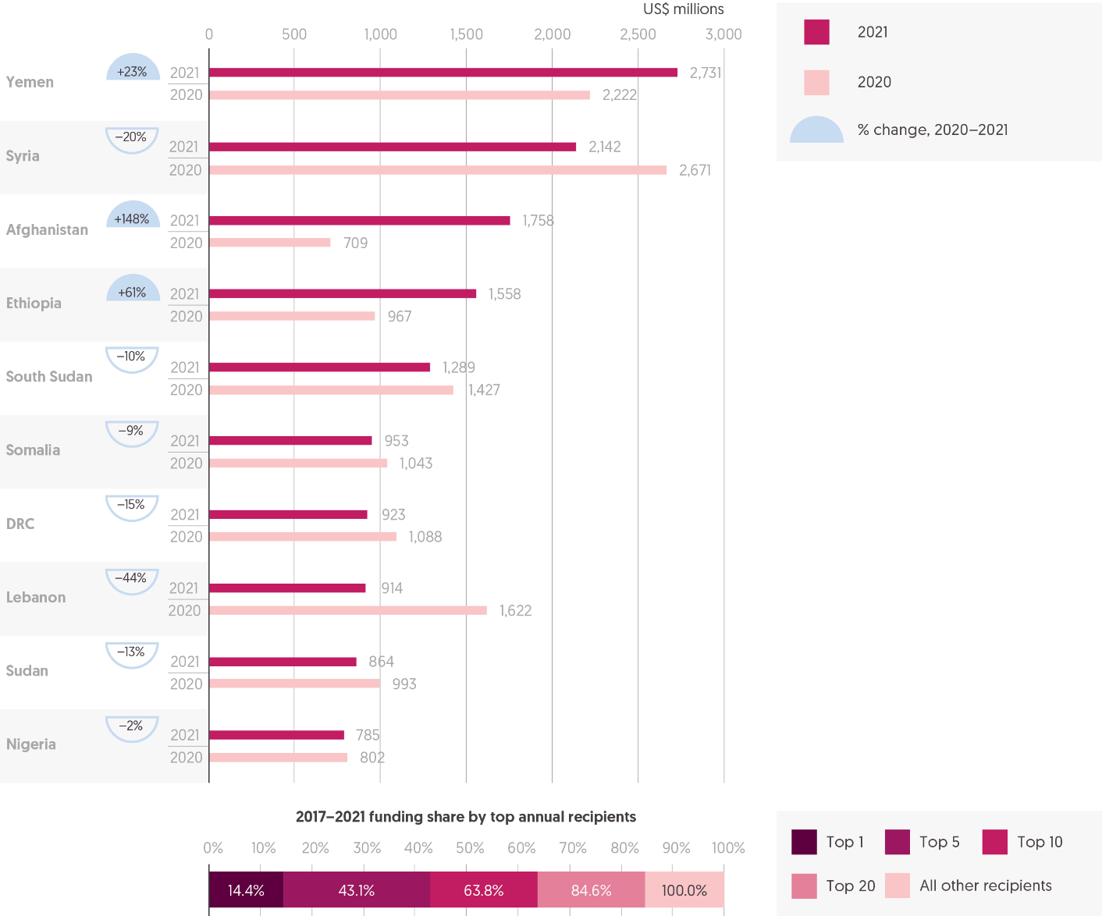

Source: Development Initiatives based on UN Office for the Coordination of Humanitarian Affairs (OCHA) Financial Tracking Service (FTS) data.

Notes: DRC = Democratic Republic of Congo. Data is in constant 2020 prices. Totals for previous years differ from those reported in previous Global Humanitarian Assistance reports due to deflation and updated data.

In 2021, the number of countries receiving international humanitarian assistance decreased. The 10 largest recipients accounted for a greater share of total funding than in 2020. Most humanitarian assistance was allocated to countries experiencing protracted crisis.

* In 2021, 144 countries received some international humanitarian assistance, 20 fewer than in 2020. Of these countries, 108 received more than US$1 million (33 fewer than in 2020) and 84 received more than US$5 million (27 fewer than in 2020).
* Countries experiencing protracted crisis – with five or more years of consecutive UN-coordinated appeals – accounted for 86% (US$20.1 billion) of all country-allocable humanitarian assistance in 2021.

The make-up of the group of 10 largest recipients changed little in 2021, as has typically been the case in recent years. The proportion of total country-allocable humanitarian assistance per year channelled to the 10 largest recipients grew in 2021 but has varied relatively little over the past decade.

* In 2021, the 10 largest recipients received 60% of country-allocable international humanitarian assistance, a slight increase from 58% in 2020. However, this was below the average of 64% over the past five years.
* Two countries entered the group of 10 largest donors in 2021 – Afghanistan and Nigeria – displacing Turkey and Iraq (the first time since 2013 in which Iraq is not among the 10 largest recipients).
* Over time, the make-up of the group of 10 largest recipients has changed relatively little. Just 14 countries appeared in this group in the past five years (2017−2021); with seven countries – South Sudan, Somalia, Syria, Lebanon, Ethiopia, Yemen and DRC—present every year over this period.

Following two years of consecutive, large decreases in funding in 2019 and 2020, more assistance was channelled to Yemen, once again making it the largest recipient of financial support.

* In 2021, Yemen received US$2.7 billion, 23% more than in 2020, though still substantially less than peak funding to the country in 2018 of US$4.8 billion. The assistance provided to Yemen accounted for 12% of all country-allocable funding, slightly lower than the average for the past five years of 14%.
* Funding to Syria fell in 2021 to US$2.1 billion, a decrease of 20% (US$529 million) from 2020.
* The most notable increase in funding was to Afghanistan, as the Taliban take-over of the country caused the humanitarian situation to deteriorate drastically. In 2021, the volume of international humanitarian assistance provided to Afghanistan more than doubled from US$709 million in 2020 to US$1.8 billion.
* Assistance to Ethiopia also grew considerably in 2021, from US$967 million to US$1.6 billion.
* The most significant decrease in funding was to Lebanon, by 44% (US$708 million) to US$914 million.

## Channels of delivery

Figure 4.2: Patterns of funding remain unchanged  
Channels of delivery of international humanitarian assistance from public donors, 2020−2021

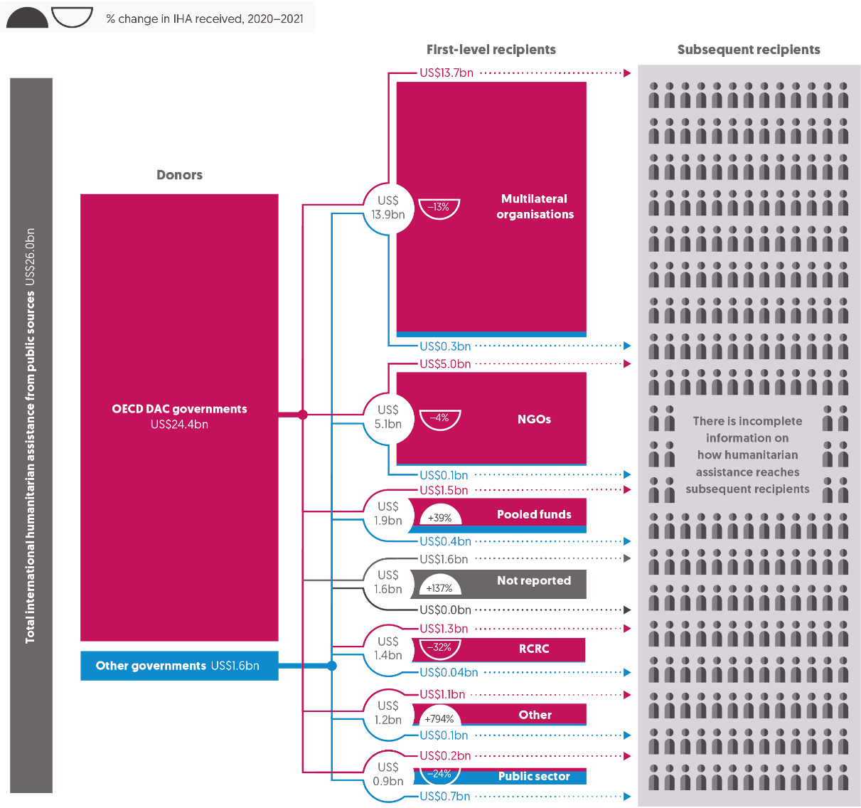

Source: Development Initiatives based on UN Office for the Coordination of Humanitarian Affairs (OCHA) Financial Tracking Service (FTS) data.

Notes: RCRC = International Red Cross and Red Crescent Movement. Data is in constant 2020 prices. Figures include first-level recipient data from government sources (DAC and other governments) and EU institutions as reported on UN OCHA’s FTS. Data for private humanitarian assistance is not included, as figures collected via DI’s manual data collection annual exercise are available only up to 2020. 'Pooled fund' refers to funding to UN Central Emergency Response Fund (CERF), Country-Based Pooled Funds (CBPFs) and other pooled funds. ‘Public sector’ refers to funding to national governments and inter-governmental organisations. The following categories of: Academia/think/research, Foundations, Other, Private individual/organisation, Private organisation/foundation, Private sector corporations and Undefined have been merged under ‘Other’.

Despite many years of rhetorical commitments to alter funding behaviour, the patterns of funding from public donors have not changed in the past decade, with only minor shifts evident year-on-year. Funding to multilateral organisations reduced as a proportion of total assistance in 2021 but still constitutes the majority of assistance from public donors. As in previous years, funding preferences differ between public and private donors (see Figure 3.4, Chapter 3).

* In 2021, funding to multilateral organisations accounted for 54% of total international humanitarian assistance, down from 60% in 2020. The average over the past 10 years is 56%.
* By volume, funding to multilateral organisations reduced to by US$2.0 billion to US$13.9 billion, returning to 2019 levels.
* Non-governmental organisations (NGOs) were the second-largest recipients of funding from public donors, receiving 19% of total contributions. This represented a slight fall by volume from 2020, from US$5.3 billion to US$5.1 billion. In 2020, NGOs’ receipt of 20% of all international humanitarian funding was the highest proportion of the past 10 years.

DAC donors continue to provide the vast majority of international humanitarian assistance (see Figure 3.1, Chapter 3). The volume of funding from non-DAC donors increased markedly in 2014 – driven primarily by increases in assistance from Saudi Arabia and the UAE – and has fluctuated by volume and as a proportion of total international humanitarian assistance from public donors. The funding preferences of non-DAC governments have varied more year-on-year than those of DAC donors. Reporting by non-DAC countries is voluntary and not reconciled as DAC member reporting is, so consistency of reporting may influence year-on-year variations to some degree.

* In 2021, DAC donors accounted for 94% of all assistance from public donors.
* The 6.5% of assistance from public donors contributed by non-DAC donors in 2021 is significantly below the 16% reported in 2018. Over this period, 2018 to 2021, funding from DAC donors grew by US$4.5 billion, while non-DAC funding reduced by US$2.3 billion.

The variation in total volumes and proportions of funding from non-DAC donors is mirrored in allocation patterns to different organisation types, with preferences differing from those of DAC donors.

* Multilaterals are consistently the largest recipients of funding from non-DAC donors, as they are for DAC donors. However, a smaller proportion of funding is provided by non-DAC donors, an average of 36% over the past 10 years.
* Proportions allocated vary year-on-year. For instance, they reduced from 54% in 2020 to 16% in 2021, in part driving the overall reduction in assistance to multilaterals noted above. Reported funding to a range of multilaterals reduced from a number of non-DAC donors, with decreased funding from Saudi Arabia (falling by 75%, from US$593 to US$150) the primary driver.
* The public sector has typically received a greater proportion of funding from non-DAC donors than from DAC donors, reaching a high of 42% of assistance in 2021.
* While only 2.6% of non-DAC funding was to the Red Cross Movement in 2021, allocations were as high as 35% in 2015.

## Direct funding to local and national actors

Figure 4.3: Direct funding to local and national actors fell significantly in 2021, in volume and as a share of total assistance

Total volumes and proportion of funding to local and national responders, 2017−2021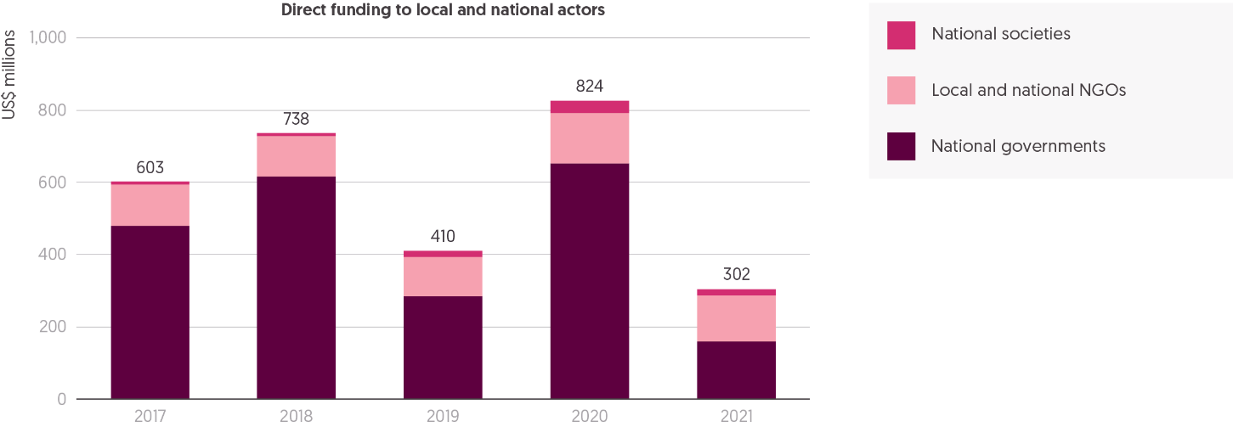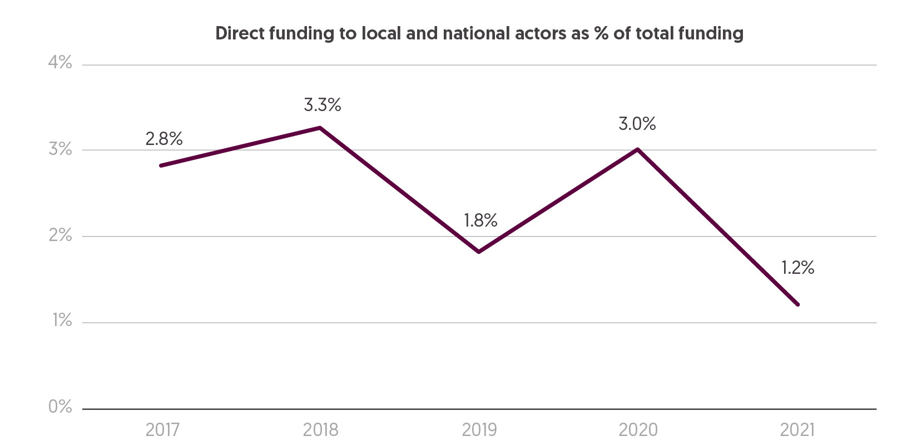

Source: Development Initiatives based on UN Office for the Coordination of Humanitarian Affairs (OCHA) Financial Tracking Service (FTS) data.

Notes: Local and national actors include all local, national or local/national non-governmental organisations (NGOs), determined by internal organisation coding. Southern international NGOs, which receive funding to operate within the country they are headquartered in, are included as national actors. RCRC national societies that received international humanitarian assistance to respond to domestic crises are included in local and national actors. Similarly, international funding to national governments is considered as funding to national actors only when contributing to the domestic crisis response. Funding is shown only for flows that reported with information on the recipient organisation. Data is in constant 2020 prices.

Increasing the volume of direct, quality funding to local actors, as well as access to information, decision-making and coordination mechanisms, is critical to ensuring that crisis preparedness and response capacity lies with those most affected. This is a central priority of the Grand Bargain 2.0.[123] Despite the high profile of localisation, substantive progress against commitments has not been made. Gains seemingly achieved in 2020 during the Covid-19 response have been lost in 2021, as direct funding to local and national actors fell to the lowest levels since before 2016.

* From 2017 to 2021, direct international humanitarian funding to local and national actors, as reported to the UN Office for the Coordination of Humanitarian Affairs (OCHA) Financial Tracking Service (FTS), halved, from US$603 million to US$302 million. This represents a drop in the share of total direct funding to local and national actors from 2.8% in 2017 to 1.2% in 2021.
* Following a spike in 2020 in direct funding to local and national actors, during the Covid-19 response, 2021 saw a 63% decrease, from US$824 million to US$302 million, driven by a reduction in funding to national governments from US$654 million to US$157 million.
* The volatility in overall volumes of direct funding to local and national actors throughout the period 2017 to 2021 is primarily driven by a fluctuation in funding to national governments. In 2019, the significant drop in funding to national governments was largely driven by a 70% decrease in funding to the Government of Yemen from US$484 million in 2018 to US$146 million, all of which was reported and provided by the Government of Saudi Arabia. The recovery in 2020 was driven by the Covid-19 pandemic response, which saw a broader disbursement of humanitarian assistance directly to governments. In 2020, 41 national governments received more than US$5 million, compared to just 10 governments in 2018.

Following an increase in funding in 2019, direct funding to local and national NGOs also fell in 2021, from US$140 million to US$129 million.

Figure 4.4 Most funding reached local and national actors through an intermediary, though available data remains limited  
Total funding to national and local NGOs, direct and indirect, as reported to FTS and CBPFs, 2017–2021

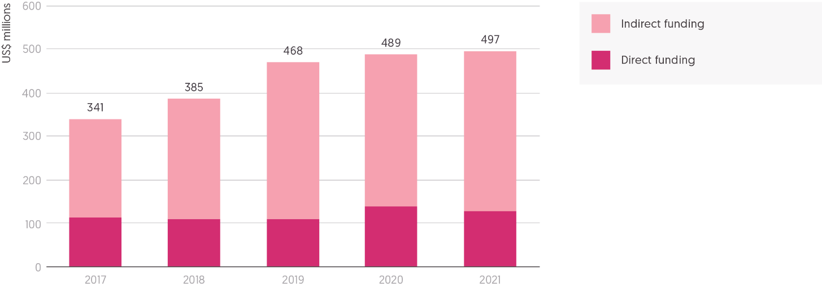

Source: Development Initiatives based on UN Office for the Coordination of Humanitarian Affairs (OCHA) Financial Tracking Service (FTS) data and UN OCHA Country-Based Pooled Funds (CBPFs) data hub.

Notes: Direct funding is sourced from the FTS, containing all direct funding from first-level donors, such as governments or private donors, to organisations that could be identified as national and local non-governmental organisations (NGOs). Southern international NGOs, which receive funding to operate within the country they are headquartered in, are included as national NGOs. Calculations of indirect funding through CBPFs, as either direct allocations or sub-grants of CBPF allocations, are sourced through the UN CBPF data hub. Indirect funding from sources other than CBPFs is taken from FTS where reported as net funding received. Data is in constant 2020 prices.

Most funding that reaches local and national actors passes through one or more intermediaries. However, the availability of data to monitor indirect funding flows remains limited. For 94% of direct funding reported to FTS (excluding data for country-based pooled funds), there is no further information to show where resources may have been passed from one organisation to another. Improved reporting of financing to final responders would help improve analysis of progress on localisation. The limited available data shows that most funding to local and national NGOs (L/NNGOs) is indirect.

* Total reported direct and indirect international humanitarian assistance to local and national NGOs has slowly increased year on year since 2017, from US$341 million to US$497 million in 2021, although growth has slowed in the past two years.
* While volumes reaching L/NNGOs directly and indirectly have increased, the share of overall funding to NGOs channelled to L/NNGOs has fallen. In 2019, the volume of total reported funding to L/NNGOs of all NGO funding was 9.6%, falling to 8.0% in 2021.
* The available data suggests that, of the total funding reaching L/NNGOs, the proportion provided directly has fallen in the period 2017 to 2021. In 2021, L/NNGOs received 75% (US$368 million) of funding indirectly, although this proportion is likely to be much higher.

Figure 4.5: Funding gains made to local and national actors for the health sector and Covid-19 response were not maintained in 2021  
International humanitarian assistance to local and national actors by sector, 2019–2021

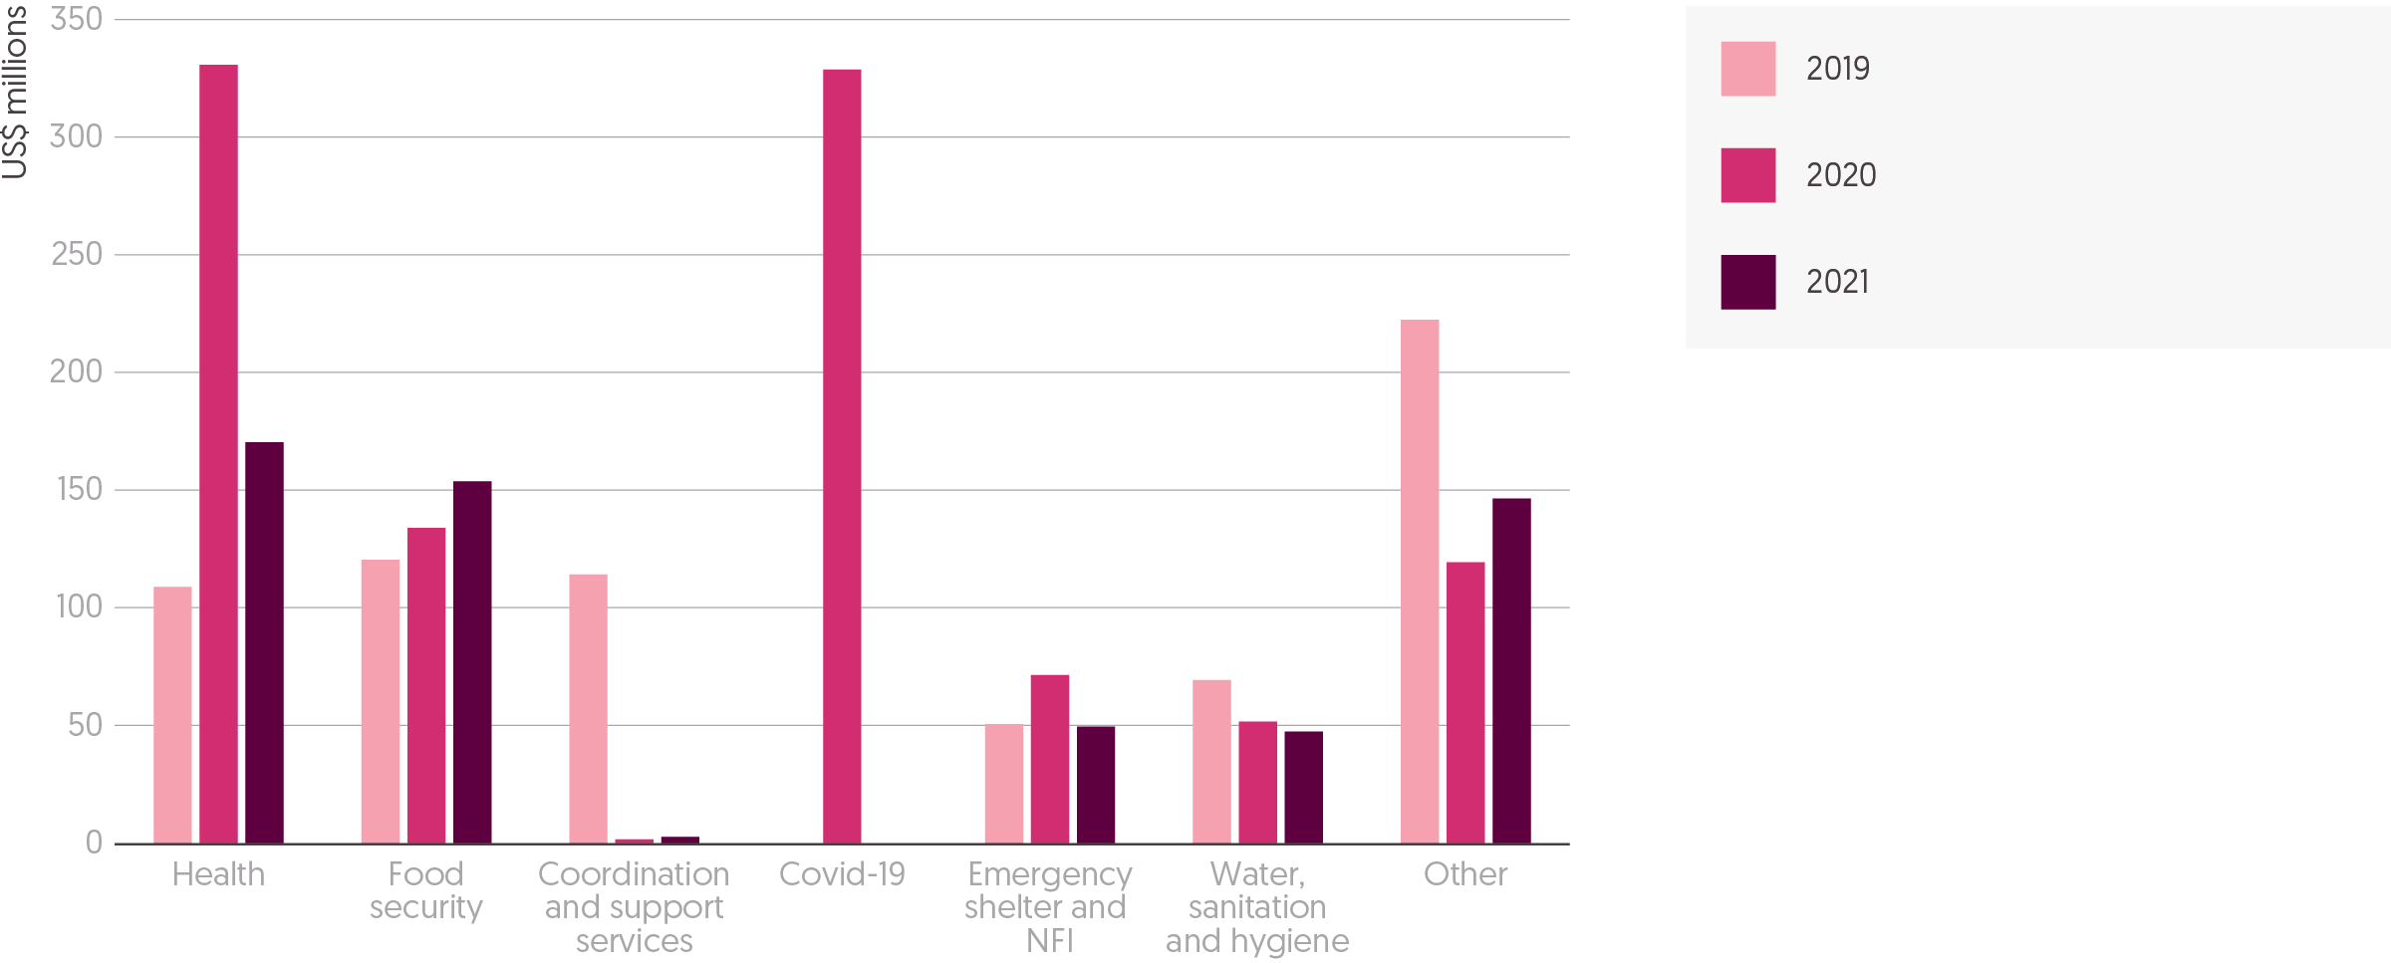

Source: Development Initiatives based on UN Office for the Coordination of Humanitarian Affairs (OCHA) Financial Tracking Service (FTS) data and Country-Based Pooled Funds (CBPFs) data hub.

Notes: NFI = Non-food items. Local and national actors include all local, national or local/national non-governmental organisations (NGOs), determined by internal organisation coding. Southern international NGOs which receive funding to operate in the country they are headquartered in are included as national actors. RCRC national societies that received international humanitarian assistance to respond to domestic crises are included in local and national actors. Similarly, international funding to national governments is considered as funding to national actors only when contributing to the domestic crisis response. Funding is shown only for flows that reported with information on the recipient organisation. Data is in constant 2020 prices. Clusters that received funding of less than US$30 million over the period 2018−2021 were aggregated as ‘Other’. Flows to local and national actors with unspecified clusters/sectors were not included in this analysis.

In 2020 there was a spike in funding for specific sectors to local and national actors (L/NAs), highlighting the critical role they played in the Covid-19 response. However, gains in 2020 were not sustained in 2021, when overall funding reported against a cluster to L/NAs fell to below 2019 levels.

* Total funding to L/NAs across all sectors peaked in 2020, reaching US$1.0 billion, a 52% increase from 2019 (US$685 million). In 2021, this funding dropped to US$569 million.
* Driven largely by an increase in funding to national governments in 2020, funding to L/NAs for the health cluster more than tripled, from US$108 million in 2019, to US$330 million in 2020. The proportion of health sector funding channelled to L/NAs increased from 10% in 2019, to 23% in 2020, then fell to 13% (US$170 million) in 2021.
* US$329 million was dispersed to L/NAs for programming within the Covid-19 cluster. Nearly all of this (99.8%) was passed to national government actors.
* The volume of funding to L/NAs for the food security sector has steadily grown between 2019 (US$120 million) and 2021 (US$153 million). As a proportion of all cluster funding to L/NAs, food security has increased, from 18% of total funding to L/NAs in 2019 to 27% in 2021. However, as a proportion of overall funding to the food security cluster, funding to L/NAs remains minimal, at around 3% per year, with the majority being channelled through UN agencies.
* The coordination and support services cluster accounts for only 5.1% of funding to L/NAs in the period 2019–2021. The large spike in 2019 was caused by large volumes of funding from the Saudi Government to Yemen.

Box 4.1: Tracking funding to local and national actors for the Syrian refugee response in Turkey

Very little funding for local and national actors (L/NAs) involved in humanitarian response reaches them directly. Insufficient reporting to platforms such as UN OCHA’s FTS means there is a lack of transparency around how much international funding reaches local actors through an intermediary organisation, including the identity of the intermediaries and the final recipients. To fill this evidence gap, recent research carried out by Development Initiatives and the Refugee Council of Turkey (forthcoming) investigated how international grant financing (both humanitarian and development) for the Syrian refugee response is directed to L/NAs in the context of Turkey. Turkey is host to the world’s largest population of refugees, including 3.8 million Syrian refugees.[124] L/NAs are at the forefront of the refugee response and, in the context of a protracted crisis, Turkey exemplifies many of the challenges faced elsewhere.

The study looked at all grant funding flows for the Syrian refugee response and found that, in 2020, 48% of funding was provided as humanitarian assistance and 43% as development assistance. Notably, a much larger share of the funding passed on through an intermediary was humanitarian (77%). Overall, the research found that international funding for L/NAs involved in the Syrian refugee response in Turkey was not widely accessible, especially for NGOs. Of total funding, 9.0% in 2019 and 18% in 2020 reached national actors directly from donors, of which nearly all was channelled to the Government of Turkey (95%). Within this, funding to local and national NGOs (L/NNGOs) was especially low, with just 1.6% in 2019 and 0.5% in 2020 of international funding for the Syrian refugee response being channelled directly by donors to L/NNGOs. By comparison, in 2020, 6.2% was directly channelled to international NGOs (INGOs). The study was also able to trace only very minimal amounts reaching local, refugee-led and women’s organisations.

Despite limited access to direct funding, L/NAs are responsible for implementing the majority of international programming in Turkey. In 2020, L/NAs received 81% of total funding provided by international donors for the Syrian refugee response. However, 63% was channelled indirectly, through one or more intermediaries. Of this indirect funding going to L/NAs, 62% was channelled to the Turkish Red Crescent, and 30% to the government.

Various barriers prevent international funding reaching L/NAs directly, including funding-instrument regulations, donor preferences and eligibility and compliance requirements, which can be prohibitive for some actors. While funding is reaching L/NAs indirectly, the type of funding and the nature of participation and partnerships are impeding locally led delivery. The result of this is a funding system that positions local actors as ‘sub-contractors’ to international organisations and does little to facilitate locally led coordination and priority-setting. This is partly due to the type of funding available for local actors. Findings from this study reinforced the importance of multi-year, flexible funding, especially critical for the types of medium-term, resilience-building programming prevalent in Turkey. While improvements have been made to partnerships between international and national organisations, the reliance on short-term humanitarian funding cycles does not promote genuinely equitable partnerships. Removing some of the barriers local actors face in accessing funding, while also providing more quality funding, is critical to ensuring a more locally led and effective response.

**Box 4.2:** Overhead cost allocation in the humanitarian sector

The pass-through of overheads to local and national actors is identified as an urgent priority for humanitarian reform.[125] Overheads, or indirect costs, broadly refer to the costs incurred to manage an organisation, but which are not directly attributable to a specific programme. Ensuring local and national actors have access to such funding is considered one of the most effective ways to strengthen the capacity of organisations and support their long-term sustainability, as well as addressing some of the inequalities in the humanitarian funding system.[126] However, international organisations, which often act as funding intermediaries to local and national actors, have been criticised for not passing on, or ‘sharing’, overhead costs with partners. A recent mapping of the current practices of UN agencies and INGOs, carried out by DI with the UN International Children’s Emergency Fund and Oxfam, found that the provision of overheads to L/NNGOs is inconsistent and at best ad hoc, both between and within organisations. Only a few organisations mapped have policies currently in place on overhead-sharing, though many are in the process of developing them.

There are emerging examples of good practice, where international intermediaries have been providing or sharing a percentage overhead with their national partners. Several UN agencies have policies which include a set percentage, or percentage range, of indirect costs that local and national partners are eligible to claim: UN High Commissioner for Refugees (4%), UN Women (up to 8%) and UN Population Fund (up to 12%). Some INGOs, such as Christian Aid and the Catholic Agency for Overseas Development, systematically share overheads equally with partners, while others have pockets of internal cost recovery sharing within certain country offices. Some donors have also started to engage on this issue. For example, both the UK’s Foreign, Commonwealth & Development Office Humanitarian Response Funding guidelines for the Rapid Response Facility for Covid-19[127], and the Danish International Development Agency, through new guidelines for Danish civil society organisations, provide an additional overhead which must be passed on to national partners. Donors such as the Netherlands are stipulating that recipients must share the overhead allowance with downstream partners.

For L/NNGOs interviewed in the study, good practice involves overheads being provided as unrestricted and unaudited funding that is not time-bound, and which is calculated on the entire budget. The provision of overheads should also not undermine other administrative costs, and good practice includes an allowance for both indirect costs and direct support costs, based on a clear, shared understanding of the different types of costs.

Intermediaries face various barriers in sharing or providing overheads to local and national partners. This includes both internal cost recovery regulations and regulations applied by donors, as well as the challenges for INGOs in adjusting to a potential loss in income. Overhead-sharing is complicated further by a lack of common classifications and definitions of what constitutes an overhead.[128] There is also a lack of transparency around how overheads are currently being passed down funding chains. The Inter-Agency Standing Committee Results Group 5 has identified the cascading of overheads as a priority and is currently developing best practice guidance.

## Pooled funds for crisis response

Figure 4.6: Funding to UN pooled funds returned to a pattern of steady growth  
Total funding to UN-managed pooled funds, 2012−2021 (by CBPFs/CERF and as percentage of total public international humanitarian assistance)

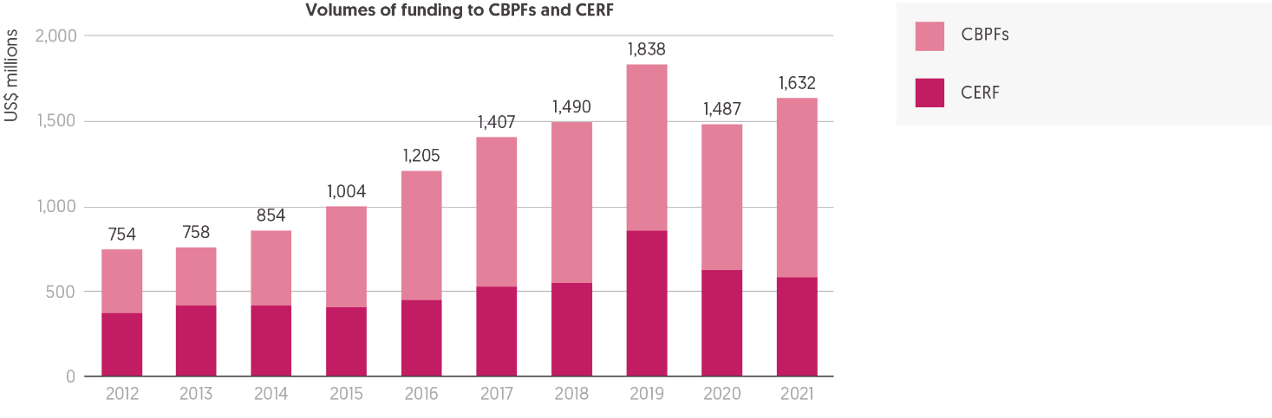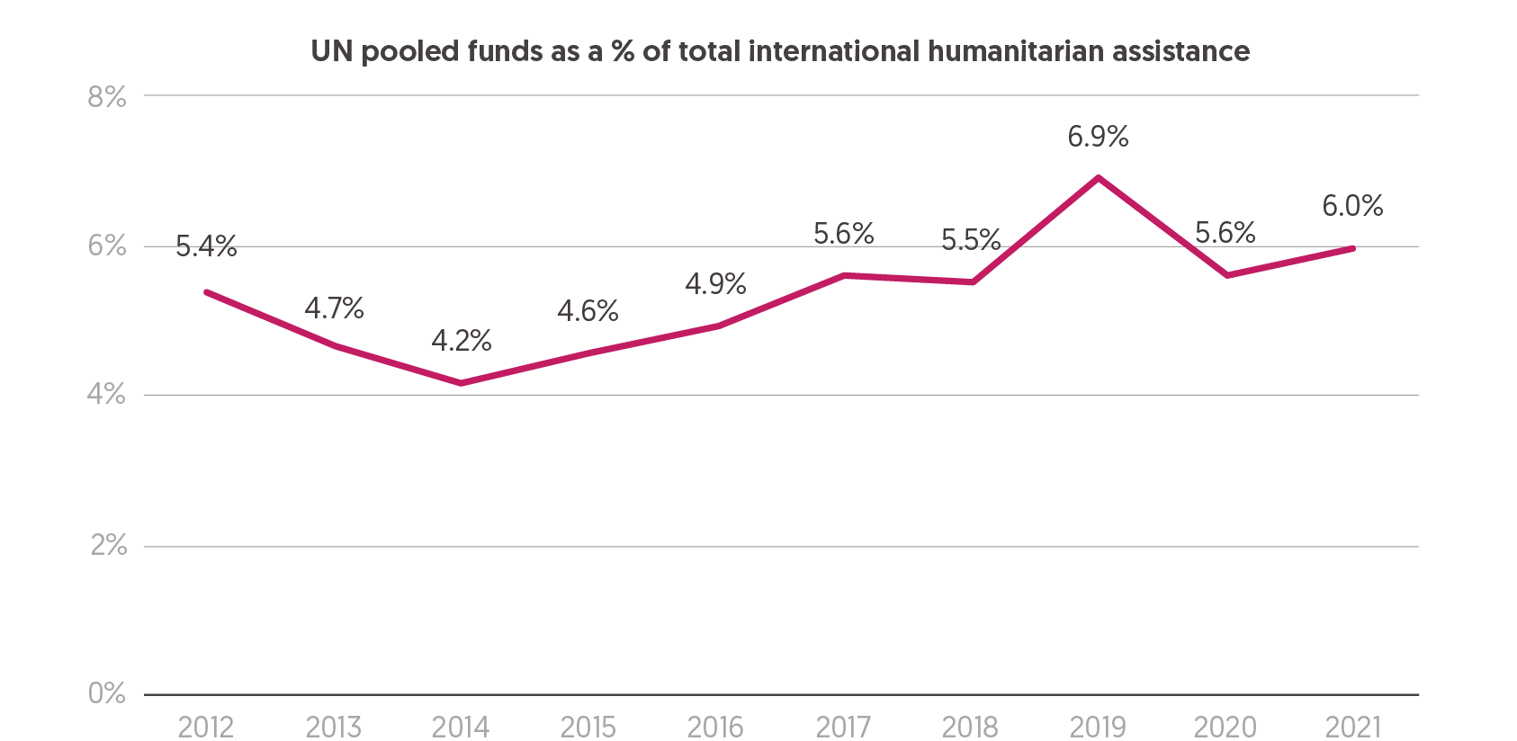

Source: Development Initiatives based on UN Office for the Coordination of Humanitarian Affairs (OCHA) Central Emergency Response Fund (CERF) data hub and country-based pooled funds (CBPFs) data hub.

Notes: CBPFs consist of funding from emergency response funds and common humanitarian funds. Annual figures include carry-overs from the previous year. Data is in constant 2020 prices. Total international humanitarian assistance used to calculate the share of pooled funding includes only total assistance from public donors, excluding assistance from private sources.

The UN’s country-based pooled funds (CBPFs) and Central Emergency Response Fund (CERF) pool funding from multiple donors, targeting funds for priority interventions at country level or where there are gaps (geographic or temporal) in the wider international response. CBPFs are recognised as an established channel for funding to local and national actors (see Figure 4.3). Despite an apparent spike in funding in 2019, and fall the following year, the overall trend for the past decade has been one of steady growth in funding to UN pooled funds, primarily driven by increases to CBPFs.

* In 2021, total funding to UN pooled funds rebounded from a sharp decline in 2020 (primarily driven by an uneven release of funding across financial years in 2019 and 2020 by one donor), to grow by 10%, an increase of US$145 million.
* Growth in 2021 is consistent with the average year-on-year increase in total funding to UN pooled funds across the last decade, which is also 10%.
* This growth in the volume of funding has, since 2014, also resulted in a steady increase in the proportion of total international humanitarian assistance channelled through UN pooled funds (notwithstanding the spike in funding in 2019), with pooled funds accounting for 6.0% of all assistance, up from 4.2% in 2014.

CBPFs have come to account for an increasing share of total funding for UN pooled funds, with the increase in total funding in 2021 driven by growth in funding to CBPFs.

* CBPFs received over US$1 billion for the first time in 2021, with funding increasing by 21% (US$184 million) in the past year and almost threefold (178%) in the last decade (since 2012).
* Following the very rapid growth in funding to the CERF in 2019, levels of funding declined for the second consecutive year, down US$39 million from 2020 and by almost a third (32% or US$276 million) from 2019 to US$585 million.
* CBPFs accounted for almost two thirds (64%) of total funding to UN pooled funds UN pooled funds in 2021, the highest share of total funding so far.

As with total international humanitarian assistance, a small number of donors provide the bulk of funding to UN-managed pooled funds.

* Over two thirds (69%) of total funding to UN pooled funds came from just five donors (Germany, the UK, the Netherlands, Sweden and Norway) in 2021.
* Germany was by far the single largest donor, alone accounting for almost a third (31% or US$511 million) of total funding to UN pooled funds in 2021. Contributions from Germany almost doubled between 2020 and 2021, up 46%. The additional US$161 million this provided drove the overall increase in funding to UN pooled funds. In 2021, 72% of Germany’s assistance was directed to CBPFs.
* The UK remained the second-largest donor to UN pooled funds, despite a second consecutive year of reductions in support from the UK, contributing US$236 million to CBPFs and the CERF in 2021, US$35 million less than in 2020, and US$521 million less than in 2019.

## Earmarking

Figure 4.7: Unearmarked funding to UN agencies declined, to the smallest proportion in six years  
Proportions of resources received by UN agencies reported as earmarked and unearmarked, 2016−2021

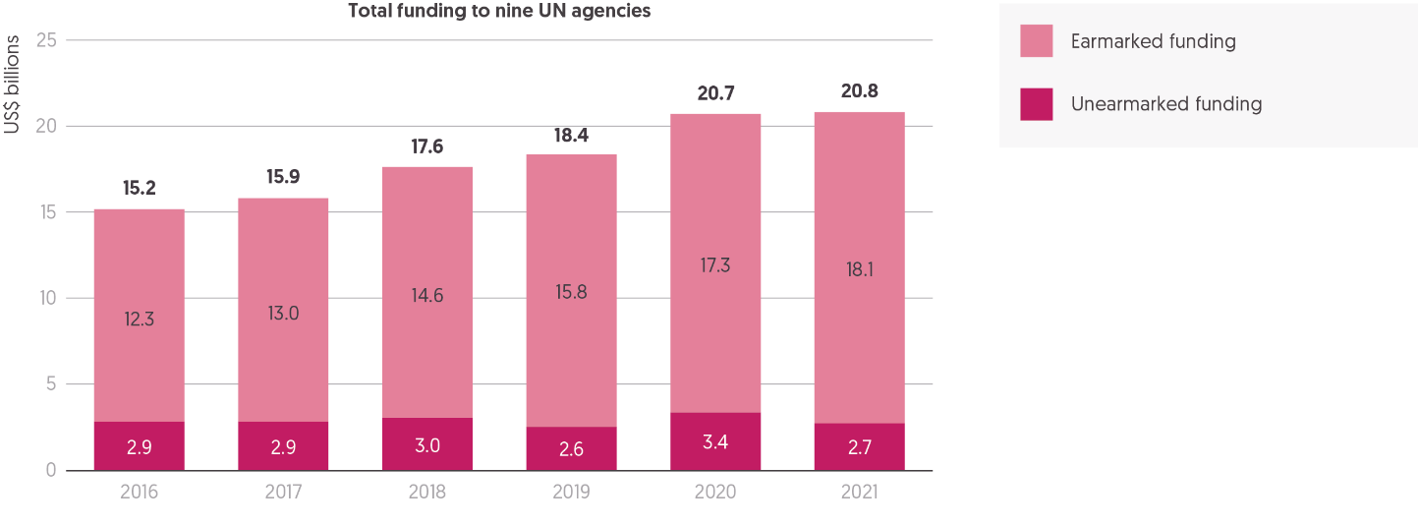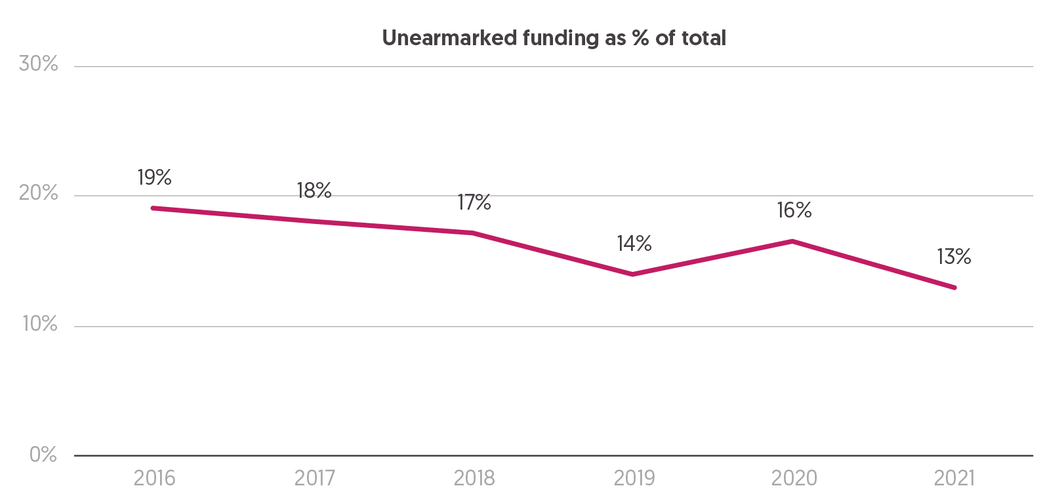

Source: Development Initiatives based on data provided bilaterally by UN agencies.

Notes: The calculations comprise earmarked and unearmarked humanitarian and humanitarian-related contributions given to the Food and Agriculture Organization (FAO), International Organization for Migration (IOM), UN Development Programme (UNDP), UN Office for the Coordination of Humanitarian Affairs (OCHA), UN High Commissioner for Refugees (UNHCR), UN International Children’s Emergency Fund (UNICEF), UN Relief and Works Agency for Palestine Refugees in the Near East (UNRWA), World Food Programme (WFP) and World Health Organization (WHO). 2021 data for IOM and 2020, as well as 2021 data for UNDP, is an estimation and not available at the time of writing. Data is in constant 2020 prices.

Quality funding refers to a range of funding characteristics that separately and in combination can enable more effective and efficient humanitarian responses. It includes the duration (e.g. multi-year), extent of earmarking, contractual quality and flexibility of grants (for instance, in terms of light reporting requirements and ease of agreeing no-cost extensions). Quality funding is one of the core priorities of the Grand Bargain 2.0, with a caucus, launched in March 2022, focusing on increasing the volume of multi-year funding provided by donors.[129]

In some areas, progress is evident. Analysis in the *Global Humanitarian Assistance Report 2021* indicated that the volume of multi-year funding provided by donors has increased.[130] Responses to the Covid-19 pandemic drove change, with the Inter-Agency Standing Committee developing guidance in the Covid-19 response on the flexibility of funding passed to implementing partners, along with key messages on funding flexibility.[131] Yet, the desired critical mass of quality funding has not yet been realised, with very little of quality funding reported to be reaching local and national actors (see Box 4.2, Overhead cost allocation in the humanitarian sector).

Despite commitments within the Grand Bargain to a global target of 30% of donor funding to be provided unearmarked or softly earmarked, little progress has been made.[132] In 2021, the volume and proportion of funding provided unearmarked to UN agencies decreased, with the proportion of unearmarked funding falling to its lowest level since the signing of the Grand Bargain.

* In 2021, unearmarked funding to nine UN agencies accounted for 13% of total funding received, the lowest percentage reported in six years. This reduction marks a return, following the rise in 2020 to 16%, to a steady trend of falling proportions of unearmarked funding since 2016.
* The volume of funding that was unearmarked also reduced in 2021 to US$2.7 billion, a fall of US$715 million from 2020. This is the second-smallest volume of unearmarked funding provided in the last six years (volumes fell to US$2.6 billion in 2019) and lower than levels in 2016 (US$2.9 billion).
* The decrease in the proportion of unearmarked funding in 2021 was primarily driven by a reduction in allocations to the World Health Organization, following a rapid increase in 2020 during the initial response to the Covid-19 pandemic. Unearmarked funding grew by US$615 million in 2020, and then fell in 2021 by US$630 million, returning to US$83 million, similar to levels pre-2020.
* Unearmarked funding to the UN Relief and Works Agency for Palestine Refugees in the Near East also fell sharply in 2021, from US$568 million in 2020 to US$118 million in 2021. Levels in 2021 are far below the yearly average of US$726 million received between 2016 and 2020.

The distinct variation between agencies in the proportion of unearmarked funding received, evident in previous years, continued in 2021.

Three UN agencies report receiving 30% or more of their humanitarian funding as unearmarked or softly earmarked in 2021, in line with the Grand Bargain target: UN OCHA (51%, US$139 million), the UN High Commissioner for Refugees (36%, US$1.6 billion) and the UN Relief and Works Agency for Palestine Refugees in the Near East (30%, US$118 million).

Among agencies receiving a small proportion of their funding unearmarked in 2021, the World Health Organization received 6.3%, the World Food Programme 3.6%, and the Food and Agriculture Organization 2.0%.

Box 4.3: Tracking multi-year funding – technical and political challenges and options

Multi-year funding remains high on the agenda of the Grand Bargain 2.0 reform process, under its first priority to achieve a critical mass of quality funding.[133] Efforts to increase volumes of multi-year funding have been channelled through a Grand Bargain caucus in early 2022. However, while volumes have risen since 2016,[134] and some donors report higher levels in 2021, amounts are not yet sufficient to enable transformative change within the humanitarian sector.

Annual budgeting cycles and legal and administrative structures often impede multi-year commitments. There is a lack of common understanding of the anticipated programmatic benefits of multi-year funding, as well as a need to clarify in what circumstances and to whom allocations of multi-year funding achieve the greatest impacts. Allocation dilemmas endure, between flexible long-term funding and immediate responses to emerging crises, within a context of endemic underfunding. Having a clear overview of the volumes, recipients and results of multi-year funds is fundamental to resolving current challenges. Yet this picture currently remains far from complete, with donors reporting the allocation of higher levels of multi-year funding than recipients report securing.

The common definition of ‘multi-year’ is inconsistently applied and reported against, resulting in a lack of clear baselines against which to measure progress and compare practice between donors and agencies. Tools such as the International Aid Transparency Initiative and the Financial Tracking Service are currently equipped to track multi-year funding but lack comprehensive data due to incomplete reporting by donors and recipients.

Several changes to reporting practices would improve information available on the status of multi-year funding. A nuanced definition would enable reports to be independently verified and interpreted. Specifying timeframes through parent and child flows on FTS would improve the quality of data. Humanitarian agencies may need to upgrade their internal financial data management systems to distinguish effectively between projects with multi-year funding and contract extensions, and report accordingly. Ultimately, these shifts should support the monitoring of commitments and catalyse the delivery of significantly greater volumes of multi-year funding for humanitarian responses.

## Cash and voucher assistance

Figure 4.8: Funding for humanitarian cash and voucher assistance continues to increase in 2021  
Total funding for humanitarian cash and voucher assistance, 2016−2021

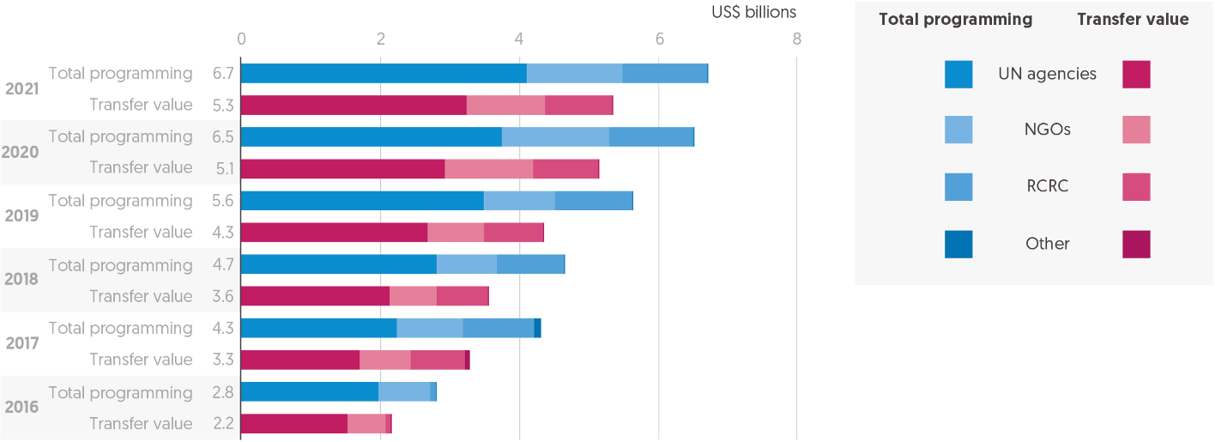

Source: Development Initiatives based on data collected with the help of the CALP Network from implementing partners and on UN Office for the Coordination of Humanitarian Affairs (OCHA) Financial Tracking Service (FTS) data.

Notes: CVA = cash and voucher assistance; NGO = non-governmental organisation. RCRC = International Red Cross and Red Crescent Movement. Data for 2021 is preliminary, as data for some organisations has not yet been provided or is based on estimations. Double counting of CVA programmes sub-granted from one implementing partner to another is avoided where data on this is available. Programming costs are estimates for organisations that provided only the amount transferred to beneficiaries. Data is not available for all included organisations across all years. For instance, the RCRC started to systematically track CVA only in 2017. Data is in current prices.

Providing cash or vouchers, rather than in-kind goods, can provide choice and empower recipients of humanitarian assistance. The clearest success story of the Grand Bargain has been the growth in the use of cash and voucher assistance (CVA). With the rapid increase in CVA, the Grand Bargain process has sought to address the attendant challenges of accountability and coordination in the delivery of assistance that have accompanied this growth. The first caucus of the Grand Bargain 2.0 focused on addressing these challenges and concluded in February 2022 with the agreement of the cash coordination model.[135]

In 2021, humanitarian assistance provided in the form of cash or vouchers increased for the sixth consecutive year.

* Preliminary data on global humanitarian CVA shows that the volume transferred to recipients rose to US$5.3 billion in 2021, an increase of 3.7% from 2020. Since 2017, the global volume of CVA transferred to recipients has grown by at least 62%.[136]
* Including associated programming costs, the global volume of humanitarian CVA reached an estimated US$6.7 billion in 2021.
* According to self-reported information by implementing organisations of CVA, which provided the data underlying this analysis, the majority of implementing agencies managed to consolidate or even increase their respective volumes of CVA transferred to recipients following growth in CVA operations in 2020 as part of the response to the Covid-19 pandemic.
* Data for 2021 is preliminary, with figures from a few NGOs yet to be captured. Assuming similar levels of CVA programming in 2021 as 2020 for these missing NGOs, the transfer value of global CVA would be an estimated US$5.7 billion, with total programming costs of US$7.1 billion.
* With more complete data for 2021, the likely level of yearly growth would be 12%, still some way below the increases of 19% in 2019 and 2020, but similar to the rise seen in 2018.
* In 2021, CVA made up 19% of total international humanitarian assistance. Accounting for missing data, CVA is likely to account for a slightly higher proportion of total assistance in 2021, at 21%.

In 2021, UN agencies provided the most CVA, with growth in CVA from these agencies driving the overall global rise.

* UN agencies account for the largest proportion of CVA, 61% of preliminary data for 2021.
* In 2020, for the first time, CVA provided by NGOs increased by a greater volume than that provided by UN agencies; growing by US$469 million, compared with an increase of just US240 million from UN agencies.
* In 2021, accounting for gaps in the preliminary data, CVA from NGOs and UN agencies will have grown by similar amounts from 2020 values.
* The UN agency with the largest percentage increase in its humanitarian CVA operations in 2021 was the UN International Children’s Emergency Fund at US$351 million transferred to recipients, 43% more than in 2020. Of that amount, 99.4% of the transfers were in cash and 0.6% in vouchers.
* When final accounting is completed, the International Red Cross and Red Crescent Movement (RCRC) expects to have transferred to recipients a similar volume of humanitarian CVA in 2021 as in 2020, at around US$1.0 billion.

Cash remains the preferred delivery modality.

* In 2021, 71% of total CVA was provided as cash and 29% as vouchers.
* This represents the same split between cash and vouchers reported in 2019 and 2020.

The growth in volumes of humanitarian CVA globally is now reflected in the existence of multipurpose cash (MPC) clusters in some response plans.

* In 2021, total funding requirements for MPC clusters reached US$339 million across response plans tracked by FTS. This is almost five times the requirements for MPC clusters in 2016. However, it represents only 0.9% of total financial requirements for response plans tracked by FTS in 2021.
* At the time of writing, MPC cluster requirements have significantly increased once more for 2022. This rise is driven by the US$600 million requirements of the Ukraine 2022 flash appeal for MPC, meaning total requirements tracked by FTS for MPC clusters have reached US$903 million for 2022.

Despite the increased profile and significant growth in CVA programming in recent years, publicly available data on CVA remains sparse. It is still not possible to comprehensively trace how much international humanitarian assistance is implemented as CVA from publicly reported data.

Chapter 5

methodology and definitions

## What is humanitarian assistance?

Humanitarian assistance is intended to save lives, alleviate suffering and maintain human dignity during and after human-made crises and disasters associated with natural hazards, as well as to prevent and strengthen preparedness for when such situations occur. Humanitarian assistance should be governed by the key humanitarian principles of humanity, impartiality, neutrality and independence. These are the fundamental principles of the international Red Cross and Red Crescent Movement, which are reaffirmed in UN General Assembly resolutions and enshrined in numerous humanitarian standards and guidelines.

In this report, when used in the context of financing data, international humanitarian assistance refers to the financial resources for humanitarian action spent outside the donor country. Our calculations of international humanitarian assistance are based on what donors and organisations report as such and do not include other types of financing to address the causes and impacts of crises, which we refer to as crisis-related financing.

There is no universal obligation or system for reporting expenditure on international, or indeed domestic, humanitarian assistance. The main reporting platforms for international humanitarian assistance are the Organisation for Economic Co-operation and Development (OECD) Development Assistance Committee (DAC) and the Financial Tracking Service (FTS) of the UN Office for the Coordination of Humanitarian Affairs (OCHA). Increasingly, data on humanitarian activities is also published according to the International Aid Transparency Initiative Standard.[137] OECD DAC members are obligated to report their humanitarian assistance to the DAC systems as part of their official development assistance (ODA), in accordance with definitions set out by the DAC.[138] Some other governments and most major multilateral organisations also voluntarily report to the DAC.

The FTS is open to all humanitarian donors and implementing agencies to voluntarily report contributions of internationally provided humanitarian assistance according to a set of inclusion criteria determined by the Inter-Agency Standing Committee.[139]

The analysis of international humanitarian assistance in the *Global Humanitarian Assistance Report 2022* draws largely on data reported to the OECD DAC and the FTS. Between these sources, there is variation in inclusion criteria for humanitarian assistance, as well as volumes reported, so we aim to consistently explain and source the data that we use. Since the 2018 report, we have included humanitarian funding reported to FTS that has been provided by OECD DAC members as assistance to countries not eligible for ODA. We also use other sources to calculate international humanitarian assistance, including reports from UN agencies and non-governmental organisations (NGOs) on private humanitarian funding and data from the Central Emergency Response Fund on contributions from public donors; data sources and methodologies for these are also clearly marked and explained.

## Cash

Our global estimate of humanitarian assistance provided in the form of cash and vouchers in 2021 is based on data collected from 27 organisations with support from the Cash Learning Partnership and supplemented with FTS data. The data will be analysed in greater detail in a forthcoming publication.[140] The methodology used for these estimates builds on one developed by Development Initiatives for research in 2016. For more information on this methodology and research, see *Counting cash: tracking humanitarian expenditure on cash-based programming*.[141]

## Channels of delivery

We use ‘channels of delivery’ to describe the first level of organisations receiving funding for the delivery of humanitarian assistance – multilateral agencies, NGOs, the public sector and the international Red Cross and Red Crescent Movement – whether they deliver the assistance themselves or pass it on to partner organisations. Our data on channels of delivery in Figure 4.2 (Chapter 4) comes from the FTS. When referring to private donors’ channels of delivery in the report, we use our own dataset (see ‘Private funding’).

## Climate-related ODA

This data includes all ODA disbursements reported to the OECD DAC Creditor Reporting System (CRS) and marked with a relevant Rio marker by DAC members, multilateral organisations and other government donors that voluntarily report to the OECD DAC. The two Rio markers can be used to report the relevance of any ODA funding in terms of:

* Mitigation, where a project contributes to stabilising greenhouse gas concentrations in the atmosphere by promoting efforts to reduce or limit greenhouse gas emissions or enhance greenhouse gas sequestration
* Adaptation, where a project seeks to reduce the vulnerability of human or natural systems to current and/or expected impacts of climate change.

We include ODA marked as both principal and significant for both markers.

## Country and region naming conventions

Country and region naming conventions used throughout this report are based on those used by the OECD DAC or the UN. Region naming conventions are based on those used by the OECD except the Middle East and North of Sahara regions, which have been combined. The conventions used do not reflect a political position of Development Initiatives.

## Crisis categories

For our analysis of crises by category, we apply thresholds to several indicators and cross-check with other data sources, notably ACAPS Crisis Overview. We use information from the Conflict Barometer 2021, of the Heidelberg Institute for International Conflict Research, to identify countries affected by conflict. For countries affected by disasters associated with natural and technical hazards, we use indicators in the INFORM Index for Risk Management and Centre for Research on the Epidemiology of Disasters Emergency Events Database (EM-DAT) data. And to identify displacement crises, we use data from the UN High Commissioner for Refugees (UNHCR), the Internal Displacement Monitoring Centre and the UN Relief and Works Agency for Palestine Refugees in the Near East (UNRWA).

## Deflators

Where appropriate in performing analyses of financial trends, we adjust for inflation by applying deflators in constant 2020 prices by source location of the funding. We use US$ gross domestic product deflators from the OECD DAC for DAC members and EU institutions and calculate these deflators from International Monetary Fund Economic Outlook April 2022 data for other countries. In the limited cases where data was missing from both of these sources, we estimate deflators based on the historical average real and nominal growth of gross domestic product based in US$. For financial flows that have a multilateral source, we deflate using the ODA-weighted average DAC deflator from the OECD. Consistent with our annual methodology, data in the *Global Humanitarian Assistance Report 2021* was shown in constant 2019 prices, so totals may vary between reports.

## Dimensions of vulnerability, fragility and risk

We focus on three intersecting dimensions facing people in need in our analyses: climate vulnerability, socioeconomic fragility and conflict risk. We use country-level data for each of those dimensions.

We classify countries’ climate vulnerability using data from the Notre Dame Global Adaptation Initiative (ND-GAIN) vulnerability index. We identify people living in countries ranked in the top quintile of this index as having high climate vulnerability. People living in countries with no index data are assumed not to have high vulnerability.

The classification of socioeconomic fragility is based on the OECD States of Fragility framework 2020. Country-level socioeconomic fragility is calculated as the average of the framework’s first principal components of social, political and economic fragility dimensions. We identify people living in countries in the top quintile of this index as having high socioeconomic fragility. Countries with no index data are assumed not to have high fragility.

Our classification of high-intensity conflict risk uses information from the Conflict Barometer 2021 (of the Heidelberg Institute for International Conflict Research). Country-level conflict intensity is taken as the maximum of any sub-state, intra-state, and inter-state conflict intensity scores. People living in countries with a conflict score of 4+ (high-intensity, violent conflict) are identified as those with high-intensity conflict risk. People living in countries with no conflict data are assumed not to have high-intensity conflict risk.

## Disaster risk reduction

For our analysis of ODA to disaster risk reduction (DRR) in 2020 in Figure 3.11 (Chapter 3), we include the following funding flows as reported to the OECD DAC CRS:

* Funding reported with the purpose code 43060 ‘Disaster risk reduction’
* Funding reported with the value 2 under the ‘Disaster risk reduction’ marker, expressing DRR as principal objective of the associated activity
* Additional funding with DRR as principal objective as expressed by the project information reported to the CRS (this additional funding was identified by Development Initiatives through a search for DRR keywords in the project titles and descriptions of CRS entries; the output of the keyword search was then manually screened for relevance to DRR).

ODA in 2020 to the newly added ‘Covid-19 control’ purpose code that has also been marked as relevant to DRR has been excluded from this analysis, to focus on the risk reduction for natural hazards and to avoid conflating that with pandemic risk.

## Earmarked funding

‘Earmarked’ funding comprises all non-core (‘other’) funding directed to multilateral organisations. Unearmarked funding may include softly earmarked contributions where this data was provided, for instance by region, to better reflect progress against the Grand Bargain commitment of providing more unearmarked and softly earmarked funding. Our definitions of different levels of earmarking used in our data collection reflect those in the annex of the Grand Bargain document.[142]

Our calculation of earmarking to nine UN agencies – the Food and Agriculture Organization, the International Organization for Migration (IOM), the UN International Children’s Emergency Fund (UNICEF), the UN Development Programme, UNHCR, UN OCHA, UNRWA, the World Food Programme (WFP) and the World Health Organization (WHO) – is primarily based on data provided directly to us by each agency based on its internal reporting or extracted from annual reports.

## Exchange rates

To convert original currency values into US$ values, we use exchange rates from the OECD DAC for currencies of DAC members, UN operational exchange rates for other currencies, and supplement with World Bank Development Economics Vice Presidency (DEC) alternative conversion factors where these are not available. The UN operational exchange rates are also used by UN OCHA FTS.

## Funding for local and national actors

Our analysis of direct funding to local and national actors in Figures 4.3, 4.4 and 4.5 (Chapter 4) uses data from FTS that we then ‘code’ according to a set of organisational categories. Figures 4.3 and 4.4 combine this FTS data with data available from country-based pooled funds on the funds’ direct and indirect funding to local and national actors, which uses the funds’ own classifications of recipients that might differ from the definitions below. For our own coding process, we use the following categories of local and national non-state actors and national and subnational state actors, as defined by the Inter-Agency Standing Committee Humanitarian Financing Task Team in its *Localisation Marker Definitions Paper*.[143]

* National NGOs/civil society organisations (CSOs): national NGOs/CSOs operating in the aid-recipient country in which they are headquartered, working in multiple subnational regions, and not affiliated to an international NGO. This category can also include national faith-based organisations.
* Local NGOs/CSOs: local NGOs/CSOs operating in a specific, geographically defined, subnational area of an aid-recipient country, without affiliation to an international NGO/CSO. This category can also include community-based organisations and local faith-based organisations.
* Red Cross/Red Crescent National Societies: national societies based in and operating within their own aid-recipient countries.
* Local and national private sector organisations: organisations run by private individuals or groups as a means of enterprise for profit, based in and operating within their own aid-recipient countries and not affiliated to an international private sector organisation.
* National governments: national government agencies, authorities, line ministries and state-owned institutions in aid-recipient countries, such as national disaster management agencies. This category can also include federal or regional government authorities.
* Local governments: subnational government entities in aid-recipient countries exercising some degree of devolved authority over a specifically defined geographic constituency, such as local/municipal authorities.

There are two other categories of first-level recipients featured in this analysis:

* Internationally affiliated NGOs: NGOs affiliated to an international NGO through interlinked financing, contracting, governance and/or decision-making systems. This category does not include local and national organisations that are part of networks, confederations or alliances wherein those organisations maintain independent fundraising and governance systems.
* Southern international NGOs: NGOs based in aid-recipient countries that are not OECD members, carrying out operations outside the aid-recipient country in which they are headquartered and not affiliated to an international NGO. The same organisation is classified as a national NGO/CSO when carrying out operations in the country in which it is headquartered.

## Gender-relevant international humanitarian assistance

Our dataset of gender-relevant international humanitarian assistance is based on a keyword search methodology applied to funding data reported to the UN FTS and consists of two major components.

* Gender-specific funding: funding that is reported to support gender-relevant humanitarian programming, with a key focus on addressing gender-related needs and advancing gender equality. This includes all funding reported under the Global Protection Cluster Gender-based Violence Area of Responsibility and other financial flows that reference gender-specific goals in the flow description, such as ‘women’s empowerment’ or ‘sexual and reproductive health’.
* Gender-mainstreamed funding: funding that references differing gender needs in programming, but where gender-related needs are not seen as the key focus.

For a more detailed account of our methodology, please see Appendix 1 in our separately published report, ‘Funding for gender-relevant humanitarian response’.[144]

## International humanitarian assistance

Our estimate of total international humanitarian assistance is the sum of that from private donors (see Figure 3.4, Chapter 3) and from government donors and EU institutions. Our calculation of international humanitarian assistance from government donors is the sum of:

* ‘official’ humanitarian assistance (OECD DAC donors)
* international humanitarian assistance from OECD DAC donors to countries not eligible for ODA from the FTS
* international humanitarian assistance from donors outside the OECD DAC using data from the FTS.

Our ‘official’ humanitarian assistance calculation comprises:

* the bilateral humanitarian expenditure of OECD DAC members, as reported to the OECD DAC database under Table 1
* the multilateral humanitarian assistance of OECD DAC members.

The multilateral humanitarian assistance of OECD DAC members consists of three elements.

* The unearmarked ODA contributions of DAC members to 10 key multilateral agencies engaged in humanitarian response: the Food and Agriculture Organization, IOM, the UN Development Programme, UNFPA, UNHCR, UN OCHA, UNICEF, UNRWA, WFP and WHO, as reported to the OECD DAC under Table 2a and the CRS. We do not include all ODA to the Food and Agriculture Organization, IOM, the UN Development Programme, UNFPA, UNICEF, WHO and WFP but apply a percentage to take into account that these agencies also have a ‘development’ mandate. These shares are calculated using data on humanitarian expenditure as a proportion of the total received directly from each multilateral agency.
* The ODA contributions of DAC members to some other multilateral organisations (beyond those already listed) that, although not primarily humanitarian-oriented, do report a level of humanitarian aid to OECD DAC Table 2a. We do not include all reported ODA to these multilateral organisations but just the humanitarian share of this.
* Contributions to the UN Central Emergency Response Fund that are not reported under DAC members’ bilateral humanitarian assistance. We take this data directly from the UN Central Emergency Response Fund website.

When we report on the official humanitarian assistance of individual OECD DAC countries that contribute to the EU budget, we include an imputed calculation of their humanitarian assistance channelled through the EU institutions, based on their ODA contributions to the EU institutions. We do not include this in our total international humanitarian assistance and response calculations, to avoid double counting.

Our estimate for official humanitarian assistance in 2021 is derived from preliminary DAC donor reporting on humanitarian aid grants.

Turkey is captured and shaded differently in Figures 3.1 and 3.2 (Chapter 3) because the humanitarian assistance that it voluntarily reports to the DAC largely comprises expenditure on hosting Syrian refugees within Turkey. We do not include Turkey’s spending on Syrian refugees in Turkey in our total international humanitarian assistance and response calculations elsewhere in the report, as these include only amounts directed internationally by donors.

In this year’s report, we use data from the FTS on volumes of international humanitarian assistance by recipient countries for 2021 data, which will become available in the OECD DAC CRS in December 2022 or later. FTS data was downloaded on 13 April 2022.

## People in need and people targeted for assistance

We drew estimates of people in need (PiN) from the UN OCHA Humanitarian Programme Cycle (HPC), supplemented by ACAPS. Our analysis for per-country PiN uses the maximum of HPC final-year estimates for country-level humanitarian response plans (HRPs), and ACAPS country year-maxima. To avoid double-counting, we do not include PiN as estimated by flash appeals (FAs) or regional response plans (RRPs) where a country-level HRP already exists.

For our analysis of PiN and people targeted for assistance by sector, we used HPC final-year estimates for country-level HRPs to ensure consistency and comparability. Sector-level data for Yemen 2020 HRP − which is missing from HPC − was drawn from the June−December update HRP documentation for this appeal.

## Food insecurity

Acute food insecurity classification data is from the Integrated Food Security Phase Classification. We classify people living in ‘crisis’, i.e. phase 3 level or higher, as being food insecure. Acute food insecurity numbers and phases are as reported or projected by the data year’s most comprehensive Integrated Food Security Phase Classification survey.

Survey coverage varies between years, with not all countries covered annually and some surveys limited to subnational areas. To capture a comprehensive total of people facing food insecurity, we select surveys from within two-year periods that cover the largest share of a country’s population. An exception to this is data for Yemen, where no comprehensive survey exists for the period 2019–2020 and so the figure reported is based on a 2018 survey.

Food insecurity severity is calculated based on an adapted Foster-Greer-Thorbecke (FGT; α=2) index that weights higher phases of food insecurity to produce a comparable index of severity.

## Private funding

We request financial information directly from humanitarian delivery agencies (including NGOs, multilateral agencies and the Red Cross and Red Crescent Movement) on their income and expenditure to create a standardised dataset. Where direct data collection is not possible, we use publicly available annual reports and audited accounts. For the most recent year, our dataset includes:[145]

* a large sample of NGOs that form part of representative NGO alliances and umbrella organisations such as Save the Children International, and several large international NGOs operating independently
* private contributions to IOM, UNHCR, UNICEF, UNRWA, WFP and WHO
* the International Federation of Red Cross and Red Crescent Societies and the International Committee of the Red Cross.

Our private funding calculation comprises an estimate of total private humanitarian income for all NGOs, and the private humanitarian income reported by six UN agencies, the International Federation of Red Cross and Red Crescent Societies and the International Committee of the Red Cross. To estimate the total private humanitarian income of NGOs globally, we calculate the annual proportion that the NGOs in our dataset represent of NGOs reporting to UN OCHA FTS. The total private humanitarian income reported to us by the NGOs in our dataset is then scaled up accordingly.

Data is collected annually, and new data for previous years may be added retrospectively. Due to limited data availability, detailed analysis covers the period 2016 to 2020.

Our 2021 private funding calculation is an estimate based on data on eight organisations that, combined, receive a large share of global private humanitarian funding year on year, pending data from our full dataset. These are: Médecins Sans Frontières, Plan International, Catholic Relief Services, the International Federation of Red Cross and Red Crescent Societies, the Danish Refugee Council, UNHCR, American Near East Refugee Air and World Relief. We calculate the average share that these eight organisations’ contributions represent in our private funding figure for the five previous years (50%, ranging between 47% and 52% over 2016–2020) and use this to scale up the private funding figure gathered from these eight organisations to arrive at an estimated total for 2021.

## Protracted crisis countries

Our definition of protracted crisis countries includes countries with five or more consecutive years of UN-coordinated appeals, as of the year of analysis. The types of appeals and response plans used to determine this classification are outlined in ‘UN-coordinated appeals’.

We have chosen this approach to give an indication of the countries that have consistently, for a number of years, experienced humanitarian needs at a scale that requires an international humanitarian response. Those needs can be limited to specific geographical regions or populations (such as forcibly displaced people).

## Rounding

There may be minor discrepancies in some of the totals in our charts and infographics, and between those in the text, because of rounding.

## UN-coordinated appeals

We use this generic term to describe all humanitarian response plans and appeals wholly or jointly coordinated by UN OCHA or UNHCR, including strategic response plans, humanitarian response plans, flash appeals, joint response plans and regional refugee response plans. We use data from UN OCHA FTS and UNHCR for our financial analysis of UN-coordinated appeals.

## World Bank financing in crisis contexts

Following an initial scoping exercise to identify mechanisms and channels of World Bank financing implemented in crisis contexts, seven instruments were selected based on their relevance for humanitarian actors, their volumes of funding and their accessibility of publicly available data. To ensure coherence, this selection was shared and discussed with relevant colleagues both within and external to the World Bank. The selected instruments do not provide an exhaustive overview of all World Bank financing in crisis contexts but aim to illustrate the main relevant tools currently operating in humanitarian settings.

The analysis is based on publicly available data from the World Bank Group. For the International Development Association (IDA), this includes: the IDA website, fiscal year 2021 country allocations, additions to IDA resources for IDA19 and IDA20, and mid-term operationalisation reviews, among others. For other mechanisms, sources include the Catastrophe Deferred Drawdown Option product note, the Global Risk Financing Facility website and annual report, the Global Concessional Financing Facility website, and the State and Peacebuilding Fund annual report.notes

1. OECD, 2019. DAC recommendation on the humanitarian–development­–peace nexus. Available at: <https://legalinstruments.oecd.org/en/instruments/OECD-LEGAL-5019>; UNFCCC, 2017. Technical report: opportunities and options for integrating climate change adaptation with the Sustainable Development Goals and the Sendai Framework for Disaster Risk Reduction 2015–2030. Available at: <https://unfccc.int/documents/28265>
2. SPARC, 2021. Exploring the conflict blindspots in climate adaptation finance. Available at: <https://www.sparc-knowledge.org/resources/synthesis-report-exploring-conflict-blind-spots-climate-adaptation-finance>
3. SPARC, 2021. Exploring the conflict blindspots in climate adaptation finance. Available at: <https://www.sparc-knowledge.org/resources/synthesis-report-exploring-conflict-blind-spots-climate-adaptation-finance>. Research has also shown that countries with high levels of extreme poverty have received a lower proportion of climate adaptation finance. See: Development Initiatives, 2016. Climate finance and poverty: exploring the linkages between climate change and poverty evident in the provision and distribution of international public climate finance. Available at: <https://devinit.org/resources/climate-finance-and-poverty/>
4. ICRC, 5 June 2019. Natural environment: neglected victim of armed conflict, [www.icrc.org/en/document/natural-environment-neglected-victim-armed-conflict](http://www.icrc.org/en/document/natural-environment-neglected-victim-armed-conflict) (accessed 4 June 2022); Martinezcuello, Francesco, 11 April 2022, Ukraine is ground zero for the environmental impacts of war, [www.sierraclub.org/sierra/ukraine-ground-zero-for-environmental-impacts-war#:~:text=The%20manufacture%20of%20nitric%20acid,day%20of%20the%20Ukraine%20War.u](http://www.sierraclub.org/sierra/ukraine-ground-zero-for-environmental-impacts-war#:~:text=The%20manufacture%20of%20nitric%20acid,day%20of%20the%20Ukraine%20War.u) (accessed 9 June 2022)
5. ODI, ICRC, March 2019. Double vulnerability: the humanitarian implications of intersecting climate and risk. Available at: <https://cdn.odi.org/media/documents/12647.pdf>
6. Acute food insecurity numbers and phases as reported/projected by the closest IPC survey. IPC survey coverage varies between years, with not all countries covered annually, and some surveys limited to only small areas of a country; to ensure we capture a comprehensive total of people facing food insecurity, we select surveys across the two-year period 2020–2021, which cover the largest share of a country’s population. This means that our total is not directly comparable with data presented at a single-year or multi-year view by IPC. Because not all surveys cover the same area of a country every year, to make a comparison between 2019/20 and 2020/21, we selected the most comprehensive country surveys from within each period (using a rule of thumb that the covered population in 2019/20 should be within 25% of the 2020/21 survey). For this reason, we used Yemen’s 2018 survey for 2019/20.
7. Measured by weighted depth of food insecurity (0–1). For more information, see our online ‘Methodology and definitions’, Chapter 5.
8. IDMC and NRC, 2021. Global report on internal displacement 2021. Available at: <https://www.internal-displacement.org/global-report/grid2021/>
9. OCHR, 2022, Ukraine: millions of displaced traumatised and urgently need help, say experts, [www.ohchr.org/en/press-releases/2022/05/ukraine-millions-displaced-traumatised-and-urgently-need-help-say-experts#:~:text=According%20to%20the%20most%20recent,percent%20of%20the%20entire%20population](http://www.ohchr.org/en/press-releases/2022/05/ukraine-millions-displaced-traumatised-and-urgently-need-help-say-experts#:~:text=According%20to%20the%20most%20recent,percent%20of%20the%20entire%20population) (accessed 31 May 2022)
10. UNHCR, 2021. UNHCR Covid-19 vaccine access report. Available at: [www.unhcr.org/uk/protection/operations/623b18244/unhcr-covid-19-vaccine-access-report-2021.html](http://www.unhcr.org/uk/protection/operations/623b18244/unhcr-covid-19-vaccine-access-report-2021.html)
11. OECD, 2022. ODA levels in 2021 – preliminary data. Available at: <https://www.oecd.org/dac/financing-sustainable-development/development-finance-standards/official-development-assistance.htm>.
12. This includes bilateral humanitarian assistance and multilateral humanitarian assistance reported to the OECD DAC. For more information, see ‘International humanitarian assistance’ (Chapter 5).
13. UN OCHA, 2020, Global humanitarian overview 2021, p. 11. Available at: <https://reliefweb.int/report/world/global-humanitarian-overview-2021-enarfres>.
14. UN Women, 2021. Measuring the shadow pandemic: violence against women during Covid-19. Available at: https://data.unwomen.org/publications/vaw-rga; IRC, 2020. What happened? How the humanitarian response to COVID-19 failed to protect women and girls. Available at: <https://www.rescue.org/report/what-happened-how-humanitarian-response-covid-19-failed-protect-women-and-girls>.
15. For a summary of commitments see: Development Initiatives, 2022*.* Funding for gender-relevant humanitarian response, pp. 7–8. Available at: <https://devinit.org/resources/funding-for-gender-relevant-humanitarian-response/?nav=more-about>.
16. Development Initiatives, 2022. Funding for gender-relevant humanitarian response. Available at: <https://devinit.org/resources/funding-for-gender-relevant-humanitarian-response/?nav=more-about>.
17. For more information on gender markers and recommendations to improve tracking of gender-related funding, see: Development Initiatives, 2022*.* Funding for gender-relevant humanitarian response,pp. 32–38. Available at: https://devinit.org/resources/funding-for-gender-relevant-humanitarian-response/?nav=more-about.
18. Oxfam, 2020. Climate finance shadow report 2020: assessing progress towards the $100 billion. Available at: <https://oxfamilibrary.openrepository.com/handle/10546/621066>.
19. Contributions to climate finance are tracked through the Standing Committee on Finance (SCF), which is responsible for tracking and reporting on climate financing flows and progress towards the target, facilitated through the Green Climate Fund (GCF) and the Global Environment Facility (GEF), which also manages two additional funds – the special climate change fund (SCCF) and the least developed countries fund (LDCF). United Nations Climate Change, Introduction to Climate Finance, <https://unfccc.int/topics/climate-finance/the-big-picture/introduction-to-climate-finance#:~:text=What%20is%20climate%20finance%3F,that%20will%20address%20climate%20change>.
20. Climate Policy Initiative, 2021. Global landscape of climate finance 2021. Available at: <https://www.climatepolicyinitiative.org/publication/global-landscape-of-climate-finance-2021/>.
21. In 2019, 70% of the US$80 billion in international climate finance was in the form of loans from public funds.

    Climate Policy Initiative, 2021. Global landscape of climate finance 2021. Available at: <https://www.climatepolicyinitiative.org/publication/global-landscape-of-climate-finance-2021/>.

    Of the US$59.5 billion of climate finance reported from developed countries in 2017/18, Oxfam estimates just US$19–22 billion is ‘climate-specific net assistance’ (the value of the finance when accounting for the grant equivalence of loans), and less than half went for adaptation purposes. Oxfam, 2020. Climate finance shadow report 2020: assessing progress towards the $100 billion. Available at: <https://oxfamilibrary.openrepository.com/handle/10546/621066>.
22. Migration finance makes up 90% of total climate finance. “The majority of mitigation finance went towards energy systems, which includes investments in renewable fuel production, renewable power and heat generation assets, transmission and distribution networks, as well as support to policy and national budget and capacity building. Private actors provided the majority of mitigation finance (54%), particularly in terms of the share of renewable energy finance, indicating the maturity of this market.” Climate Policy Initiative, 2021. Global landscape of climate finance 2021. Available at: <https://www.climatepolicyinitiative.org/publication/global-landscape-of-climate-finance-2021/>.
23. In 2020, OECD reporting noted just under US$80 billion was raised for international climate finance from the following sources: US$28.8 billion bilateral, public; US$34.1 billion multilateral, public; US$2.6 billion, export credits; US$14 billion, mobilised private finance. When it became apparent that the 2020 target would be missed, it was extended to 2025. Some estimates of climate-specific net assistance are significantly lower: between US$19 billion and US$22.5 billion per year in 2017/18, of which between US$6 billion and US$7 billion per year is for adaptation (annual averages – see Figure 1.2, Chapter 1). Estimates of total climate finance fall well below estimates of need (maintaining 1.5c pathway) – current annual flows are estimated to be around US$632 billion with an estimated need of US$4.5–5 trillion. UNEP, 2021. The gathering storm: adapting to climate change in a post pandemic world. Available at: [www.unep.org/resources/adaptation-gap-report-2021](http://www.unep.org/resources/adaptation-gap-report-2021); Climate Policy Initiative, 2021. Global landscape of climate finance 2021. Available at: <https://www.climatepolicyinitiative.org/publication/global-landscape-of-climate-finance-2021/>; Oxfam, 2020. Climate finance shadow report 2020: assessing progress towards the $100 billion. Available at: <https://oxfamilibrary.openrepository.com/handle/10546/621066>; Timperley, Jocelyn, 2021,The broken £100 billion promise of climate finance – and how to fix it, [www.nature.com/articles/d41586-021-02846-3](http://www.nature.com/articles/d41586-021-02846-3) (accessed 15 June 2022).
24. Make Polluters Pay, 2022. The Loss and Damage Finance Facility: why and how. Available at: <https://makepolluterspay.co.uk/educate-and-share>.
25. Monitoring the flows of climate finance is difficult, as there is no agreed definition of what constitutes climate finance or consistent accounting rules. The wide range of climate finance mechanisms continues to challenge coordination. Watson, Charlene, Schalateck, Liane and Evéquoz, Aurélien, 2022. Climate Funds Update. The global climate finance architecture. Available at: <https://climatefundsupdate.org/about-climate-finance/global-climate-finance-architecture/>.
26. “The public sector continues to provide almost all adaptation financing, with adaptation increasingly being prioritized in development finance climate portfolios, yet adaptation finance represented just 14% of total public finance. Moreover, data on adaptation finance from the private sector is still largely missing.” Climate Policy Initiative, 2021. Global landscape of climate finance 2021. Available at: <https://www.climatepolicyinitiative.org/publication/global-landscape-of-climate-finance-2021/>. The UN Environment Programme (UNEP) estimates that annual adaptation costs in developing countries could reach as much as $500 billion annually. UNEP, 2020. Adaptation gap report. Available at: [www.unep.org/resources/adaptation-gap-report-2020#:~:text=The%20UNEP%20Adaptation%20Gap%20Report%202020%20finds%20that%20while%20nations,floods%20and%20sea%2Dlevel%20rise](http://www.unep.org/resources/adaptation-gap-report-2020#:~:text=The%20UNEP%20Adaptation%20Gap%20Report%202020%20finds%20that%20while%20nations,floods%20and%20sea%2Dlevel%20rise).
27. “Climate finance should be additional to existing ODA commitments and other pre-existing flows from developed countries to avoid the diversion of funding for development needs to climate change actions. This is commonly understood to be above the 0.7% of gross national income (GNI) that has been the ODA target, unfulfilled by most developed countries, since 1970.” Watson, Charlene, Schalateck, Liane and Evéquoz, Aurélien, 2022. Climate Funds Update. The global climate finance architecture. Available at: <https://climatefundsupdate.org/about-climate-finance/global-climate-finance-architecture/>.
28. For information on transparency related to tracking climate finance, see: Watson, Charlene, Schalateck, Liane and Evéquoz, Aurélien, 2022. Climate Funds Update. The global climate finance architecture. Available at: <https://climatefundsupdate.org/about-climate-finance/global-climate-finance-architecture/>. Development finance flows targeting the objectives of the Rio conventions on biodiversity, climate change and desertification are reported to OECD DAC and flagged using the Rio marker system. For more information, see: [www.oecd.org/dac/environment-development/Revised%20climate%20marker%20handbook_FINAL.pdf](http://www.oecd.org/dac/environment-development/Revised%20climate%20marker%20handbook_FINAL.pdf). While specific markers exist for activities like disaster risk reduction, there is the possibility of some reporting overlap, depending on how a donor classifies an activity and applies relevant coefficients. For information related to additionality, analysis shows that almost half of all climate finance is not new and additional. See: Center for Global Development, 2021, Whose climate finance is ‘new and additional’? (web blog), 15 March, [www.cgdev.org/blog/whose-climate-finance-new-and-additional](http://www.cgdev.org/blog/whose-climate-finance-new-and-additional) (accessed 15 June 2022).
29. Proportions based on gross ODA disbursements, 2020. ‘Adaptation-related’ is defined here as the sum of ODA marked as having adaptation as either a principal or a significant policy objective with the Rio marker for climate change adaptation purposes. This includes all projects tagged with either a principal or a significant climate objective, for either mitigation or adaptation activities, or both. This captures only bilateral climate-relevant ODA and not that allocated via multilaterals and climate funds. While the latter represents a large proportion of climate finance, it is largely in the form of loans and far more complex to track. A look at ODI’s Climate Funds Update data can give an initial picture of broader climate finance flows via the major UNFCCC climate funds (such as the GCF, GEF and Adaptation Fund). This data also allows us to look at volumes to fragile and conflict-affected states (FCASs), which could be an initial proxy for climate finance to humanitarian zones. Climate Funds Update, <https://climatefundsupdate.org/the-funds/> (accessed 15 June 2022).
30. Of 34 countries, 33 are listed as recipients of climate-relevant bilateral ODA, excluding Palestine, which is a protracted crisis country but not a recipient of climate-relevant ODA in this dataset.
31. The 10 protracted crisis countries in the top 20 recipients of climate relevant ODA for adaptation purposes are: Myanmar, Ethiopia, Turkey, Bangladesh, Kenya, Afghanistan, Egypt, Yemen, Rwanda and Burkina Faso.
32. These include the Green Climate Fund (GCF), Global Environment Facility (GEF) and Adaptation Fund. See: Climate Funds Update, <https://climatefundsupdate.org/the-funds/> (accessed 15 June 2022).
33. Oxfam, 2022. Footing the bill: fair finance for loss and damage in an era of escalating climate impacts. Available at: <https://oxfamilibrary.openrepository.com/bitstream/handle/10546/621382/bp-fair-finance-loss-and-damage-070622-en.pdf;jsessionid=B0FF809F365A236D634CD2A61E8F4225?sequence=23>.
34. Oxfam, 2022. Footing the Bill: Fair finance for loss and damage in an era of escalating climate impacts. Available at: <https://oxfamilibrary.openrepository.com/bitstream/handle/10546/621382/bp-fair-finance-loss-and-damage-070622-en.pdf;jsessionid=B0FF809F365A236D634CD2A61E8F4225?sequence=23>.
35. SPARC, 2021. Exploring the conflict blindspots in climate adaptation finance. Available at: <https://www.sparc-knowledge.org/resources/synthesis-report-exploring-conflict-blind-spots-climate-adaptation-finance>.
36. “Poor families in rural Bangladesh spend nearly $2 billion (£1.5bn) a year on preventing climate-related disasters or repairing the damage caused by them – twice as much as the government and over 12 times more than Bangladesh receives in multilateral international climate financing. The average person in Bangladesh produces 24 times less CO2 than the average person in the US.” IIED, 2019. Bearing the climate burden: how households in Bangladesh are spending too much. Available at: <https://pubs.iied.org/16643iied>.
37. Oxfam, 2022. Footing the bill: fair finance for loss and damage in an era of escalating climate impacts. Available at: <https://oxfamilibrary.openrepository.com/bitstream/handle/10546/621382/bp-fair-finance-loss-and-damage-070622-en.pdf;jsessionid=B0FF809F365A236D634CD2A61E8F4225?sequence=23>.
38. Climate Action Network – International, 2022. The Loss and Damage Finance Facility: why and how. Available at: <https://climatenetwork.org/resource/ldff-paper/>.
39. World Resources Institute, 2022. What is loss and damage from climate change? 6 key questions answered. Available at: [www.wri.org/insights/loss-damage-climate-change?utm_medium=social&utm_source=twitter&utm_campaign=socialmedia&utm_source=twitter&utm_medium=wriclimate&utm_campaign=socialmedia&utm_term=64fa4366-2426-467b-be1d-077abc0619a1](http://www.wri.org/insights/loss-damage-climate-change?utm_medium=social&utm_source=twitter&utm_campaign=socialmedia&utm_source=twitter&utm_medium=wriclimate&utm_campaign=socialmedia&utm_term=64fa4366-2426-467b-be1d-077abc0619a1).
40. UK Government, May 2022. The UK government’s strategy for international development. Available at: <https://www.gov.uk/government/publications/uk-governments-strategy-for-international-development>.
41. The OECD DAC directives on reporting in-donor refugee costs issued in 2017 laid out the following criteria for this funding to be counted as official development assistance (ODA):

    Costs are only eligible to be counted as ODA for up to 12 months from the date of application for asylum or of entry

    Only specific costs categories qualify as ODA, mostly relating to temporary sustenance and education.

    See: OECD, 2017. Clarifications to the statistical reporting directives on in-donor refugee costs. Available at: <https://www.oecd.org/dac/financing-sustainable-development/refugee-costs-oda.htm>.
42. For more analysis on 2021 ODA data for the UK, see: Development Initiatives, 2022. UK aid: trends in the quality and quantity of UK ODA. Available at: <https://devinit.org/resources/uk-aid-trends-quality-quantity-oda/>.
43. Data last updated 21 June 2022. UNHCR, 2022. Available at: https://data.unhcr.org/en/situations/ukraine
44. Donor Tracker, 2022. Donor Tracker Insights, 6 May 2022, Ukraine crisis and refugee costs: initial assessment of impacts for development assistance. Available at: <https://donortracker.org/insights/ukraine-crisis-and-refugee-costs-initial-assessment-impacts-development-assistance>.
45. Center for Global Development, 2022. International financial institutions must help the Ukrainian people. Available at: [www.cgdev.org/blog/international-financial-institutions-must-help-ukrainian-people](http://www.cgdev.org/blog/international-financial-institutions-must-help-ukrainian-people).
46. Bruegel, 2022. Bold European Union action is needed to support Ukrainian refugees. Available at: [www.bruegel.org/2022/04/bold-european-union-action-is-needed-to-support-ukrainian-refugees/](http://www.bruegel.org/2022/04/bold-european-union-action-is-needed-to-support-ukrainian-refugees/).
47. See: High-level panel on humanitarian financing, report to the Secretary General (2016), Too important to fail – addressing the humanitarian financing gap. Available at: <https://reliefweb.int/report/world/high-level-panel-humanitarian-financing-report-secretary-general-too-important-fail>.
48. Volumes of humanitarian assistance and GNI in this section are expressed in constant 2020 prices, thereby adjusting for inflation.
49. Development Initiatives, 2022. Private funding for international humanitarian assistance. Briefing. Available at: <https://devinit.org/resources/private-funding-for-international-humanitarian-assistance/>.
50. Asian Development Bank, 2021. Fragile and conflict-affected situations and small island developing states approach. Available at: <https://www.adb.org/documents/fragile-conflict-affected-sids-approach>.
51. Asian Development Bank, 2022. Asian Development Bank and Afghanistan: fact sheet. Available at: <https://www.adb.org/publications/afghanistan-fact-sheet>.
52. Asian Development Bank, 2022. Asian Development Bank and Myanmar: fact sheet. Available at: [www.adb.org/publications/myanmar-fact-sheet](http://www.adb.org/publications/myanmar-fact-sheet).
53. Asian Development Bank, 2021. ADB approves policy changes on disaster and emergency assistance, [www.adb.org/news/adb-approves-policy-changes-disaster-and-emergency-assistance](http://www.adb.org/news/adb-approves-policy-changes-disaster-and-emergency-assistance) (accessed 25 May 2022).
54.
55. World Bank Group, 2020. World Bank Group strategy for fragility, conflict and violence 2020–2025. Available at: <https://documents.worldbank.org/en/publication/documents-reports/documentdetail/844591582815510521/world-bank-group-strategy-for-fragility-conflict-and-violence-2020-2025>.
56. For IDA, financing terms are determined with reference to recipient countries' risk of debt distress, the level of GNI per capita, and creditworthiness for the International Bank for Reconstruction and Development (IBRD) borrowing. Recipients with a high risk of debt distress receive 100% of their financial assistance in the form of grants and those with a medium risk of debt distress receive 50% in the form of grants. Other recipients receive IDA credits on regular or blend terms, with 38-year and 30-year maturities respectively.
57. IDA works to incentivise countries to borrow sustainably and promote coordination between IDA and other creditors in support of countries’ efforts.
58. International Development Association, What is IDA?, <https://ida.worldbank.org/en/what-is-ida> (accessed June 2022).
59. International Development Association, 2022. Additions to IDA resources: twentieth replenishment. Building Back better from the crisis: toward a green, resilient and inclusive future. Available at: <https://documents.worldbank.org/en/publication/documents-reports/documentdetail/163861645554924417/ida20-building-back-better-from-the-crisis-toward-a-green-resilient-and-inclusive-future>.
60. International Development Association, 2022. IDA country allocations FY2021. Available at: <https://ida.worldbank.org/en/financing>.
61. Regional Window, Window for Host Communities and Refugees, Crisis Response Window, Scale-up Window Allocations and the Private Sector Window.
62. International Development Association, 2022. Additions to IDA resources: twentieth replenishment. Building back better from the crisis: toward a green, resilient and inclusive future, p. 57. Available at: <https://documents.worldbank.org/en/publication/documents-reports/documentdetail/163861645554924417/ida20-building-back-better-from-the-crisis-toward-a-green-resilient-and-inclusive-future>.
63. International Development Association, 2020. Additions to IDA resources: nineteenth replenishment. IDA19: ten years to 2030: growth, people, resilience, p. 62. Available at: <https://documents.worldbank.org/en/publication/documents-reports/documentdetail/459531582153485508/additions-to-ida-resources-nineteenth-replenishment-ten-years-to-2030-growth-people-resilience>.
64. International Development Association, 2022. Additions to IDA resources: twentieth replenishment. Building back better from the crisis: toward a green, resilient and inclusive future, p. 73. Available at: <https://documents.worldbank.org/en/publication/documents-reports/documentdetail/163861645554924417/ida20-building-back-better-from-the-crisis-toward-a-green-resilient-and-inclusive-future>.
65. International Development Association, 2020. Additions to IDA resources: nineteenth replenishment. IDA19: ten years to 2030: growth, people, resilience, p. 63. Available at: <https://documents.worldbank.org/en/publication/documents-reports/documentdetail/459531582153485508/additions-to-ida-resources-nineteenth-replenishment-ten-years-to-2030-growth-people-resilience>.
66. Development Finance Corporate, IDA and IBRD, 2021. IDA country allocations for FY21, p. 1. Available at: <https://documents.worldbank.org/en/publication/documents-reports/documentdetail/571891638970599811/ida-country-allocations-for-fy21>.
67. International Development Association, 2021. Mid-term review of the operationalization of the Fragility, Conflict and Violence (FCV) Envelope, p. 21. Available at: <https://documents.worldbank.org/en/publication/documents-reports/documentdetail/280011636535499521/ida19-mid-term-review-of-the-operationalization-of-the-fragility-conflict-and-violence-fcv-envelope>.
68. International Development Association, 2020. Additions to IDA resources: nineteenth replenishment. IDA19: ten years to 2030: growth, people, resilience, pp. 64 and 120. Available at: <https://documents.worldbank.org/en/publication/documents-reports/documentdetail/459531582153485508/additions-to-ida-resources-nineteenth-replenishment-ten-years-to-2030-growth-people-resilience>.
69. International Development Association, 2021. Mid-term review of the operationalization of the Fragility, Conflict and Violence (FCV) Envelope, pp. ii and 11. Available at: <https://documents.worldbank.org/en/publication/documents-reports/documentdetail/280011636535499521/ida19-mid-term-review-of-the-operationalization-of-the-fragility-conflict-and-violence-fcv-envelope>.
70. World Bank. IDA country allocations for FY21. Available at: <https://documents.worldbank.org/en/publication/documents-reports/documentdetail/571891638970599811/ida-country-allocations-for-fy21>.
71. World Bank. IDA country allocations for FY20. Available at: <https://documents.worldbank.org/en/publication/documents-reports/documentdetail/149001611239024799/international-development-association-country-allocations-for-fy20>.
72. World Bank. IDA country allocations for FY19. Available at: https://ida.worldbank.org/en/financing.
73. World Bank. IDA country allocations for FY18. Available at: https://documents.worldbank.org/en/publication/documents-reports/documentdetail/935431546028343333/ida-country-allocations-for-fy18.
74. World Bank. IDA country allocations for FY17. Available at: https://documents.worldbank.org/en/publication/documents-reports/documentdetail/149981508187781672/ida-country-allocations-for-fy17.
75. International Development Association, 2020. Additions to IDA resources: nineteenth replenishment. IDA19: ten years to 2030: growth, people, resilience, p. 128. Available at: <https://documents.worldbank.org/en/publication/documents-reports/documentdetail/459531582153485508/additions-to-ida-resources-nineteenth-replenishment-ten-years-to-2030-growth-people-resilience>.
76. World Bank Group, 2019. IDA’s Crisis Response Window, lessons from Independent Evaluation Group evaluations, p. 7. Available at: <https://documents.worldbank.org/en/publication/documents-reports/documentdetail/211301554826093564/ida-s-crisis-response-window-lessons-from-ieg-evaluations>.
77. International Development Association, 2011. Additions to IDA resources: sixteenth replenishment IDA16: delivering development results, p. iv. Available at: <https://documents.worldbank.org/en/publication/documents-reports/documentdetail/180391468330881664/report-from-the-executive-directors-of-the-international-development-association-ida-to-the-board-of-governors-additions-to-ida-resources-sixteenth-replenishment-delivering-development-results>.
78. Center for Global Development, International Rescue Committee and Mercy Corps, 2019. The role of the World Bank in fragile and conflict-affected situations, p. 14. Available at: <https://www.rescue.org/report/role-world-bank-fragile-and-conflict-affected-situations#:~:text=The%20World%20Bank's%20increasing%20engagement,conditions%20that%20drive%20today's%20crises>.
79. World Bank, IDA Crisis Response Window, <https://ida.worldbank.org/en/financing/crisis-financing/crisis-response-window> (accessed 17 June 2022); World Bank Group, 2021. IDA19 mid-term review of the Crisis Response Window: early response financing. Available at: <https://documents.worldbank.org/en/publication/documents-reports/documentdetail/252271636587686210/ida19-mid-term-review-of-the-crisis-response-window-early-response-financing>.
80. International Development Association, 2022. Additions to IDA resources: twentieth replenishment. Building back better from the crisis: toward a green, resilient and inclusive future, p. 73. Available at: <https://documents.worldbank.org/en/publication/documents-reports/documentdetail/163861645554924417/ida20-building-back-better-from-the-crisis-toward-a-green-resilient-and-inclusive-future>.
81. World Bank Group, 2019. IDA’s Crisis Response Window, lessons from Independent Evaluation Group evaluations, p. 11. Available at: <https://documents.worldbank.org/en/publication/documents-reports/documentdetail/211301554826093564/ida-s-crisis-response-window-lessons-from-ieg-evaluations>.
82. IDA, 2022. IDA country allocations: FY21. Available at: <https://ida.worldbank.org/en/financing>.
83. World Bank Group, 2015. On Ebola response and recovery, World Bank and partners keep pressure on. Available at: [www.worldbank.org/en/news/feature/2015/04/16/on-ebola-response-recovery-world-bank-and-partners-keep-pressure-on](http://www.worldbank.org/en/news/feature/2015/04/16/on-ebola-response-recovery-world-bank-and-partners-keep-pressure-on).
84. World Bank: Available at: <https://ida.worldbank.org/en/financing>.
85. Triggs, G. and Wall, P. ‘The makings of a success: the Global Compact on Refugees and the Inaugural Global Refugee Forum’, International Journal of Refugee Law, 32:2, 2020, pp. 283–339;

    International Development Association, 2021. IDA19 Mid-term refugee policy review, p. i. Available at: <https://documents.worldbank.org/en/publication/documents-reports/documentdetail/826851636575674627/ida19-mid-term-refugee-policy-review>.
86. International Development Association, 2022. IDA18 Regional Sub-Window for Refugees and Host Communities, accessed in June 2022. Available at: <https://ida.worldbank.org/en/replenishments/ida18-replenishment/ida18-regional-sub-window-for-refugees-host-communities>.
87. International Development Association, 2022. IDA19 Window for Host Communities and Refugees, accessed in June 2022. Available at: <https://ida.worldbank.org/en/replenishments/ida19-replenishment/windows-host-communities-refugees>.
88. International Development Association, 2022. Additions to IDA resources: twentieth replenishment. Building back better from the crisis: toward a green, resilient and inclusive future, p. 73. Available at: <https://documents.worldbank.org/en/publication/documents-reports/documentdetail/163861645554924417/ida20-building-back-better-from-the-crisis-toward-a-green-resilient-and-inclusive-future>.
89. World Bank Group, 2020. Djibouti: new World Bank Support to improve the lives of refugees and host communities. Available at: [www.worldbank.org/en/news/press-release/2020/12/18/djibouti-new-world-bank-support-to-improve-the-lives-of-refugees-and-host-communities](http://www.worldbank.org/en/news/press-release/2020/12/18/djibouti-new-world-bank-support-to-improve-the-lives-of-refugees-and-host-communities).
90. World Bank Group, 2020. Chad: a $75 million grant from the World Bank to scale up support for refugees and host communities. Available at: [www.worldbank.org/en/news/press-release/2020/09/08/chad-refugees-and-host-communities-support-project#:~:text=WASHINGTON%2C%20September%208%2C%202020%20%E2%80%93,basic%20social%20services%20and%20livelihoods](http://www.worldbank.org/en/news/press-release/2020/09/08/chad-refugees-and-host-communities-support-project#:~:text=WASHINGTON%2C%20September%208%2C%202020%20%E2%80%93,basic%20social%20services%20and%20livelihoods).
91. Center for Global Development, 2019. World Bank financing to support refugees and their hosts: recommendations for IDA19. Available at: [www.cgdev.org/publication/world-bank-financing-support-refugees-and-their-hosts-recommendations-ida19](http://www.cgdev.org/publication/world-bank-financing-support-refugees-and-their-hosts-recommendations-ida19).
92. World Bank Group, 2018. Ten factors that improve the impact of development policy financing in IDA countries. Available at: <https://ieg.worldbankgroup.org/blog/how-improve-impact-development-policy-financing-ida#:~:text=Development%20policy%20financing%20is%20declining,actual%20or%20anticipated%20development%20needs>.

    Bretton Woods Project, 2020. Who can borrow from the World Bank? Available at: [www.brettonwoodsproject.org/2020/12/art-320866/](http://www.brettonwoodsproject.org/2020/12/art-320866/).
93. IDA countries with limits below US$20 million may request a Cat-DDO up to a maximum of US$20 million. World Bank Treasury, 2018. IDA Catastrophe Deferred Drawdown (Cat DDO). Available at: <https://thedocs.worldbank.org/en/doc/563361507314948638-0340022017/product-note-cat-ddo-ida-english-2018>.
94. Yale School of Management, 2020. Update on the progress of the World Bank’s COVID-19 response efforts. Available at: <https://som.yale.edu/blog/update-on-the-progress-of-the-world-bank-s-covid-19-response-efforts>.
95. The World Bank, 2022. World Bank provides US$8 million to support Tonga’s volcano and tsunami response. Available at: [www.worldbank.org/en/news/press-release/2022/01/20/world-bank-provides-us-8-million-to-support-tonga-s-volcano-and-tsunami-response](http://www.worldbank.org/en/news/press-release/2022/01/20/world-bank-provides-us-8-million-to-support-tonga-s-volcano-and-tsunami-response).
96. World Bank Group, 2019. Financial Intermediary Funds: a unique instrument in the aid architecture. Available at: <https://documents.worldbank.org/en/publication/documents-reports/documentdetail/556901643113768627/financial-intermediary-funds-a-unique-instrument-in-the-aid-architecture>.
97. Global Concessional Financing Facility (GCFF) 2020 annual report. Available at: <https://globalcff.org/gcff-annual-report-2020-2021/>.
98. As of 31 March 2022. Based on data provided directly from the World Bank, June 2022.
99. As of 31 May 2022. Based on data provided directly from the World Bank, June 2022.
100. Based on data provided directly from the World Bank, June 2022.
101. Global Concessional Financing Facility, 2022, Supported projects, <https://globalcff.org/supported-projects/> (accessed 18 June 2022).
102. Global Risk Financing Facility, 2022. Global Risk Financing Facility (GRiF) annual report 2021, p. 4. Available at: [www.globalriskfinancing.org/publication/global-risk-financing-facility-grif-annual-report-2021](http://www.globalriskfinancing.org/publication/global-risk-financing-facility-grif-annual-report-2021).
103. Global Risk Financing Facility, 2020. Supporting early action towards climate shocks, disasters & crises, p. 6. Available at: <https://globalriskfinancing.org/publication/global-risk-financing-facility>.
104. Global Risk Financing Facility, 2022. Global Risk Financing Facility (GRiF) annual report 2021, p. 35. Available at: <https://globalriskfinancing.org/publication/global-risk-financing-facility>.
105. Start Network, <https://startnetwork.org/start-ready> (accessed 23 May 2022).
106. World Bank Group, 2021. 2021 trust fund annual report: toward greater resilience, pp. iii and 3. Available at: <https://documents.worldbank.org/en/publication/documents-reports/documentdetail/431161643104263178/2021-trust-fund-annual-report-toward-greater-resilience>.
107. World Bank Group, 2021. Partnering with the World Bank through trust funds and umbrella 2.0 programs, p. 2. Available at: <https://www.worldbank.org/en/programs/trust-funds-and-programs/documents>.
108. World Bank Group, 2021. 2021 trust fund annual report: toward greater resilience, p. 62 Available at: <https://documents.worldbank.org/en/publication/documents-reports/documentdetail/431161643104263178/2021-trust-fund-annual-report-toward-greater-resilience>.
109. World Bank Group, 2021. 2021 trust fund annual report: toward greater resilience, p. vi. Available at: <https://documents.worldbank.org/en/publication/documents-reports/documentdetail/431161643104263178/2021-trust-fund-annual-report-toward-greater-resilience>.
110. World Bank. Available at: <https://www.worldbank.org/en/programs/state-and-peace-building-fund>.
111. World Bank Group, 2022, About SPF, [www.worldbank.org/en/programs/state-and-peace-building-fund/overview](http://www.worldbank.org/en/programs/state-and-peace-building-fund/overview) (accessed 6 June 2022).
112. World Bank Group, 2020. State and Peace Building Fund 2020 annual report, pp. 3 and 6. Available at: <https://www.worldbank.org/en/programs/state-and-peace-building-fund>; data received directly from the World Bank, June 2022.
113. World Bank Group, 2020. State and Peace Building Fund 2020 annual report, p. 12. Available at: <https://www.worldbank.org/en/programs/state-and-peace-building-fund>.
114. World Bank Group, 2020. State and Peace Building Fund 2020 annual report, p. 3. Available at: <https://www.worldbank.org/en/programs/state-and-peace-building-fund>.
115. Based on 2021 data, provided by the World Bank, June 2022.
116. UNDRR, 2015. Chart of the Sendai Framework for Disaster Risk Reduction, 2015–2030, <https://www.preventionweb.net/sendai-framework/sendai-framework-for-disaster-risk-reduction>.
117. The UNDRR Sendai Framework for Disaster Risk Reduction was one of a series of 2015 frameworks significant to resilience and climate adaptation with evaluation milestones in 2020, including the Sustainable Development Goals (SDGs) and the United Nations Framework Convention on Climate Change (UNFCCC) Paris Agreement limiting warming to 1.5°C. Notably, in 2020, the UNFCCC and the UN Office for Disaster Risk Reduction signed a memorandum of understanding urging a coherent approach to frameworks for climate change adaptation and disaster risk. The Sendai Framework also includes indicators designed to ensure coherence with the measurement of progress toward relevant SDGs, including Goal 13, which specifically addresses climate change resilience and adaptation. The commitment within the Sendai Framework (2015) for UN member states to establish national strategies for disaster risk reduction by 2020 has helped focus attention on the importance of DRR.
118. The values provided for analysis are bilateral allocable ODA, in line with OECD DAC Rio marker guidance. These flows have been limited to DAC+EU donors to limit consistency with the following aid types removed: 'General budget support' (A01), 'Core contributions to multilateral institutions' (B02), 'Imputed student costs' (E02), 'Debt relief' (F01), 'Administrative costs not included elsewhere' (G01) and 'Other in-donor expenditures' (H01, H02, H03, H04, H05). The removal of these aid types results in the following decreases in annual totals of ODA counted towards DRR & disaster preparedness: Year 2018 = –US$1.09 million, Year 2019 = –US$2.44 million and Year 2020 = –US$127.8 million. Please note: US$127.29 million of this 2020 difference is accounted for by a single entry by the donor EU institutions for the purpose code 'General budget support-related aid' reported under the DRR marker.

     We noticed for the year 2020, there was some overlap between activities going towards DRR and Covid-19. More specifically, some entries in the CRS table were reported under the DRR policy marker (principal) and the new 'Covid-19 Control' purpose code or had the term Covid-19 in their project title or short description. These observations have been removed from this analysis.

     The addition of these entries would have increased the total value for ODA towards DRR & Disaster Preparedness by US$504 million in 2020. It would also have significantly increased the amount of ODA provided towards DRR & Disaster Preparedness from some donors: South Korea by US$408.7 million, France US$344 million, EU institutions by US$85.5 million, Sweden by US$35.1 million, the UK by US$25.4 million, Canada by US$22.2 million, the Netherlands by US$14.9 million and Hungary by US$14.8 million. (Other donors would have increased by less than US$10 million.)

     An activity is counted as targeting disaster risk reduction (DRR) or disaster preparedness if any of the following four criteria are met:

     If an activity has been reported as having disaster risk reduction as its principal objective under the DRR policy marker in the CRS table.

     If an activity has been reported under the purpose code 'Disaster risk reduction' (43060) in the CRS table.

     If an activity has been reported under the purpose code 'Multi-hazard response preparedness' (74020) in the CRS table.

     A keyword search is used to capture any additional DRR & disaster preparedness observations.
119. The UNFCCC and UNDRR signed an MOU promoting coherence between National Adaptation Plans and the National Strategies for Disaster Risk Reduction on the International Day for Disaster Risk Reduction, 13 October 2020 (<https://unfccc.int/news/as-climate-impacts-increase-un-agencies-step-up-cooperation-on-disaster-risk-reduction>). UNFCCC, 2017. Technical report: opportunities and options for integrating climate change adaptation with the Sustainable Development Goals and the Sendai Framework for Disaster Risk Reduction 2015–2030. Available at: <https://unfccc.int/documents/28265>.
120. Development Initiatives, 2021. Global Humanitarian Assistance Report 2021. Available at:

     https://devinit.org/resources/global-humanitarian-assistance-report-2021/chapter-two-humanitarian-and-wider-crisis-financing/#section-2-6.
121. Countries are grouped using the INFORM composite indicator, with countries scored 6.9 or higher grouped as ‘very high’, countries between 4.7 and 6.8 grouped as ‘high’, countries between 2.8 and 4.6 grouped as ‘medium’, and countries scored 2.7 or lower grouped as ‘low’. In 2020, 10 countries were grouped as ‘very high’, 40 as ‘high’, 71 as ‘medium’, and 70 as ‘low’. The 10 countries identified as at very high risk of a crisis in 2020 are: Somalia, Afghanistan, CAR, DRC, Ethiopia, Niger, South Sudan, Syria, Chad and Yemen. In 2019, 11 countries were identified as at very high risk of a crisis: Somalia, Afghanistan, CAR, DRC, Ethiopia, Niger, South Sudan, Syria, Chad, Iraq and Yemen.
122. Capacity to deliver on DRR objectives is governed at national level and has been determined by self-assessment tools under UNDRR frameworks, the subjectivity of which is augmented by government effectiveness and the strength of institutions. European Commission Index for Risk Management, 2017. INFORM concept and methodology. Available at: <https://drmkc.jrc.ec.europa.eu/inform-index/INFORM-Risk/Methodology>.
123. The Grand Bargain 2.0, 2021. Endorsed framework and annexes. Available at: <https://interagencystandingcommittee.org/grand-bargain-official-website/grand-bargain-20-framework-and-annexes-deenesfr-0>. Commitments made in the Grand Bargain include a target of passing 25% of international humanitarian assistance ‘as directly as possible’ to local and national actors, though there is ongoing debate around who exactly counts as ‘local’ and what ‘as directly as possible’ means.
124. UNHCR Syrian Regional Refugee Response, operations data portal, <https://data2.unhcr.org/en/situations/syria> (accessed 25 May 2022).
125. Recent IASC guidance on localisation and the Covid-19 response emphasised the importance of providing overheads to local partners in new partnership agreements. The 2021 Annual Independent Review of the Grand Bargain highlighted that more widespread provision of increased core costs could be ‘transformative’ in pushing forward the localisation agenda and empowering local actors as leaders of humanitarian response. Signatories of the Charter for Change have also called for a consistent and fair approach to overheads for local partners.
126. Humentum, 2022. Breaking the starvation cycle: how international funders can stop trapping their grantees in the starvation cycle and start building their resilience. Available at: <https://humentum.org/policy/administration-costs-research-project/>.
127. FCDO, 2020. Humanitarian funding guidelines for NGOs applying for CHASE humanitarian response funding. Available at: [www.gov.uk/guidance/humanitarian-response-funding](http://www.gov.uk/guidance/humanitarian-response-funding).
128. NRC, 2019. Money where it counts. A protocol for the harmonisation of cost classification, cost charging and financial reporting for donors and not-for-profit agencies. Available at: [www.dropbox.com/sh/zt0scodmk0nqnxh/AABaLGQ-k_bO8Hf5-DV83g5ka?dl=0](http://www.dropbox.com/sh/zt0scodmk0nqnxh/AABaLGQ-k_bO8Hf5-DV83g5ka?dl=0).
129. IASC, 2022. Launch of the Grand Bargain Caucus on Quality Funding. Available at:

     <https://interagencystandingcommittee.org/grand-bargain-official-website/launch-grand-bargain-caucus-quality-funding>.
130. Development Initiatives, 2021. *Global Humanitarian Assistance Report 2021*, Figure 4.6. Available at: <https://devinit.org/resources/global-humanitarian-assistance-report-2021/chapter-4-funding-effectiveness-and-efficiency/#section-4-6>.
131. IASC Results Group 5 on Humanitarian Financing, 2021. Key messages on funding flexibility in partnership agreements. Available at: <https://interagencystandingcommittee.org/humanitarian-financing/iasc-proposal-harmonized-approach-funding-flexibility-context-covid-19>.
132. Grand Bargain, 2016. The Grand Bargain – a shared commitment to better serve people in need. Available at: <https://reliefweb.int/report/world/grand-bargain-shared-commitment-better-serve-people-need>.
133. IASC, The Grand Bargain 2.0 structure, <https://interagencystandingcommittee.org/grand-bargain-official-website/grand-bargain-20-structure> (accessed 2 June 2022).
134. Development Initiatives, 2021. *Global Humanitarian Assistance Report 2021*, Figure 4.6.Available at: <https://devinit.org/resources/global-humanitarian-assistance-report-2021/chapter-4-funding-effectiveness-and-efficiency/#section-4-6>.
135. For information on the Grand Bargain cash coordination caucus, see: <https://interagencystandingcommittee.org/grand-bargain-official-website/grand-bargain-20-caucuses-updates>.
136. While the increase since 2016 is even greater, total volumes are not quite comparable between the two years, given the RCRC Movement captured the volume of CVA implemented across the movement for the first time in 2017.
137. For more information, see Development Initiatives, 2020. Supporting Grand Bargain signatories in meeting commitments to greater transparency. Available at:

     <https://devinit.org/resources/supporting-grand-bargain-signatories-meeting-commitments-greater-transparency/>.
138. OECD DAC definitions and reporting guidelines can be found at: OECD, Development finance standards, [www.oecd.org/dac/financing-sustainable-development/development-finance-standards](http://www.oecd.org/dac/financing-sustainable-development/development-finance-standards) (accessed 9 June 2022).
139. UNOCHA FTS, 2004 (updated 2017). Criteria for inclusion of reported humanitarian contributions into the Financial Tracking Service database, and for donor / appealing agency reporting to FTS. Available at: <https://fts.unocha.org/content/about-fts-using-fts-data>.
140. Development Initiatives, forthcoming September 2022. Tracking cash and voucher assistance.
141. Development Initiatives and Overseas Development Institute, 2016. Counting cash: tracking humanitarian expenditure on cash-based programming. Available at: [www.odi.org/publications/10716-counting-cash-tracking-humanitarian-expenditure-cash-based-programming](https://www.odi.org/publications/10716-counting-cash-tracking-humanitarian-expenditure-cash-based-programming).
142. Grand Bargain, 2016. The Grand Bargain – a shared commitment to better serve people in need. Available at: <https://reliefweb.int/report/world/grand-bargain-shared-commitment-better-serve-people-need>.
143. Inter-Agency Standing Committee Humanitarian Financing Task Team, 2018*.* HFTT localisation marker definitions paper 24. Available at: <https://interagencystandingcommittee.org/humanitarian-financing-task-team/documents-public/hftt-localisation-marker-definitions-paper-24>.
144. Development Initiatives, 2022. Funding for gender-relevant humanitarian response. Available at: <https://devinit.org/resources/funding-for-gender-relevant-humanitarian-response/>.
145. We may not have data reported for each organisation in every year. For some NGO alliances, we may have collected data from only one member organisation, therefore treated here as independent.

     Development Initiatives (DI) applies the power of data and evidence to build sustainable solutions.

     Our mission is to work closely with partners to ensure data-driven evidence and analysis are used effectively in policy and practice to end poverty, reduce inequality and increase resilience.

     While data alone cannot bring about a better world, it is a vital part of achieving it. Data has the power to unlock insight, shine a light on progress and empower people to increase accountability.

     Our Global Humanitarian Assistance (GHA) programme analyses resource flows and programming targeting people at risk of and affected by crises, promoting data transparency and access to information through our research and publications – including our annual GHA reports. This content is solely the work of DI and represents our analysis and interpretation of the available data. For further details on the content of this report, and to ask questions or provide comments to its authors, please contact us by email (gha@devinit.org) or visit our website.

     The GHA programme is funded by the governments of Canada, Denmark, the Netherlands and Sweden.

     The Global Humanitarian Assistance (GHA) Report provides a comprehensive, data-driven assessment of the global financing landscape for humanitarian response. Published every year, the GHA report is a leading independent go-to resource that highlights key issues and emerging trends that those working to improve the financing response to crisis need to know about.

     This year’s report brings a detailed picture of the global financing landscape for humanitarian responses in the face of rising need. Building on more than 20 years of analysis, we set the immediate challenges facing humanitarian response in the context of longer-term trends. We set out how humanitarian needs changed in 2021 and the repercussions for 2022, in the face of escalating food insecurity, the impacts of climate change and the fallout from the conflict in Ukraine.

     Our unique analysis provides the figures on the total amount of international humanitarian assistance contributed last year, including key changes and trends in the behaviour of public donors grappling with constrained budgets. We provide novel insights into how much funding is going to countries affected by crisis and how this has changed over time, as well as how effectively humanitarian funding is meeting the needs of women and girls, and where it was targeted.

     We also look at how finance beyond humanitarian funding is reaching countries impacted by or vulnerable to crises, examining financing addressing the impacts of climate change, funding for disaster risk reduction as well as the role of multilateral development banks. And we unpack the amounts countries received in humanitarian assistance, in what form, and how it got there.

     And we look at what progress has been made against commitments to reform humanitarian finance through the Grand Bargain, analysing how donors and funding intermediaries are, and are not, fulfilling commitments to provide more quality funding, more funding to local actors and more cash and voucher assistance.

     To ask questions or provide comments please contact us by email ([gha@devinit.org](mailto:gha@devinit.org)).

     We welcome your feedback.

     **Visit**

     [www.devinit.org](http://www.devinit.org)

     **Follow us on Twitter**

     @devinitorg

     **Like us on Facebook**

     /Development.Initiatives

     **Email**

     [gha@devinit.org](mailto:gha@devinit.org)

     ISBN: 978-1-8381530-7-6

     Content produced by Development Initiatives is licensed under a Creative Commons Attribution BY-NC-ND 4.0 International license, unless stated otherwise on an image or page. We encourage dissemination of our work provided a reference is included. While the authors have made every effort to ensure that the information in this report is correct at time of publication, Development Initiatives does not assume liability for the accuracy of the data or consequences of its use.

     Designed by Steve Green at Definite.design, Dave Cuvelot and Tim Harcourt-Powell, freelance designers.

     Development Initiatives is the trading name of Development Initiatives Poverty Research Ltd, registered in England and Wales, Company No. 06368740, and DI International Ltd, registered in England and Wales, Company No. 5802543. Registered Office: First Floor Centre, The Quorum, Bond Street South, Bristol, BS1 3AE, UK.

     **GLOBAL HUB**

     Development Initiatives  
     First Floor Centre, The Quorum  
     Bond Street South, Bristol  
     BS1 3AE, UK

     +44 (0) 1179 272 505

     **EAST AFRICA HUB**

     Development Initiatives  
     Shelter Afrique Building  
     4th Floor, Mamlaka Road  
     Nairobi, Kenya  
     PO Box 102802–00101

     +254 (0) 20 272 5346

     **AMERICAS HUB**

     Development Initiatives  
     1100 13th Street, NW,  
     Suite 800, Washington DC  
     20005, US